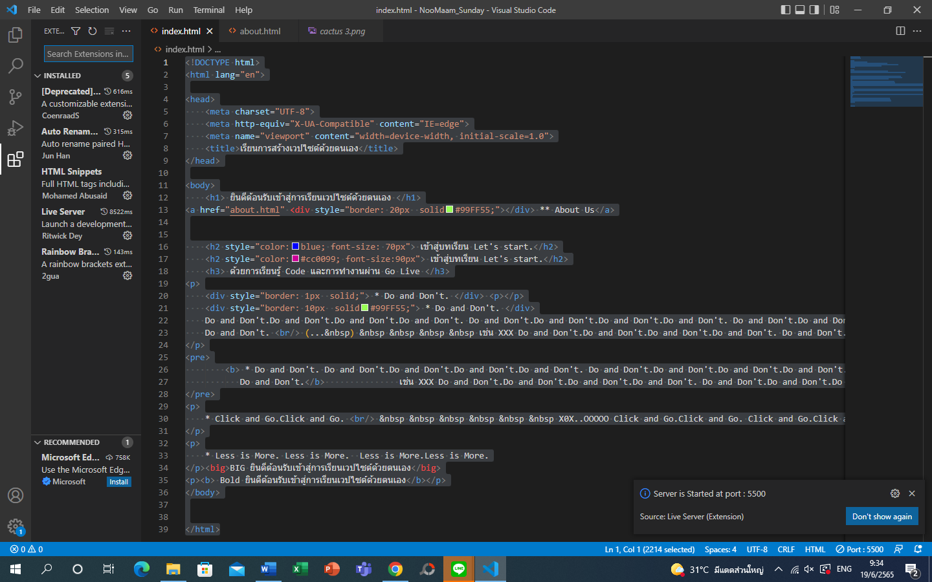

Installed Live Server then we can click “Go Live” on the file code right away.

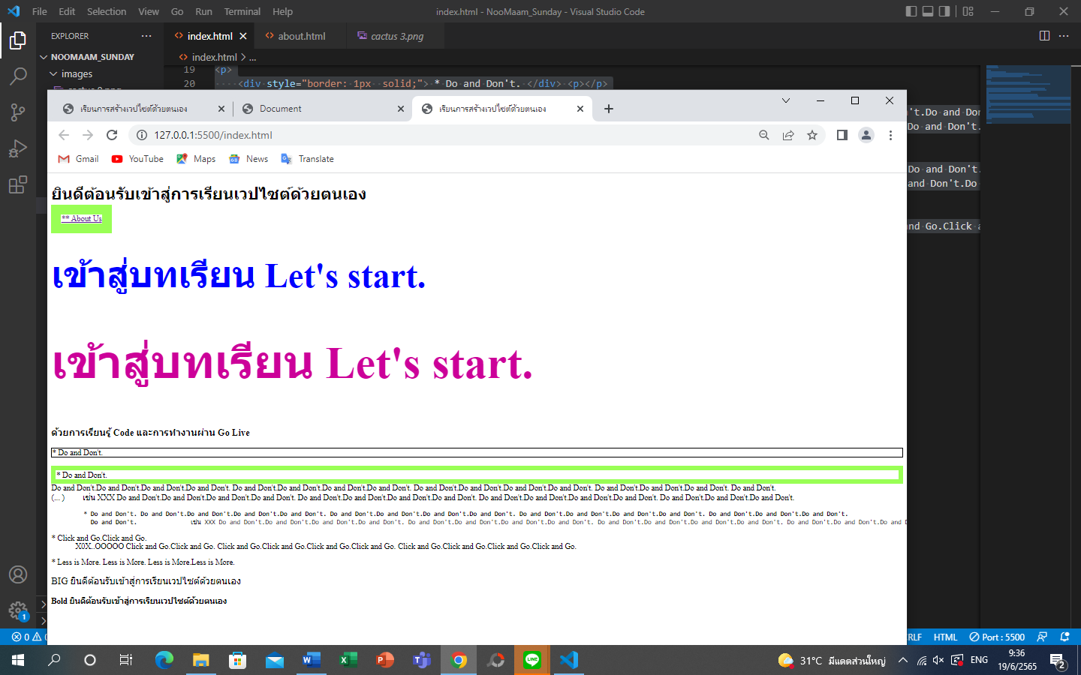

Then once click you will directly go to the home page.

Don’t click more than once, otherwise the page will reopen.

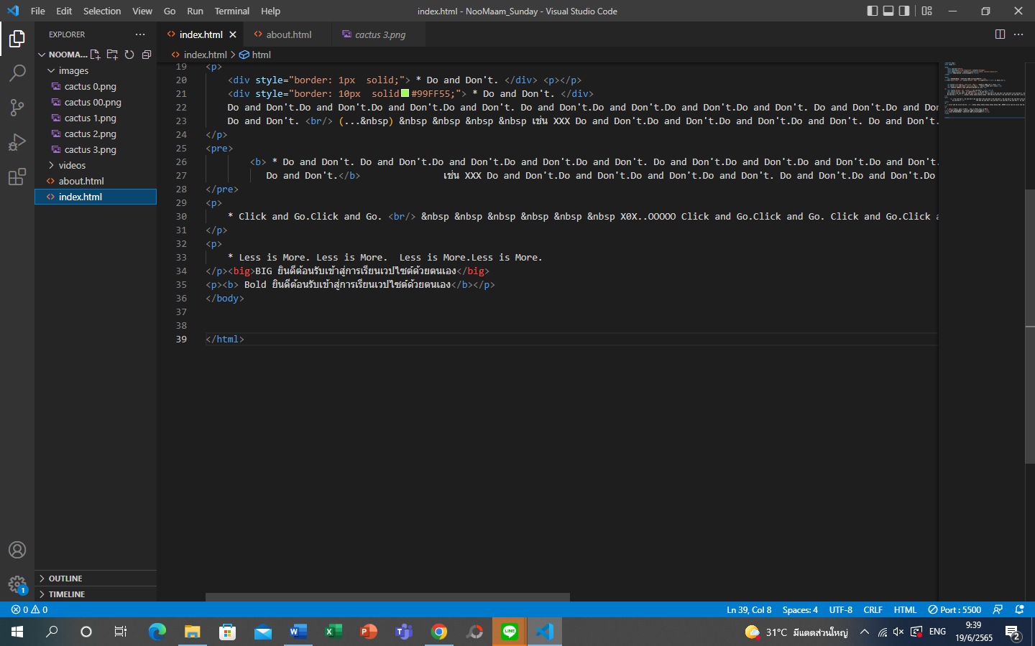

Explorer page.

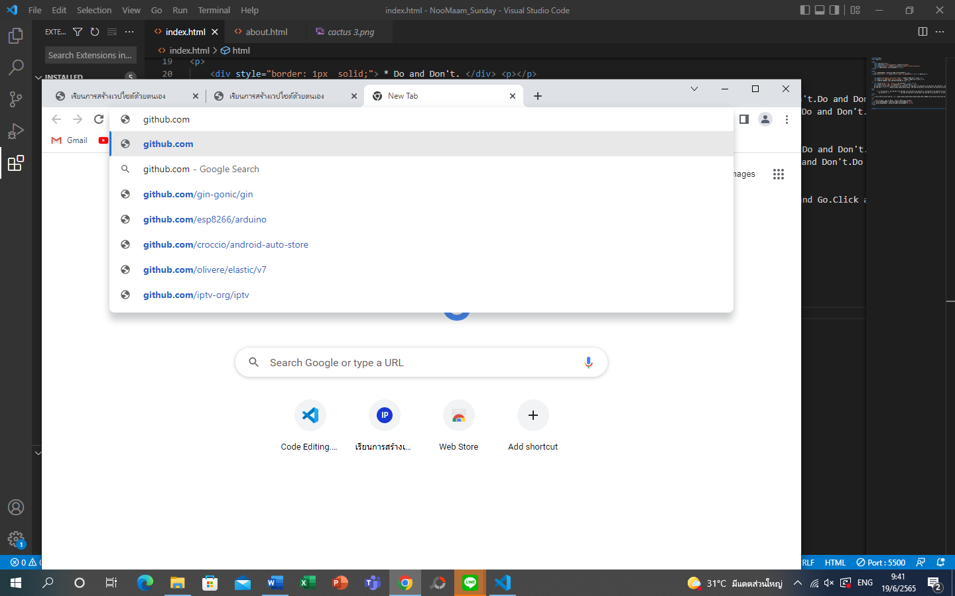install github.com for web and files on cloud server

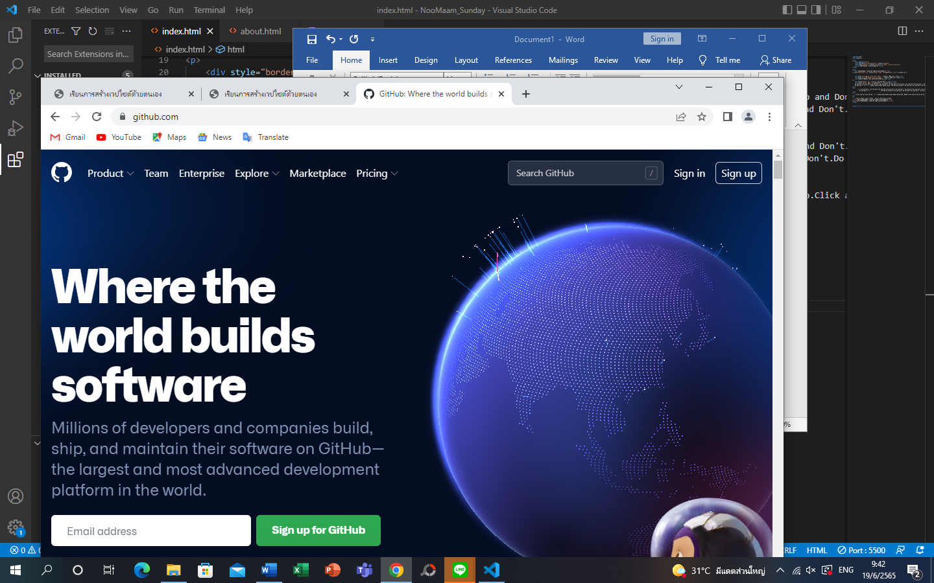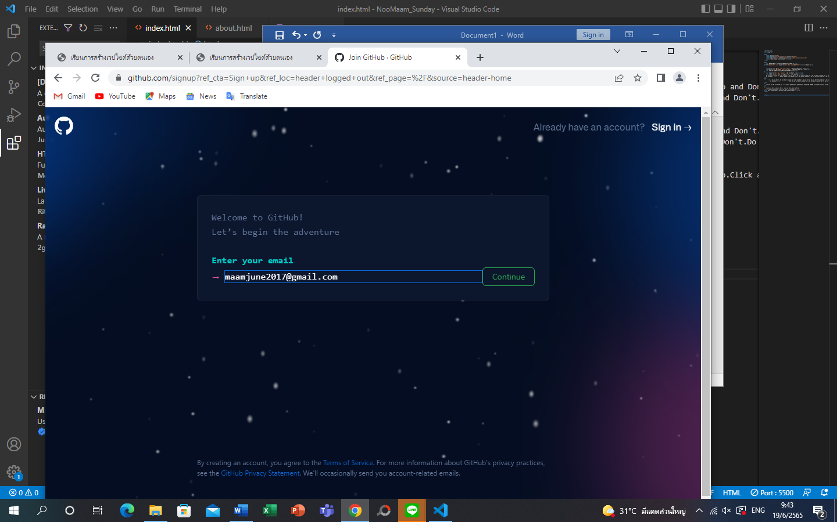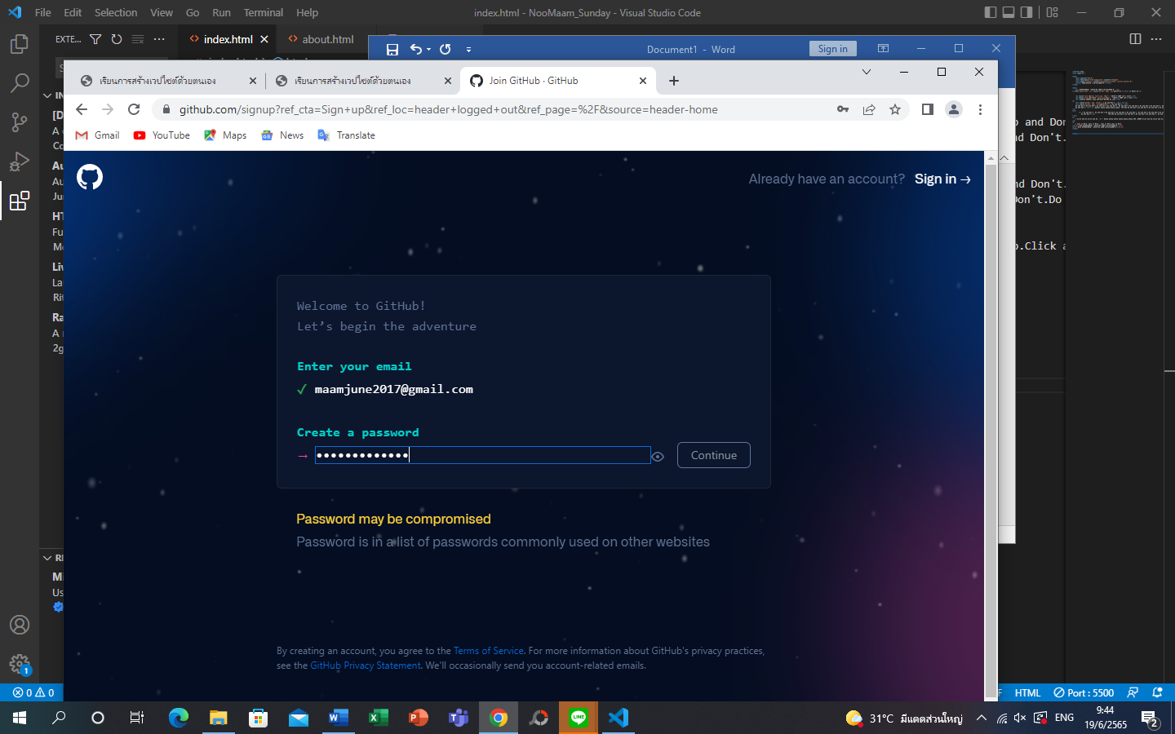PW: MJ123456789j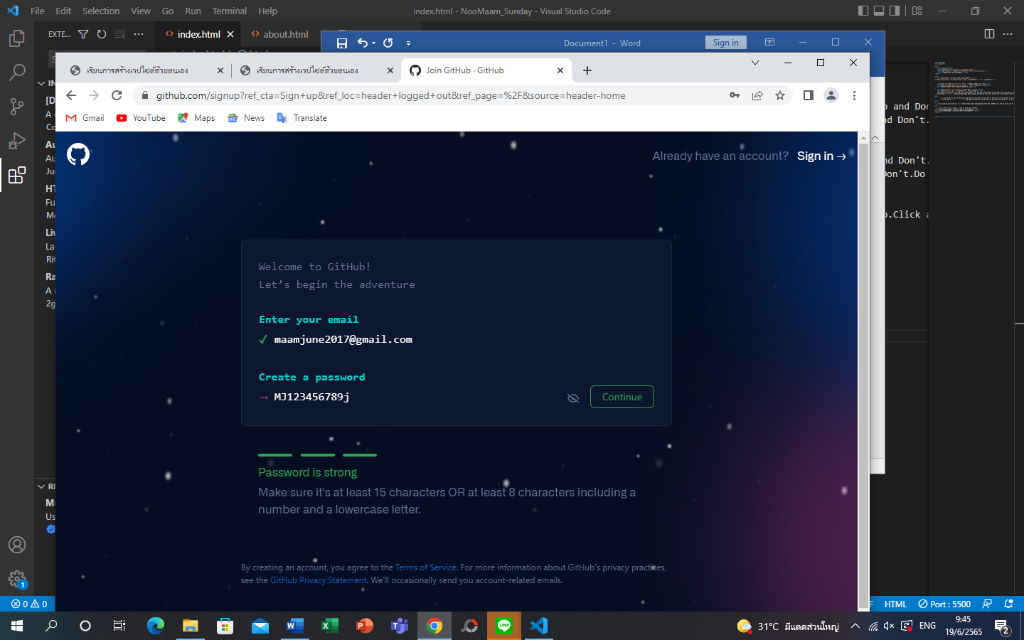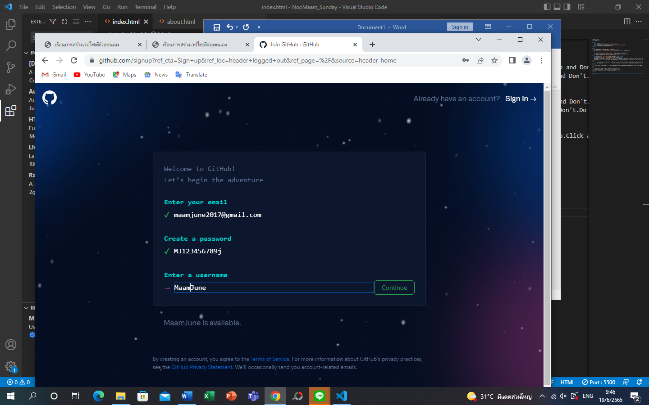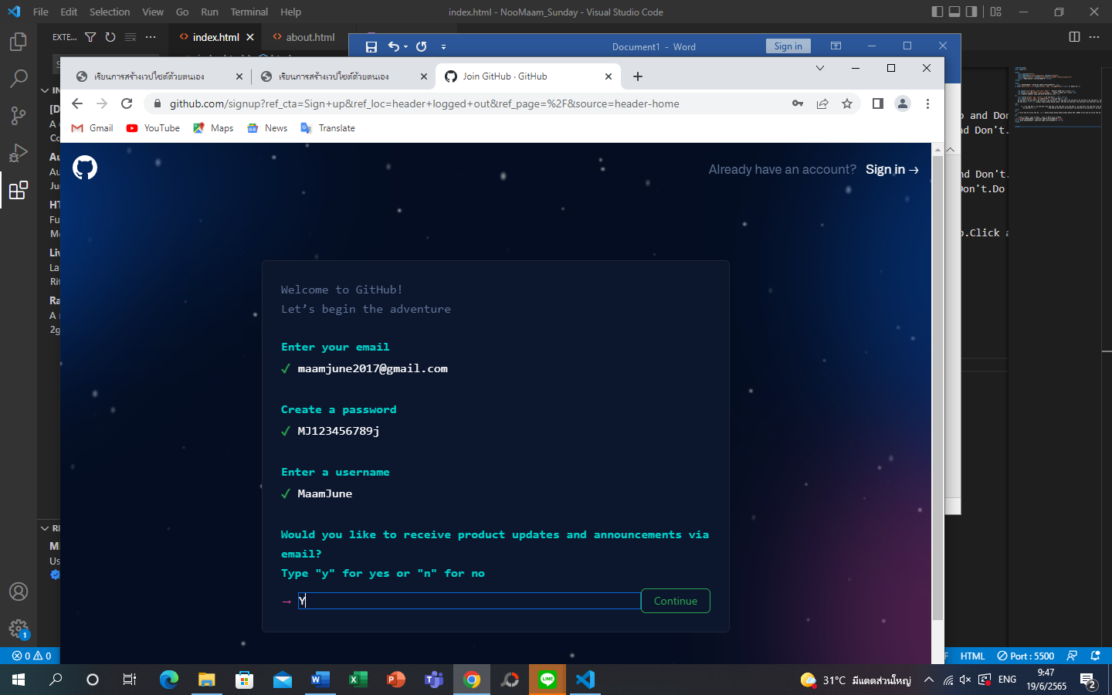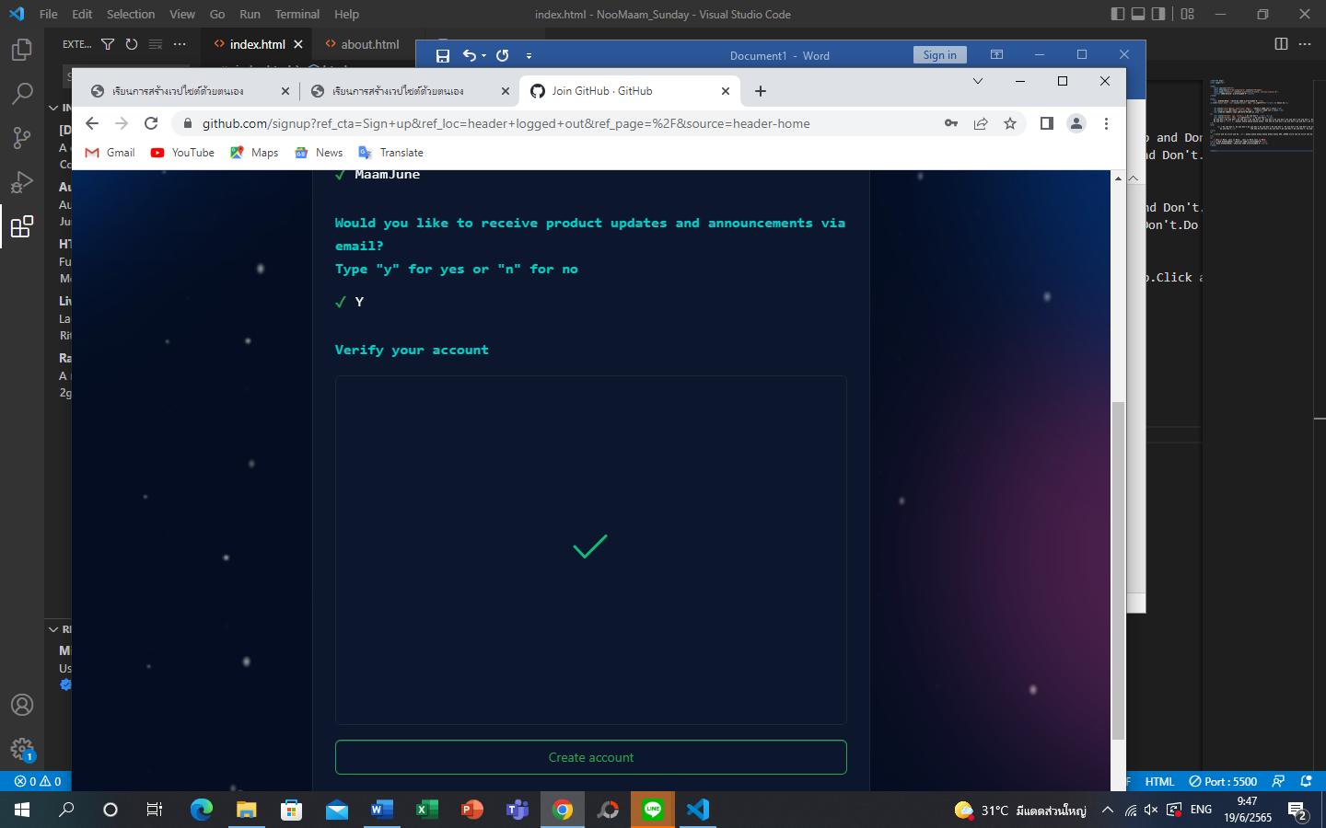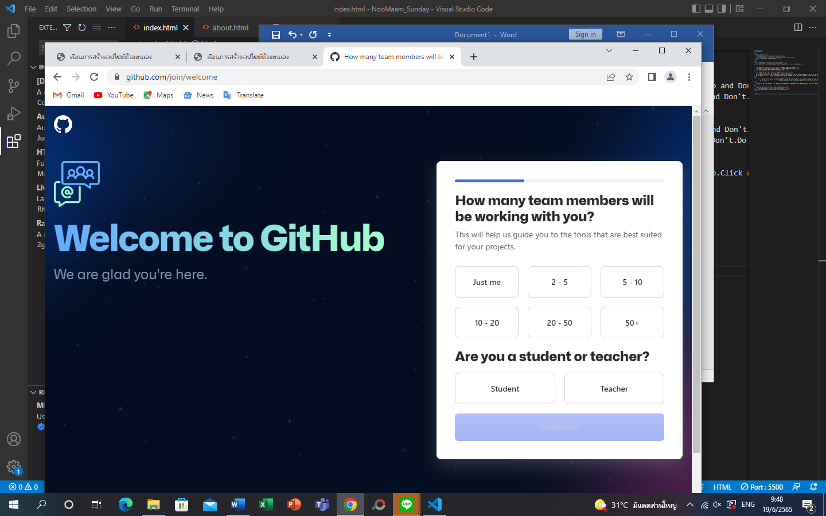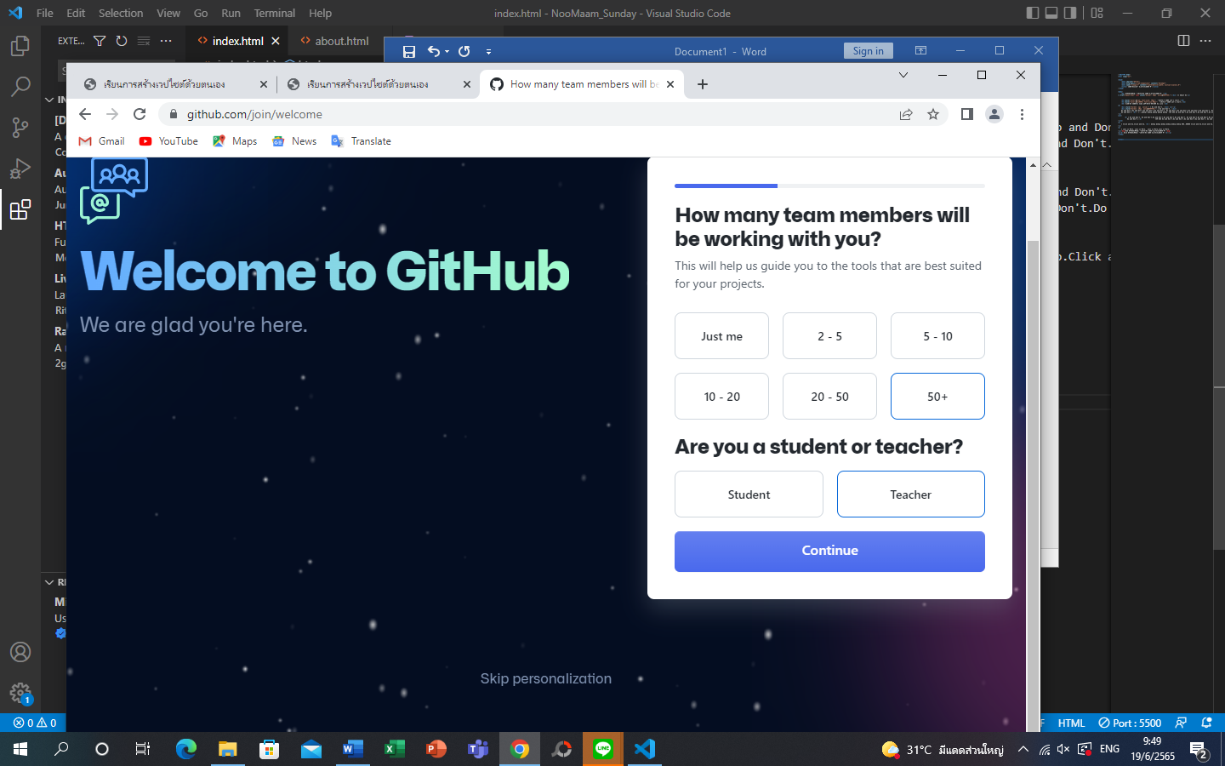

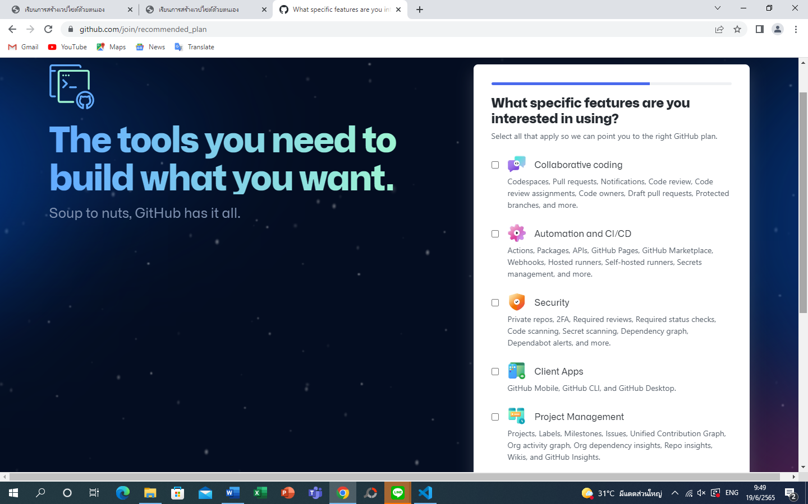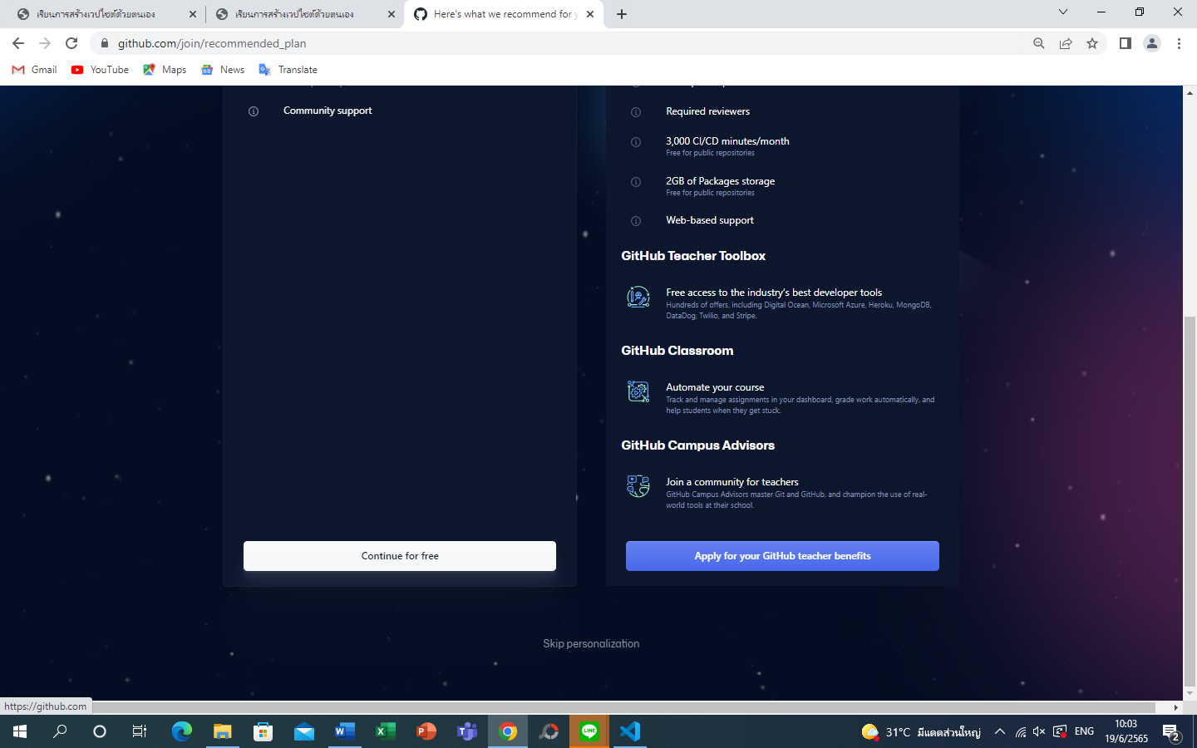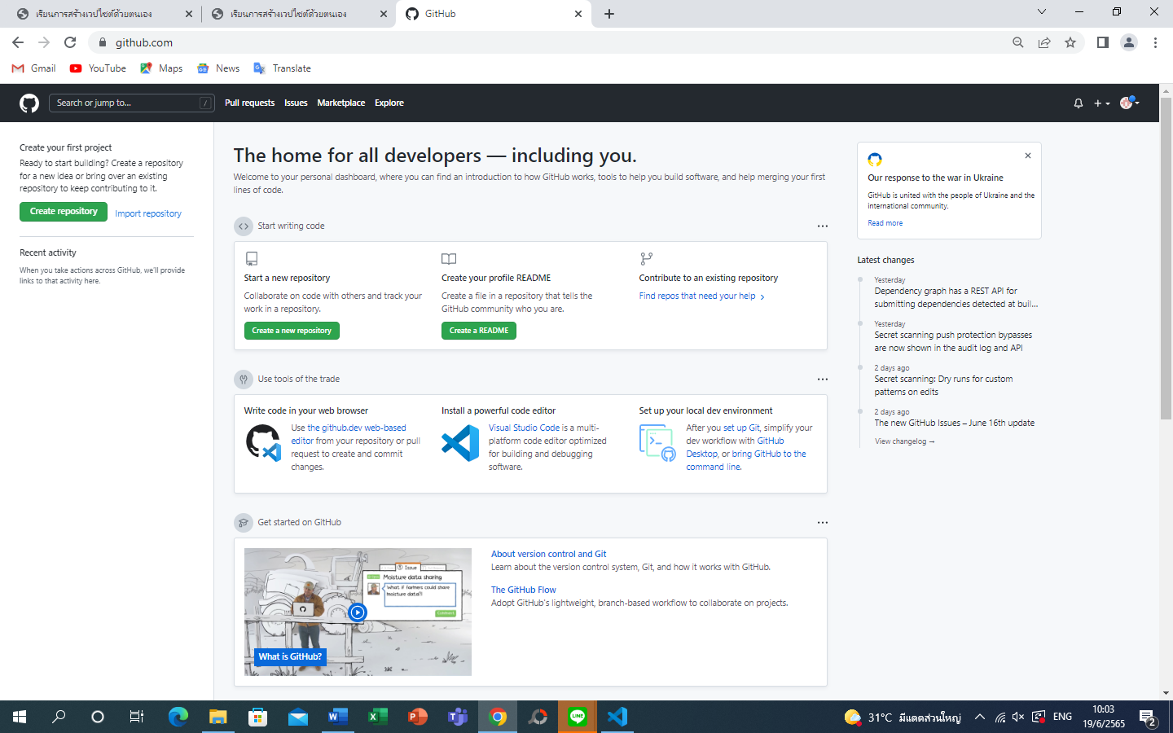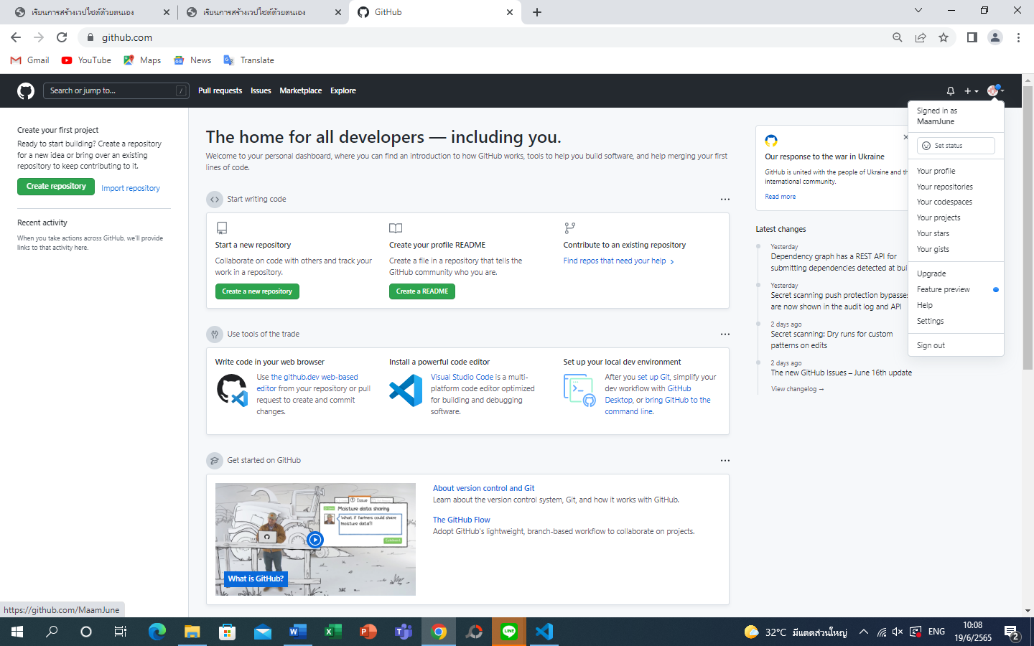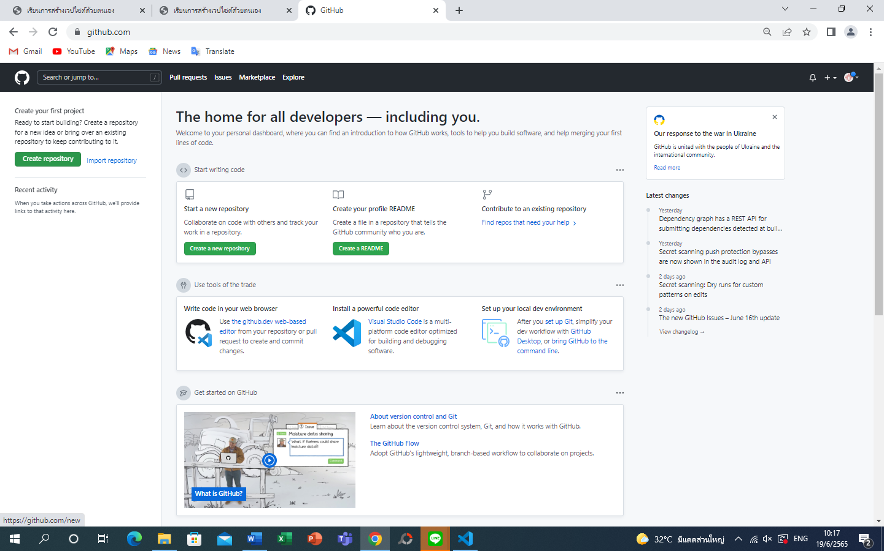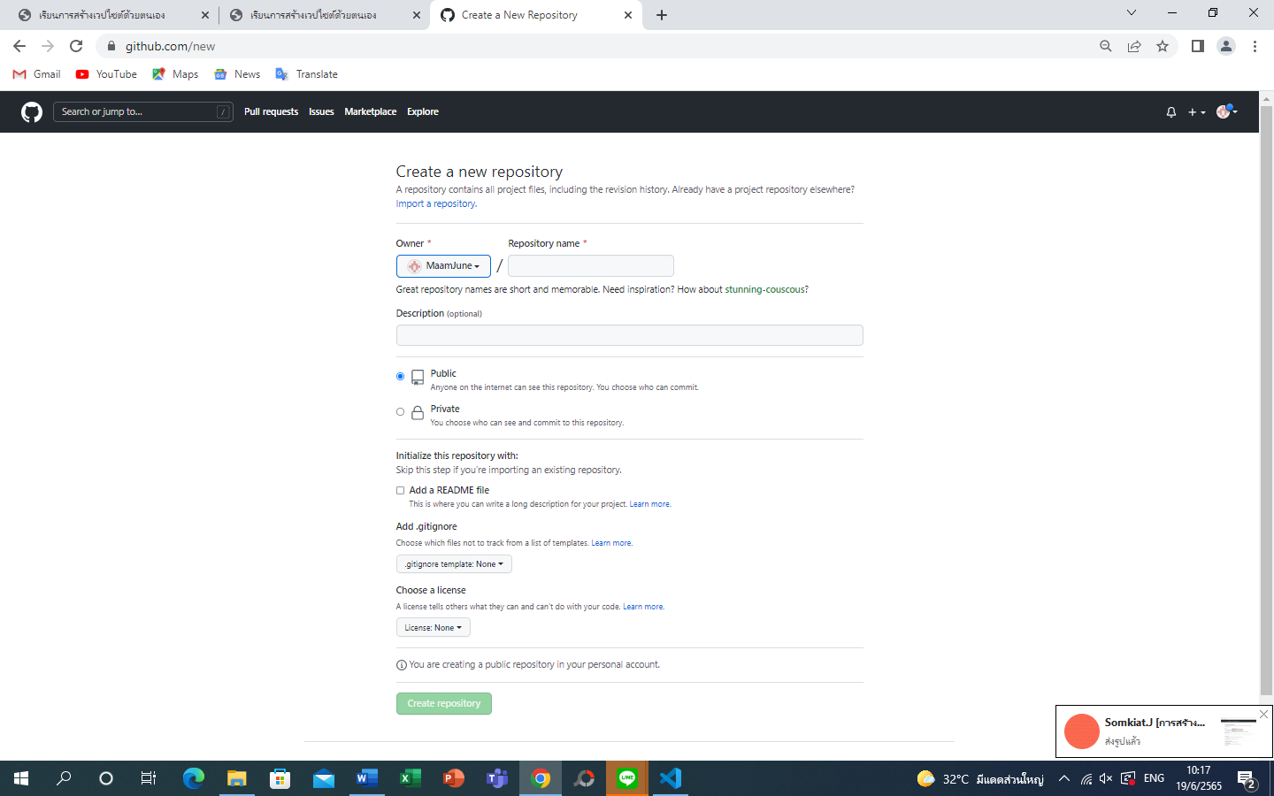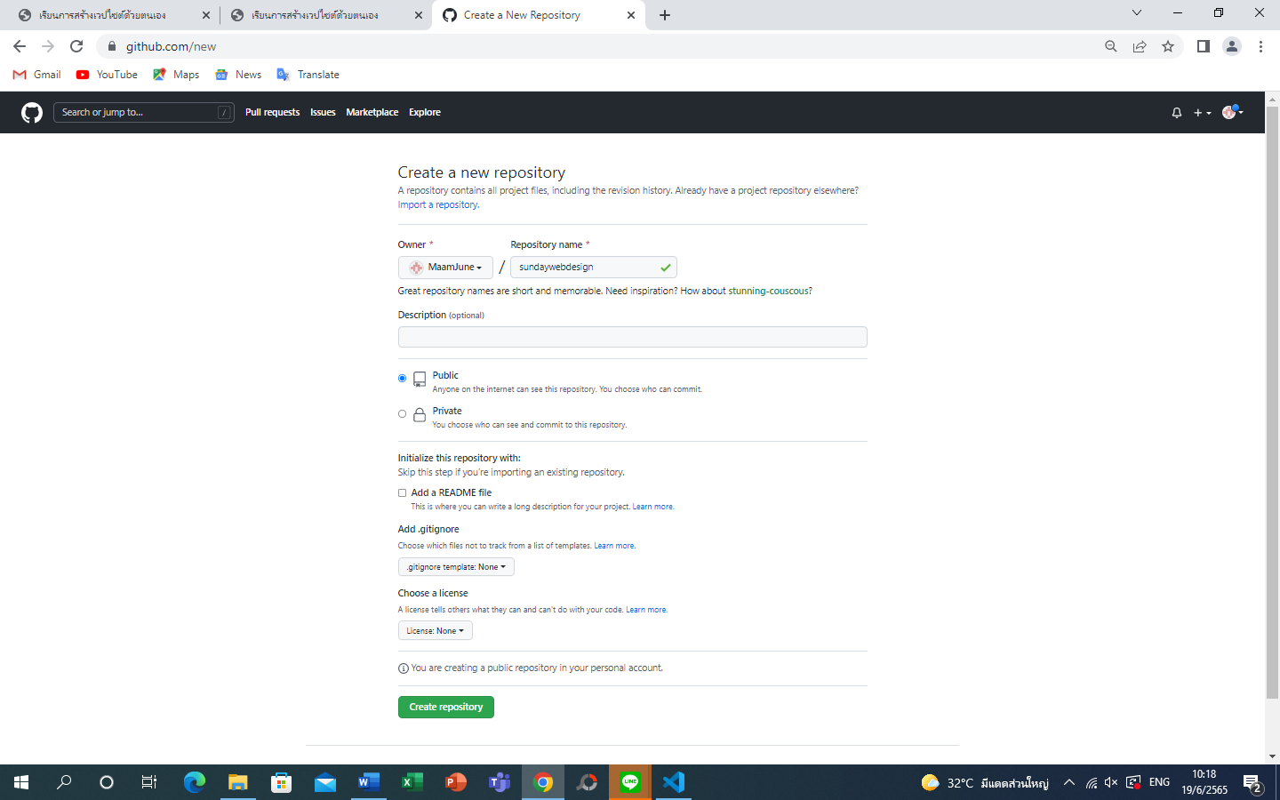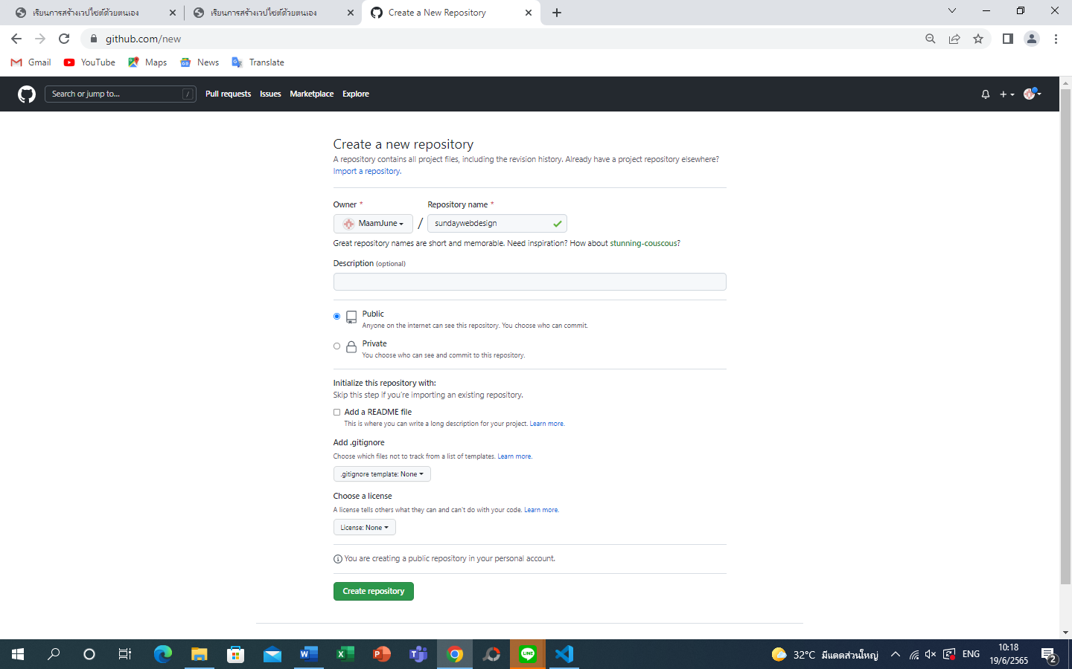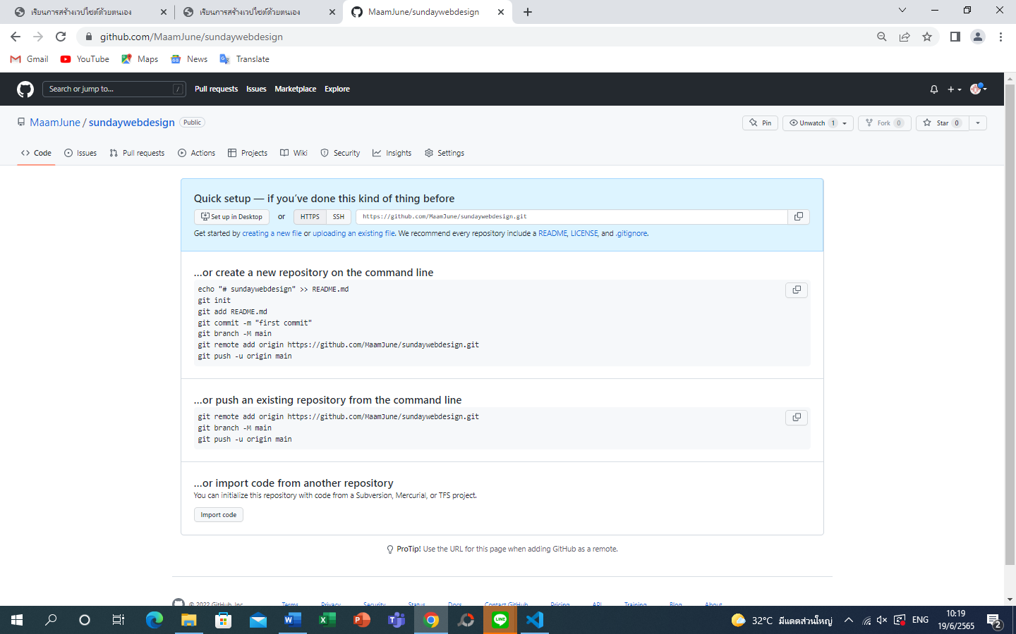will show uploading command and path

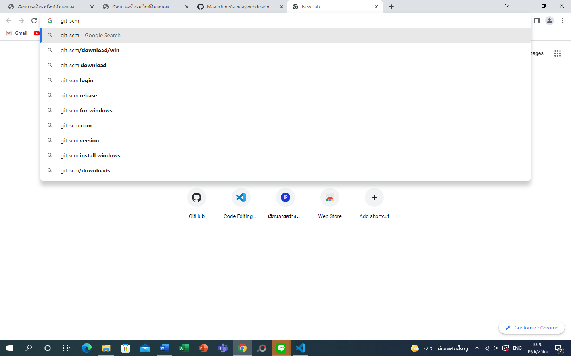install git-scm

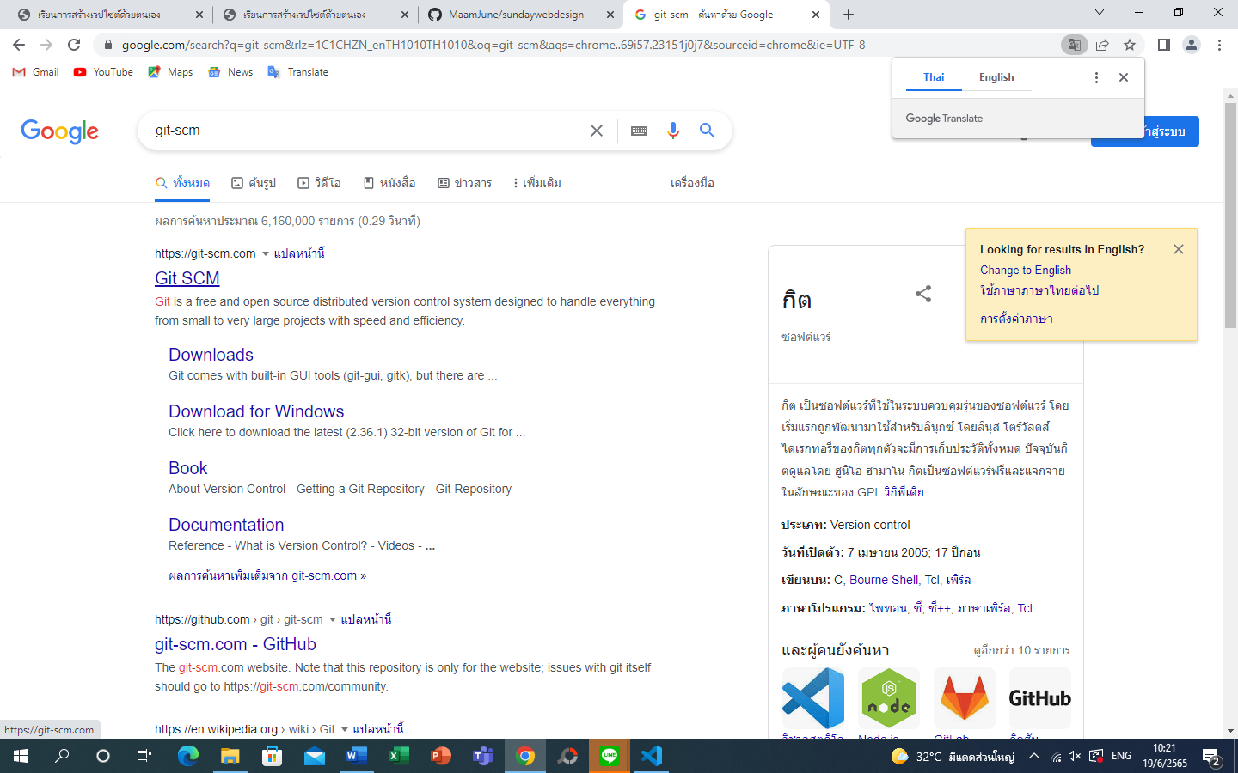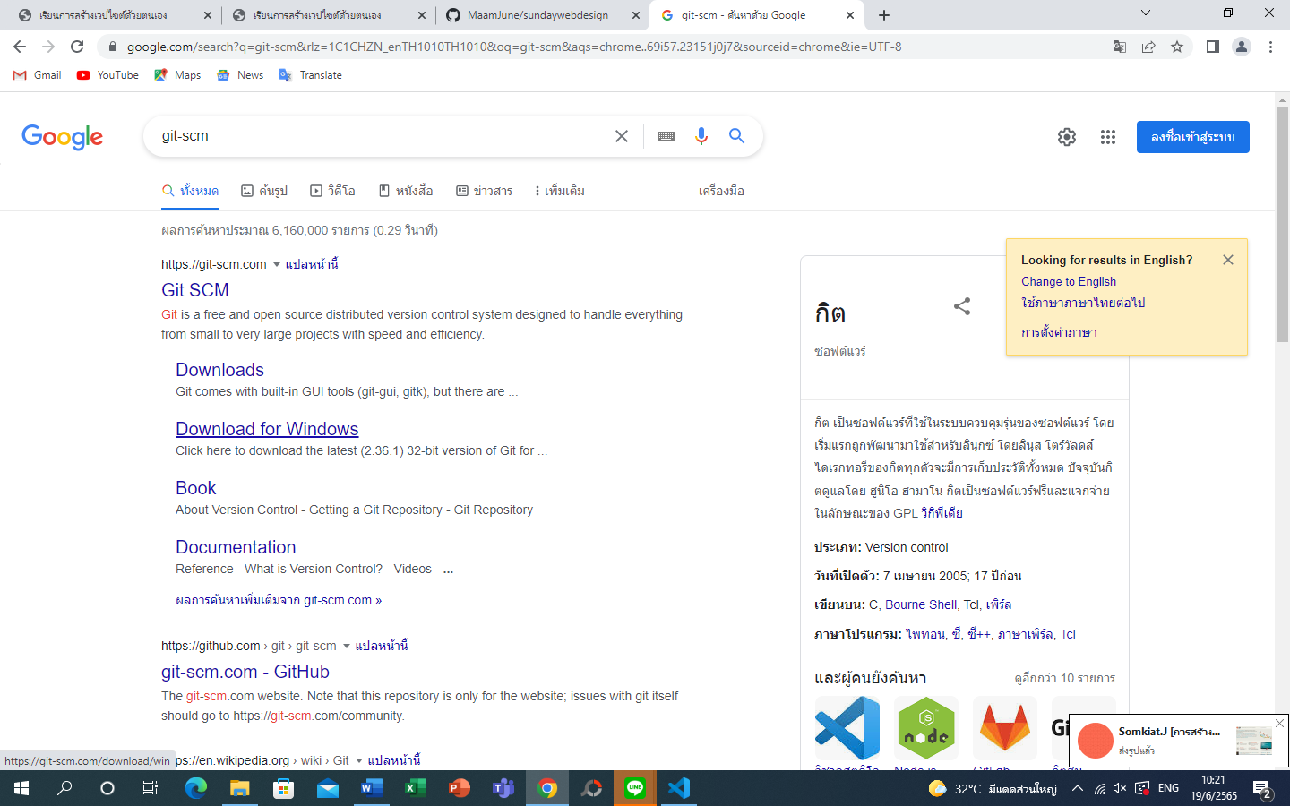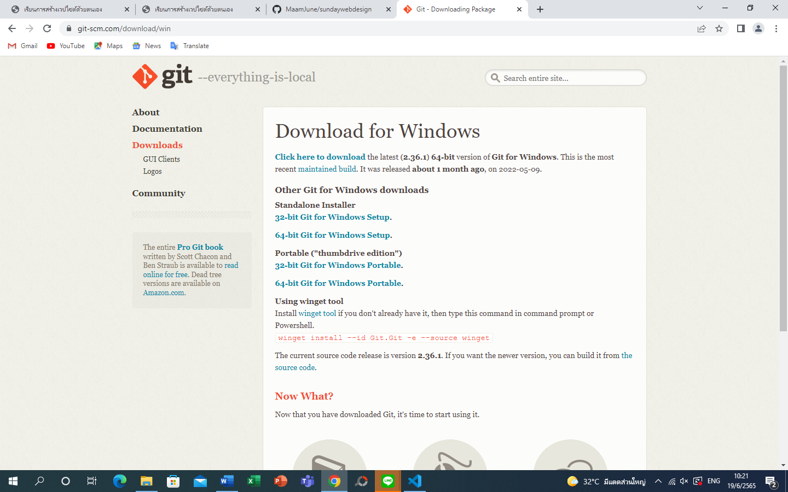download for windows 64 bits

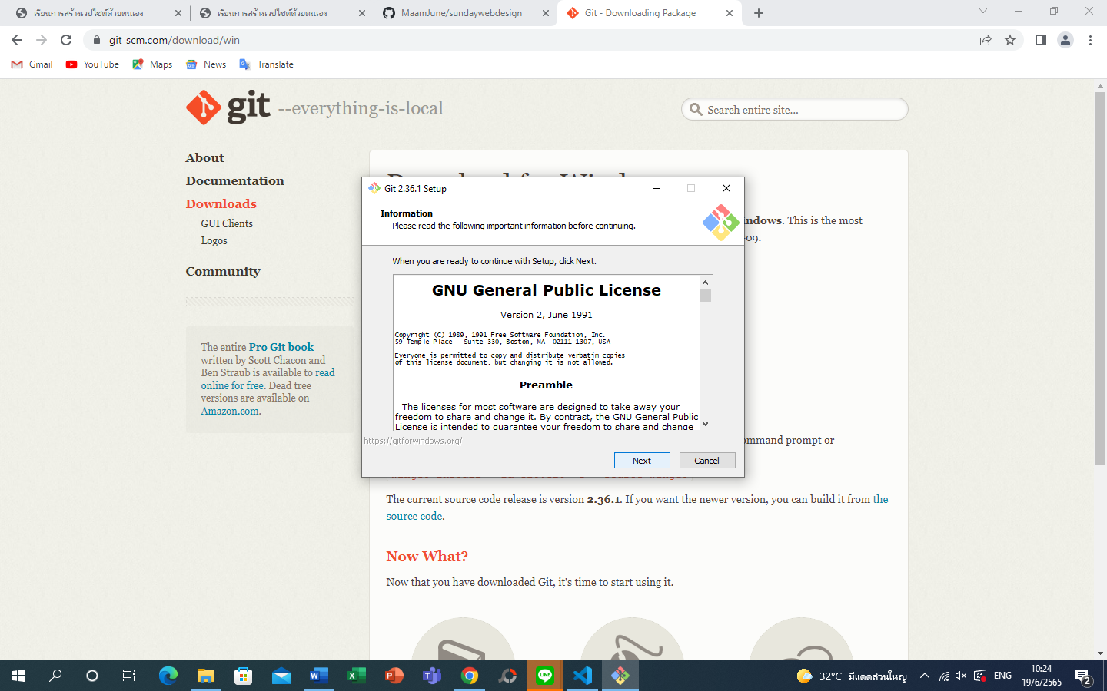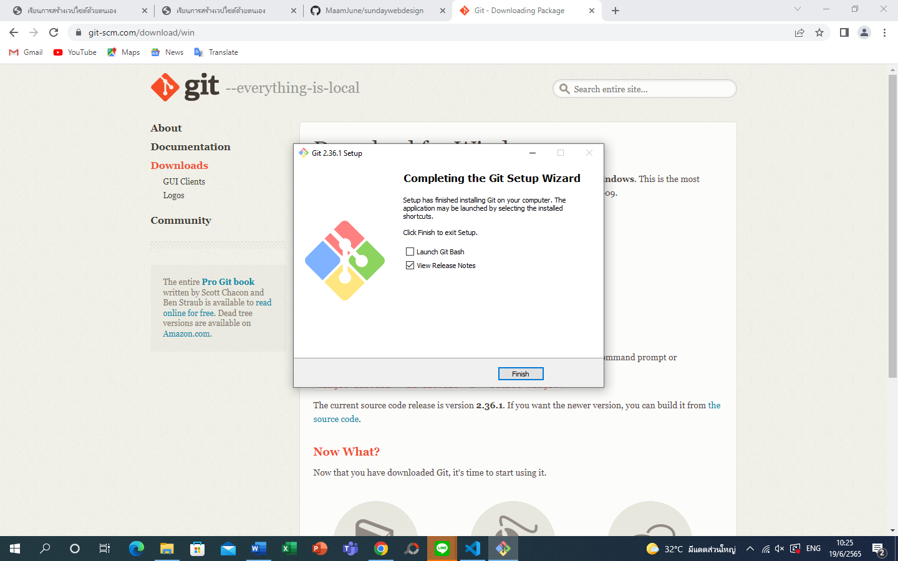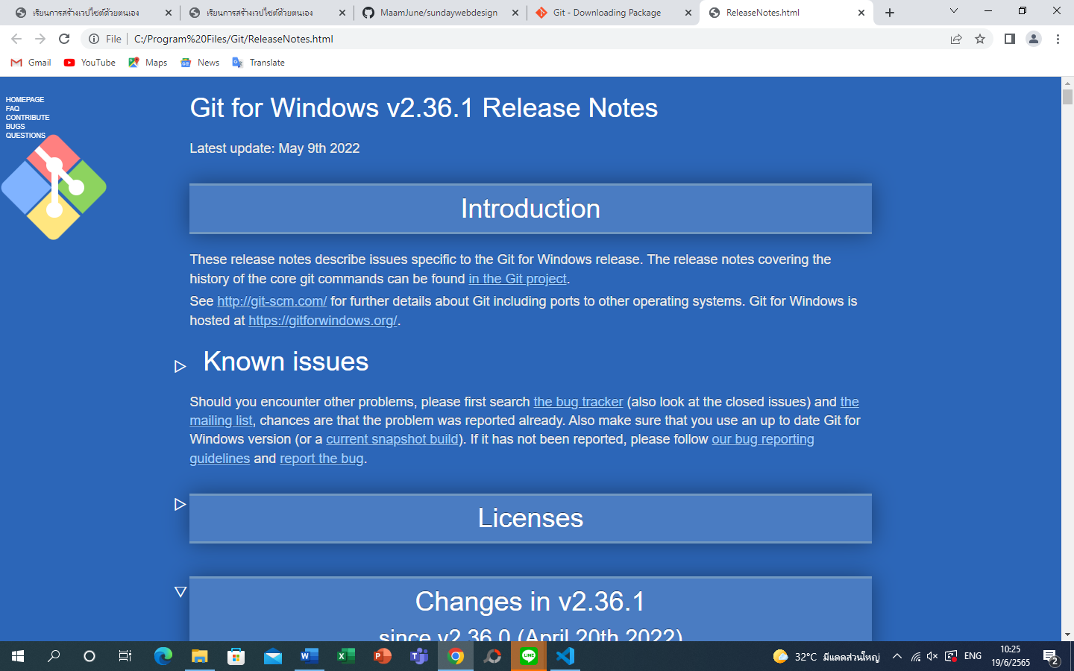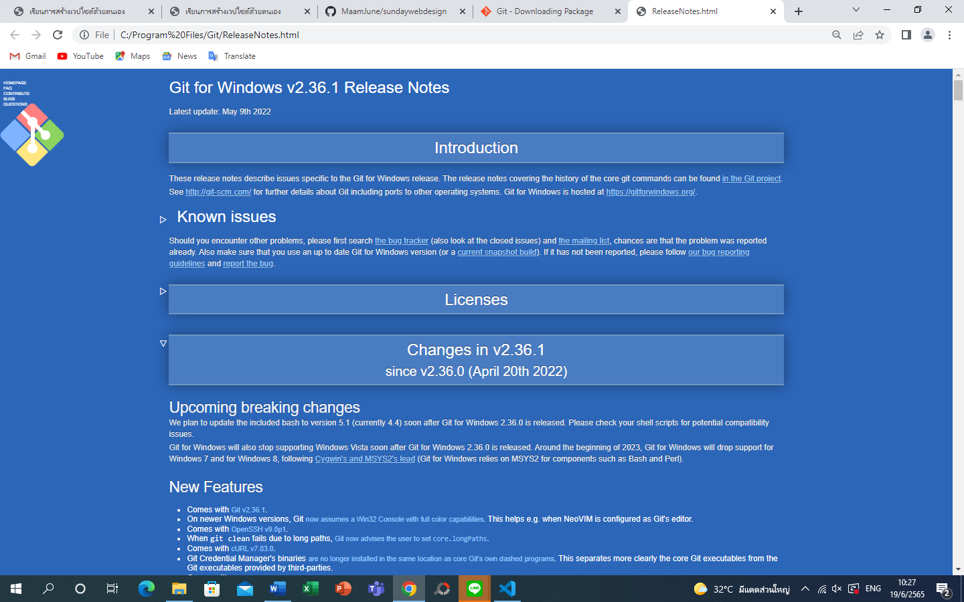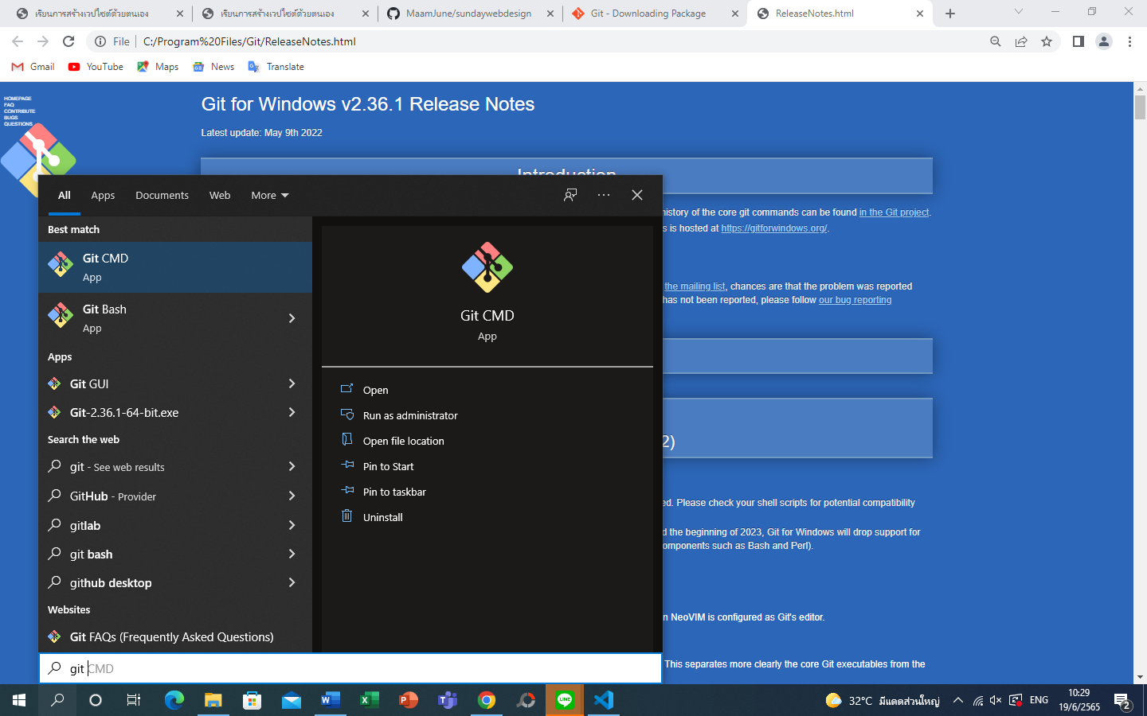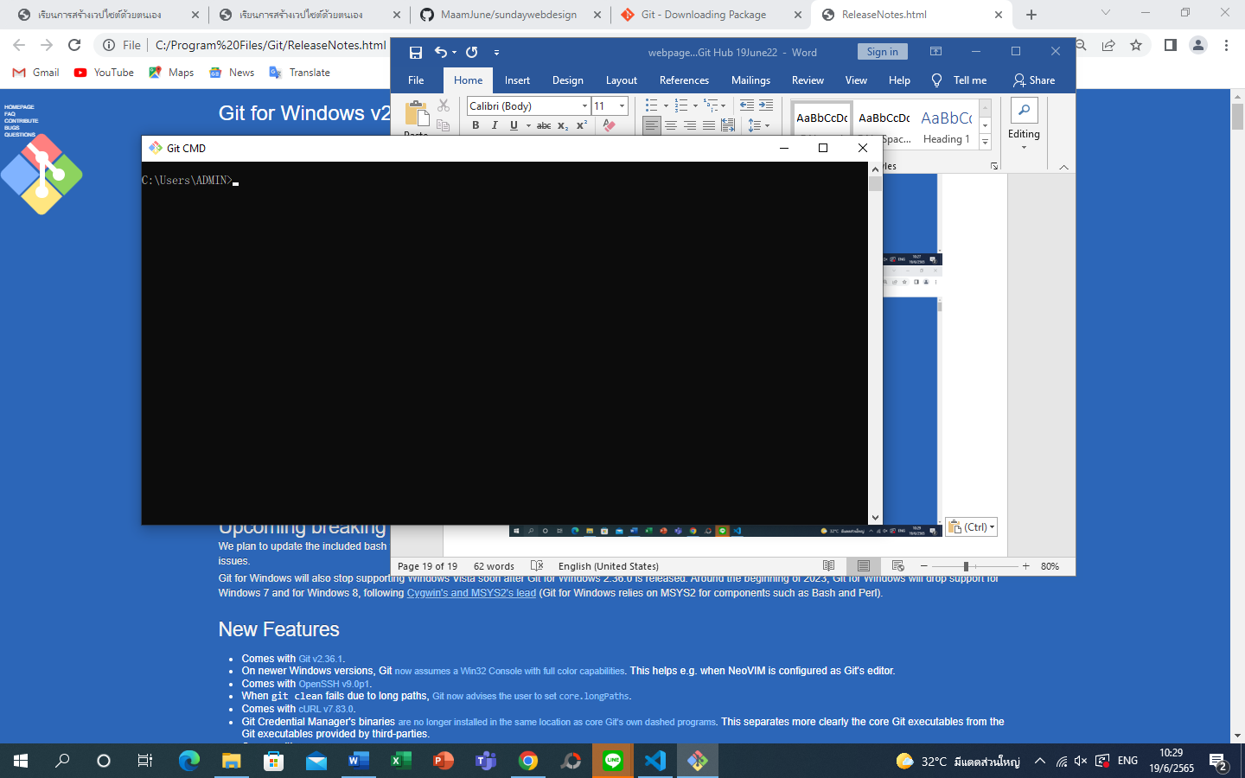

Git cmd = dos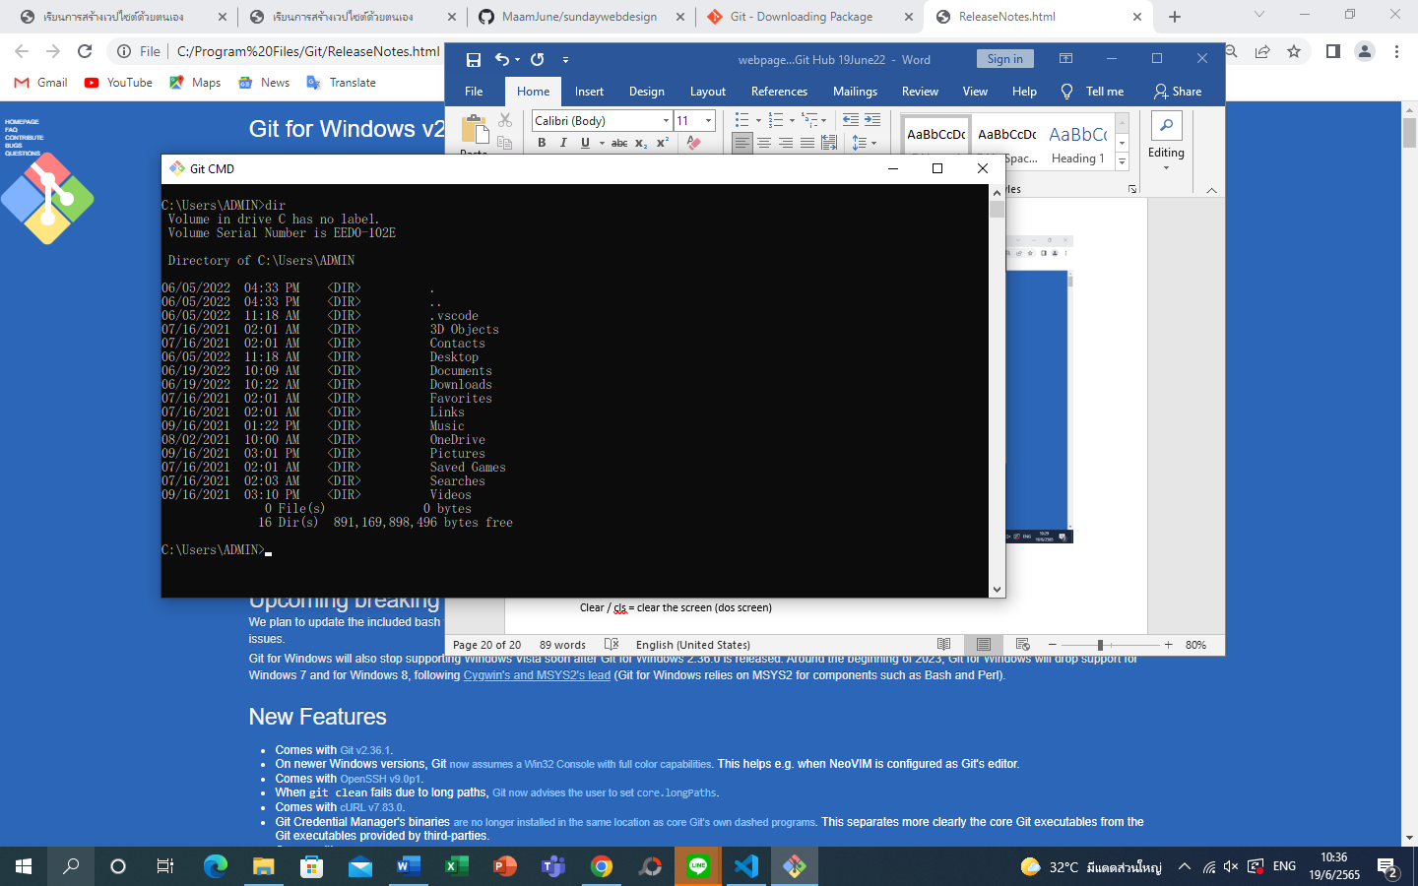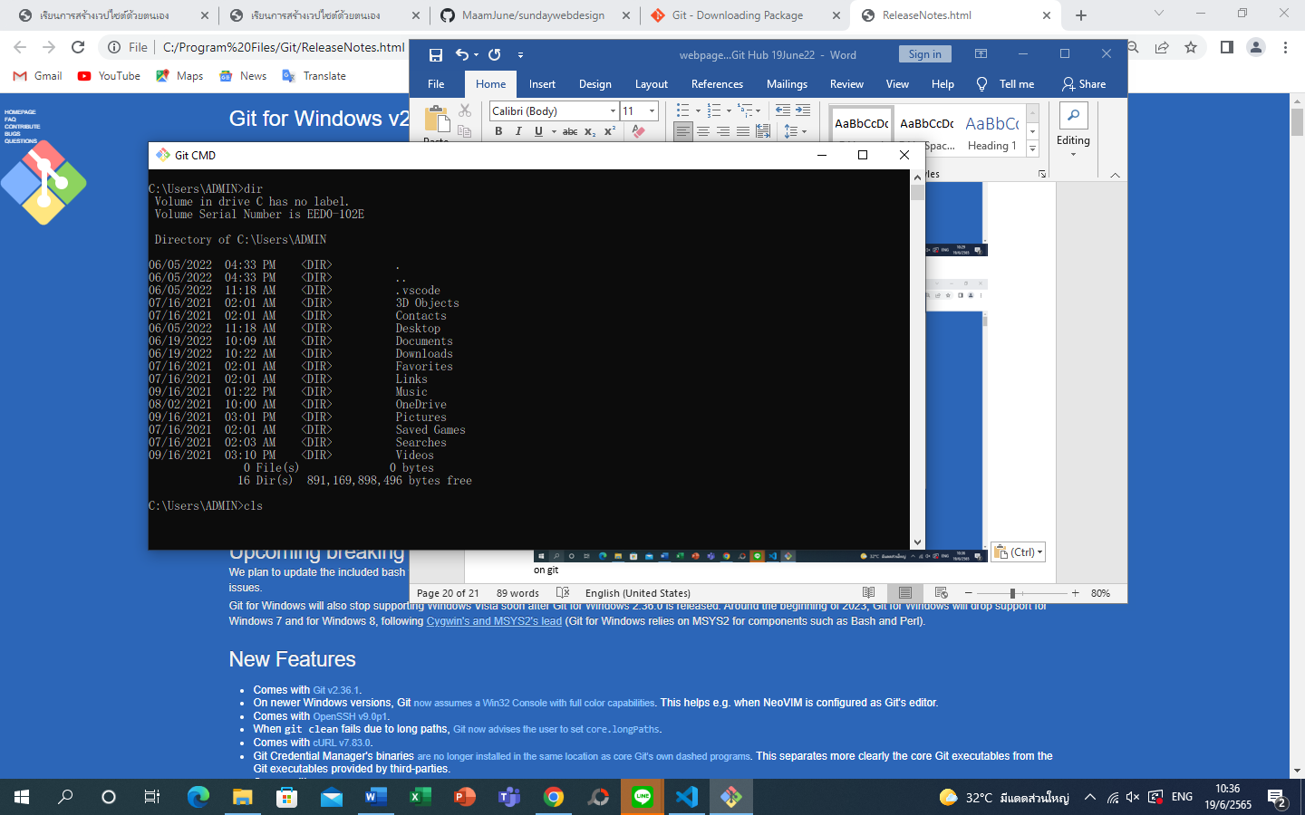 on git

Command line will be use with git bash or git cmd only

Clear / cls = clear the screen (dos screen) cls + enter

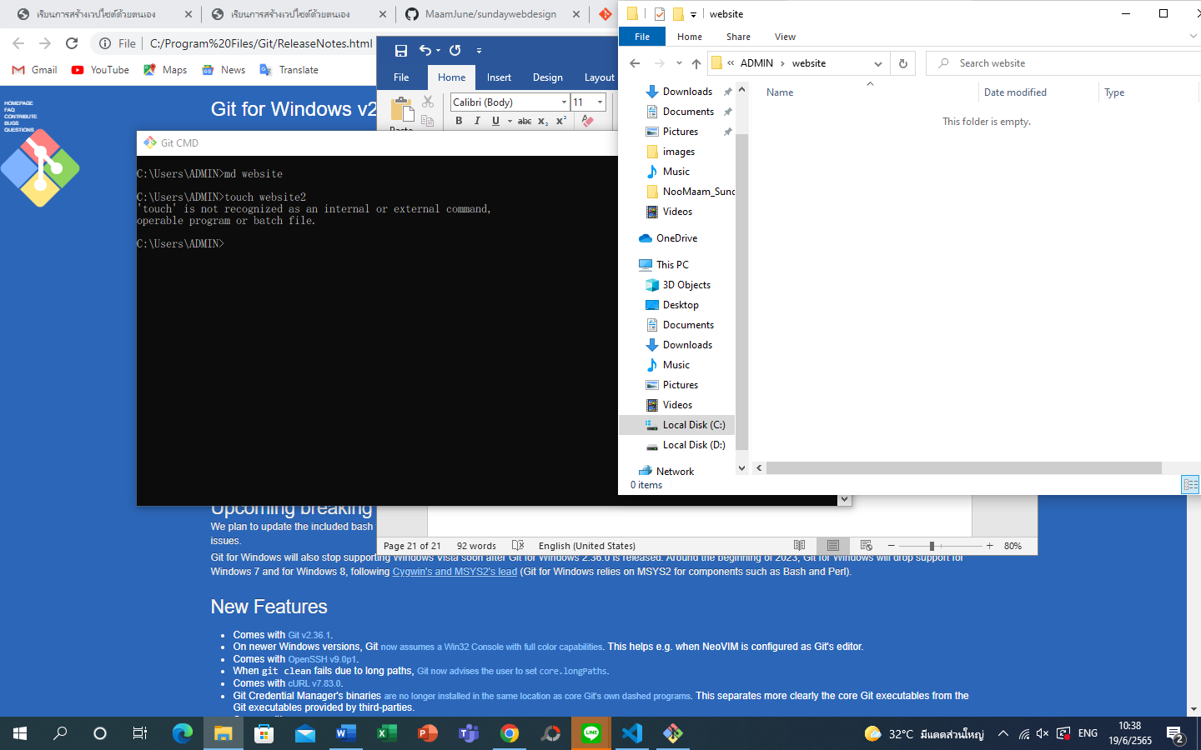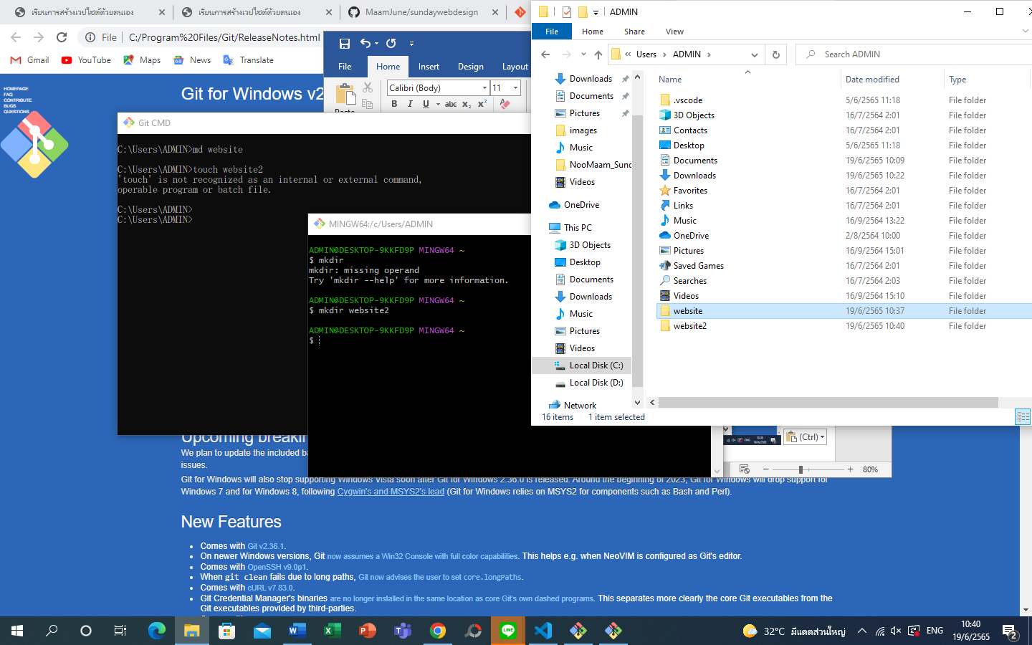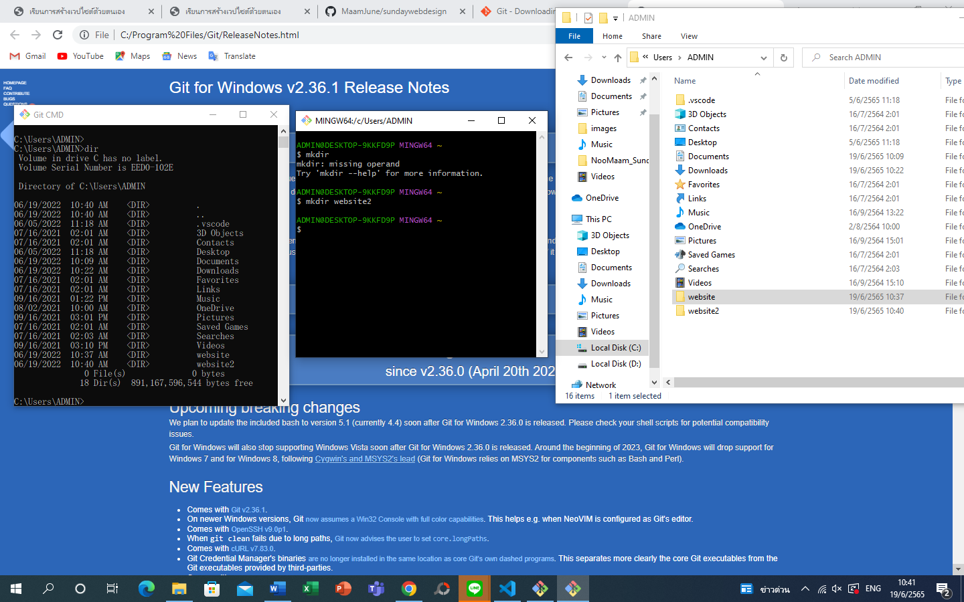create folder by git bash

To look with ls

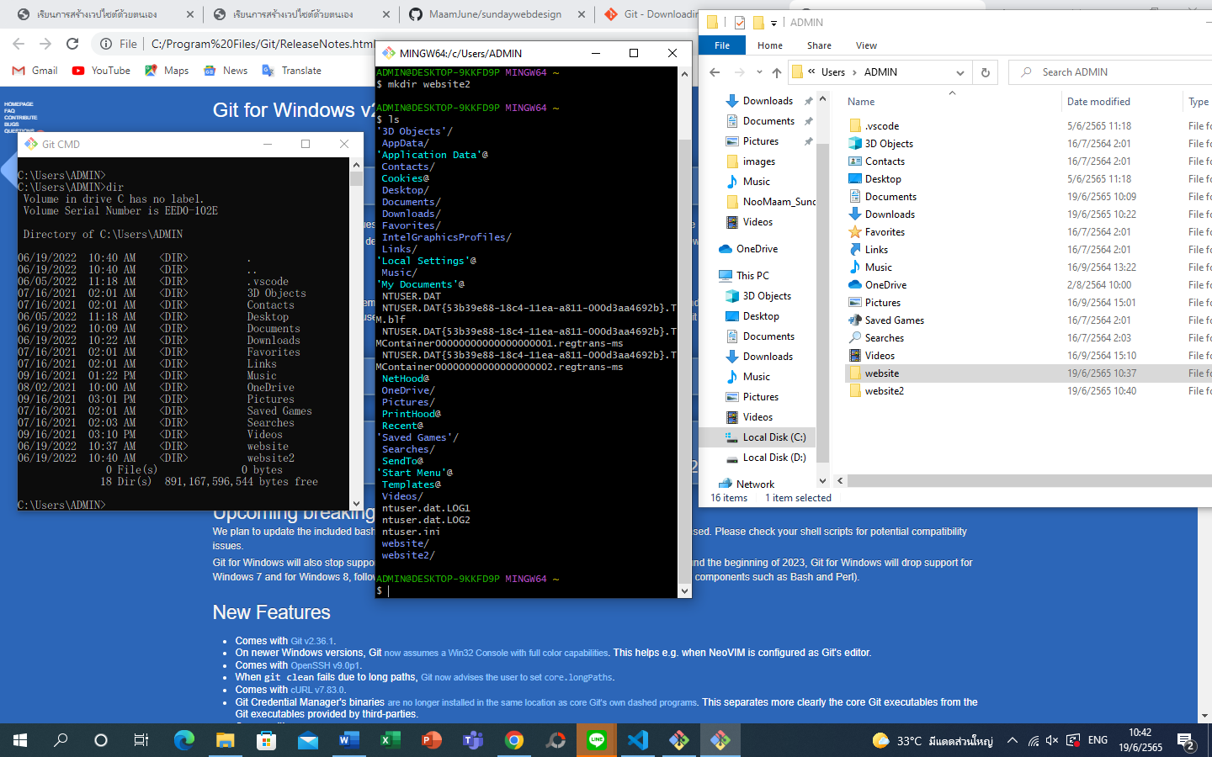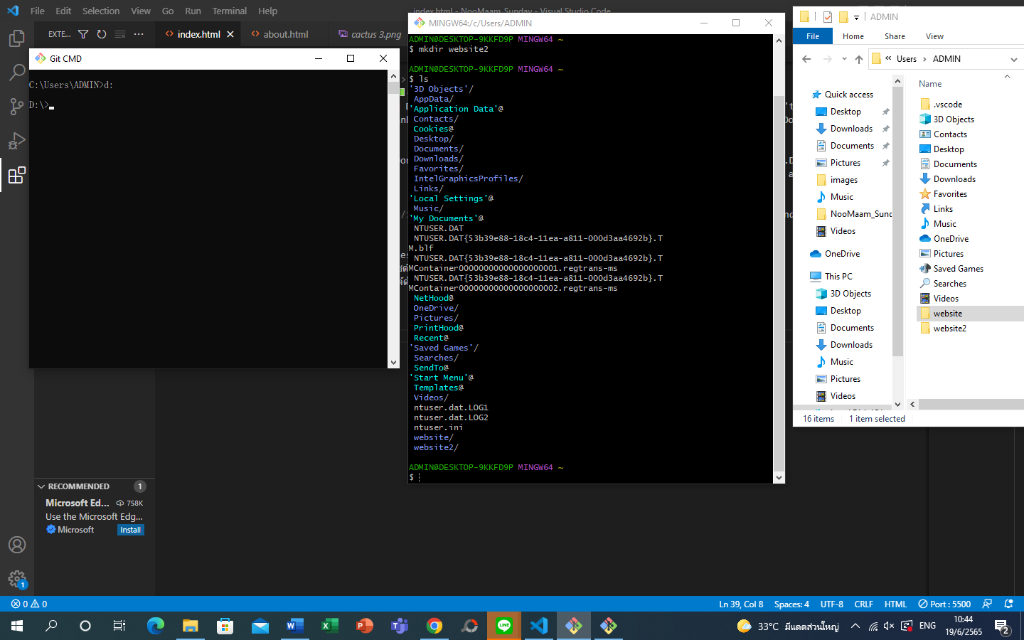at git cmd

Choose D: to go to drive D

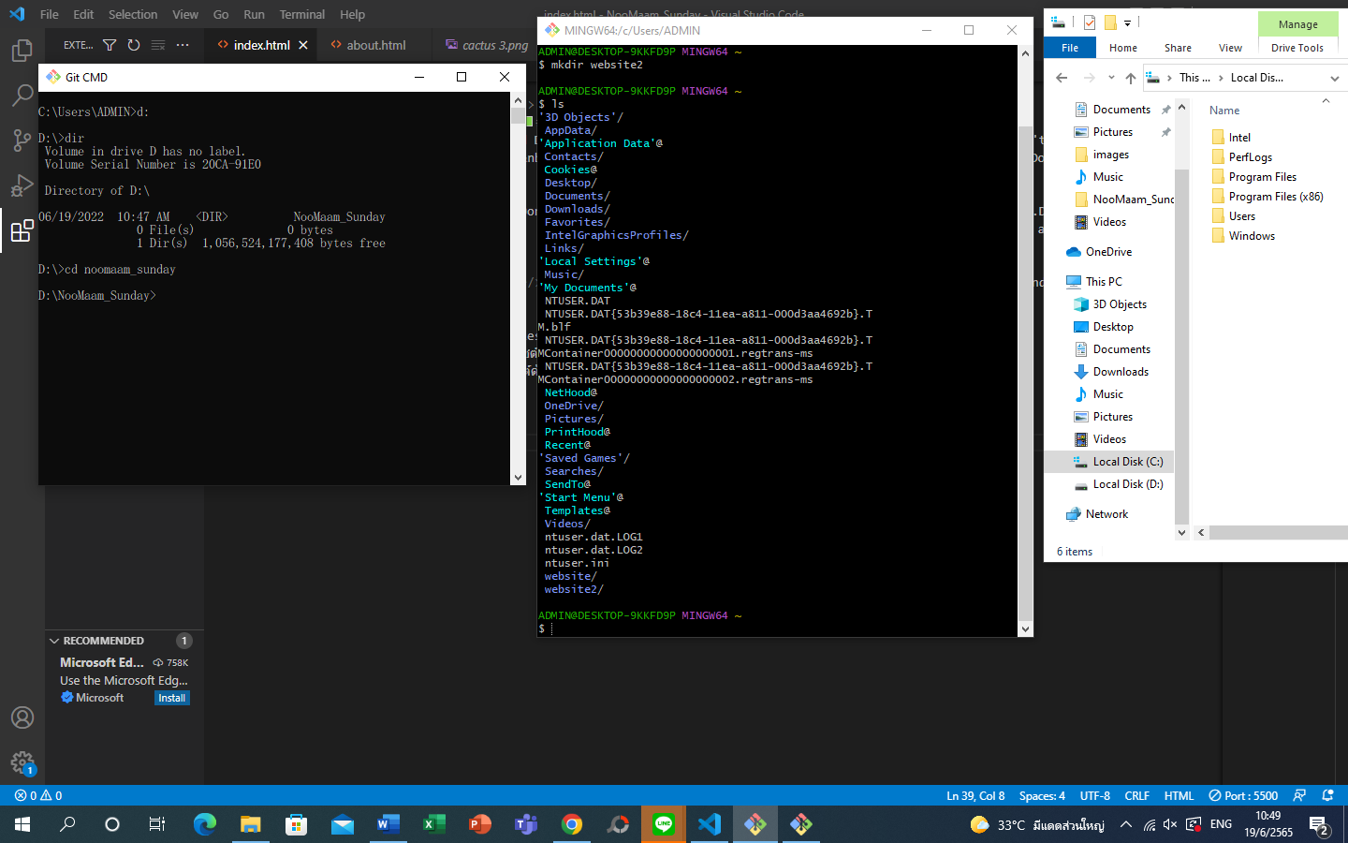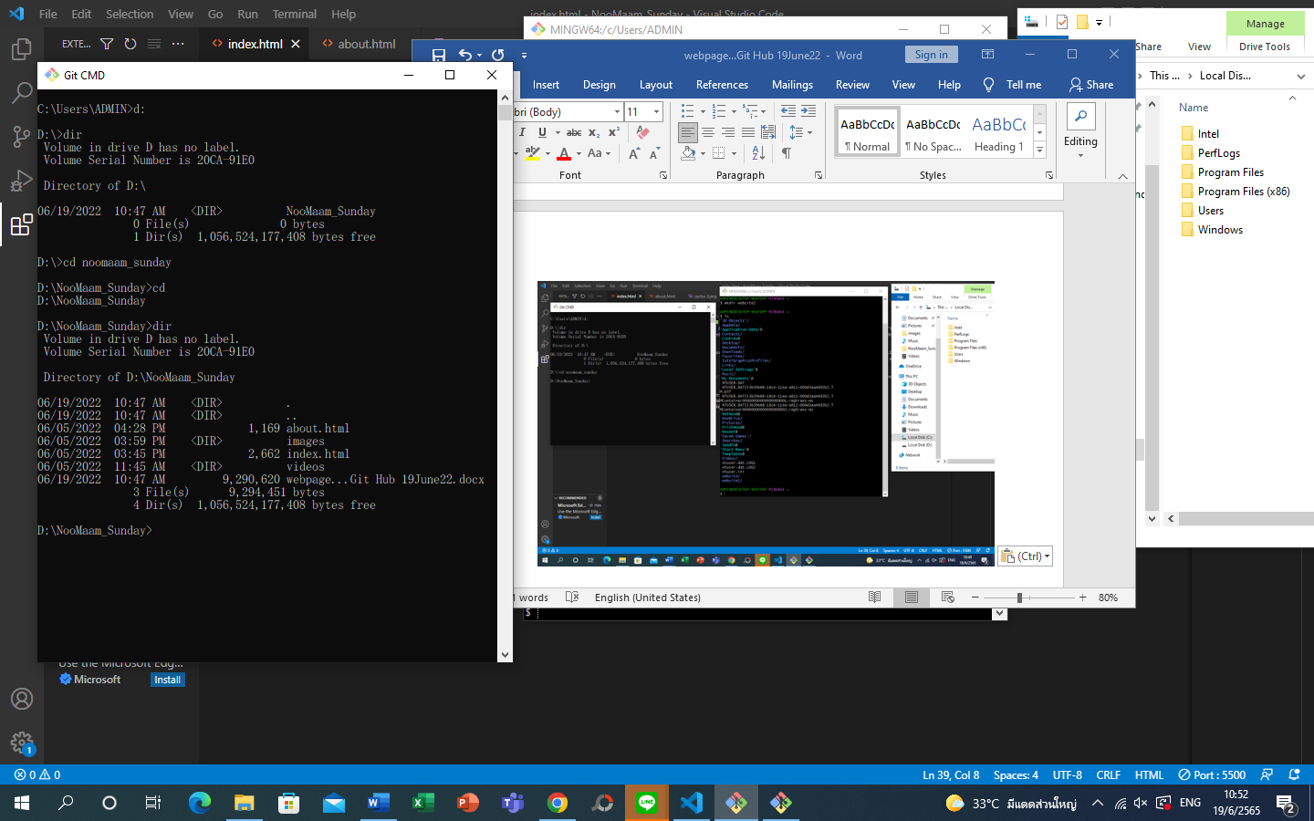

Click CD to check directory avail.

Clidk dir after the cd to see detail directory

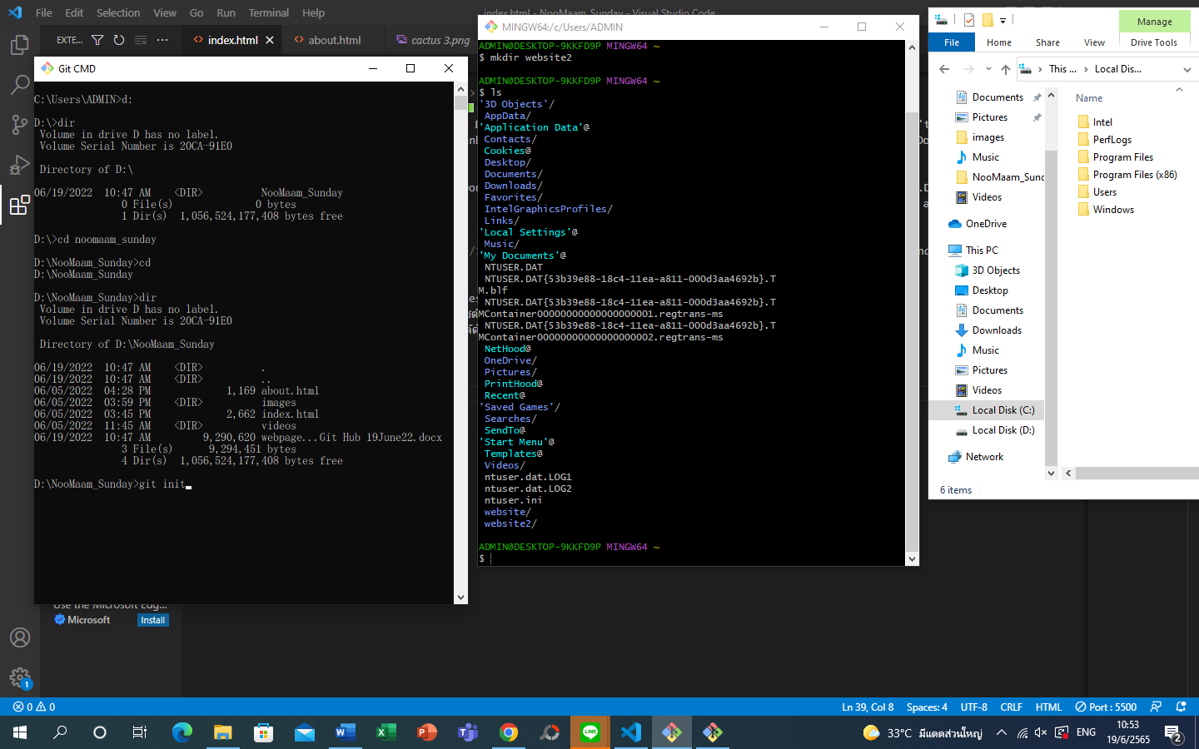

New repository to create new folder in github.com

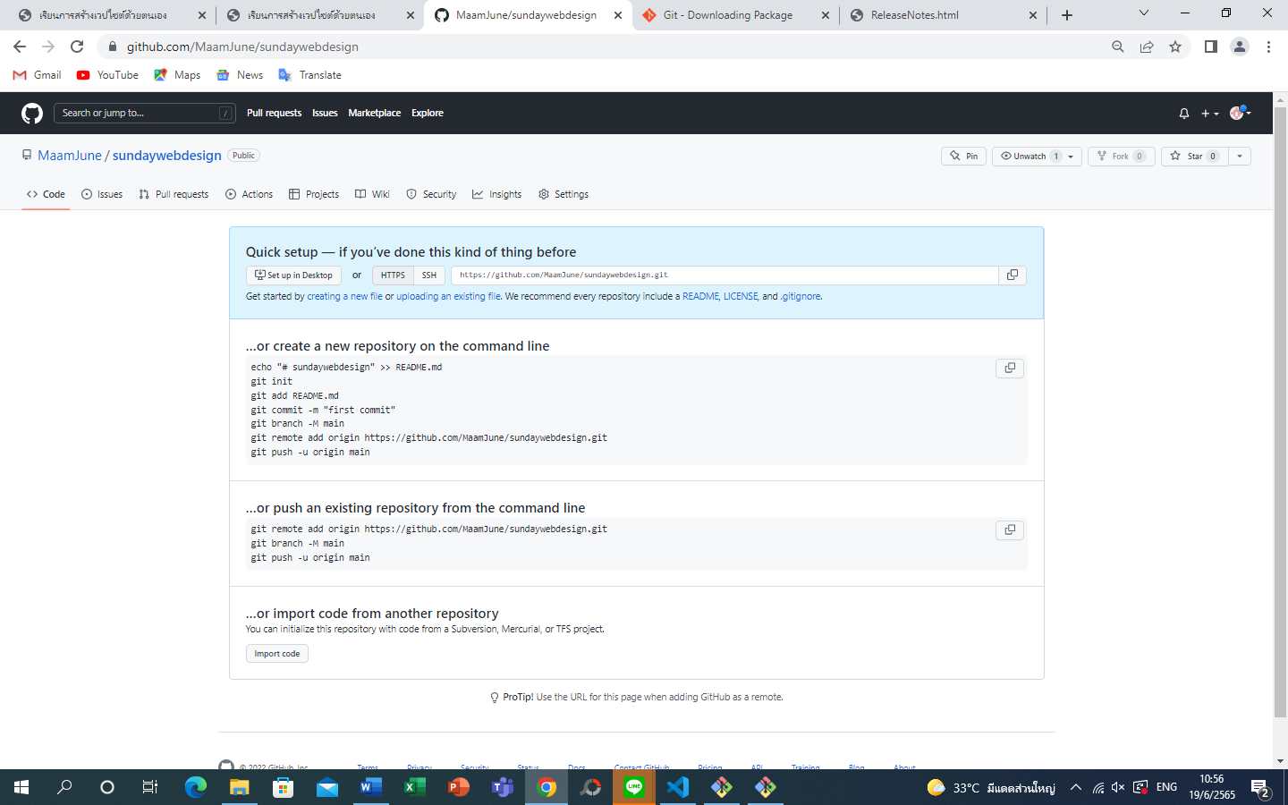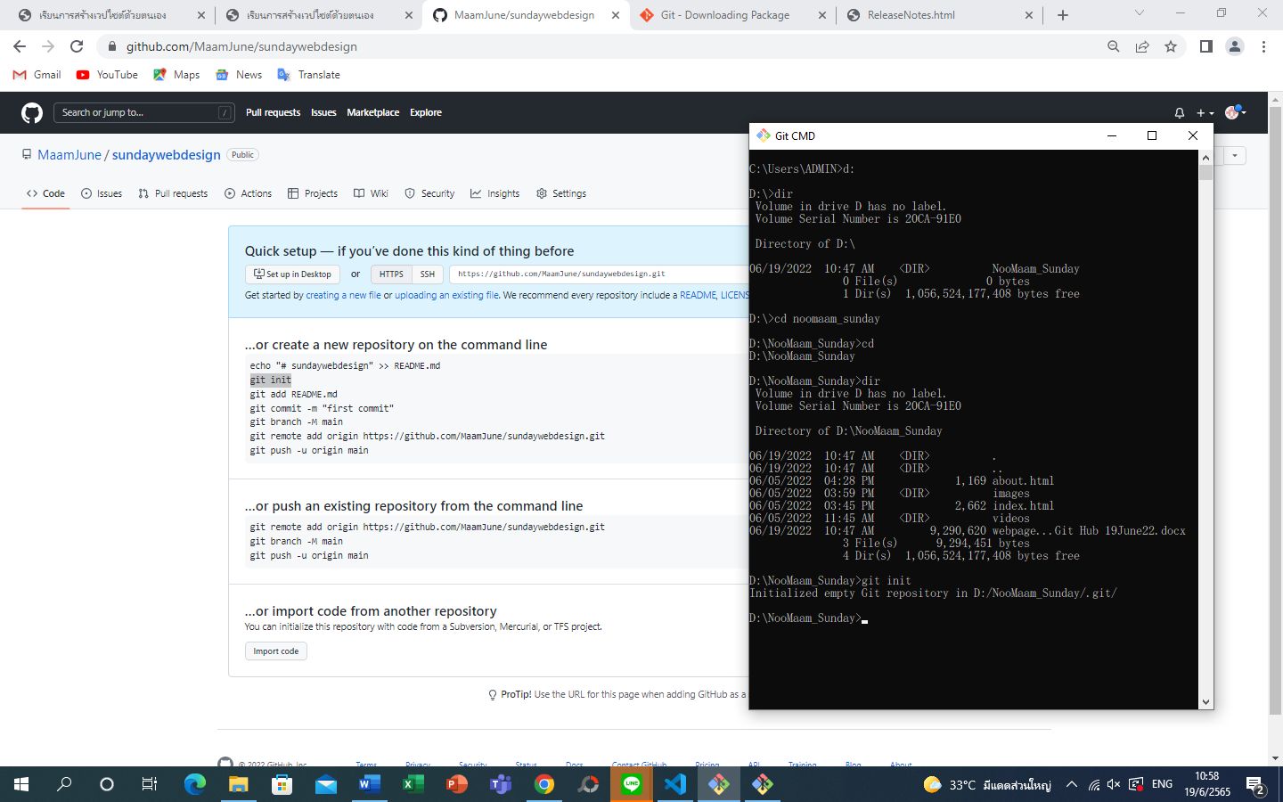type git init in git cmd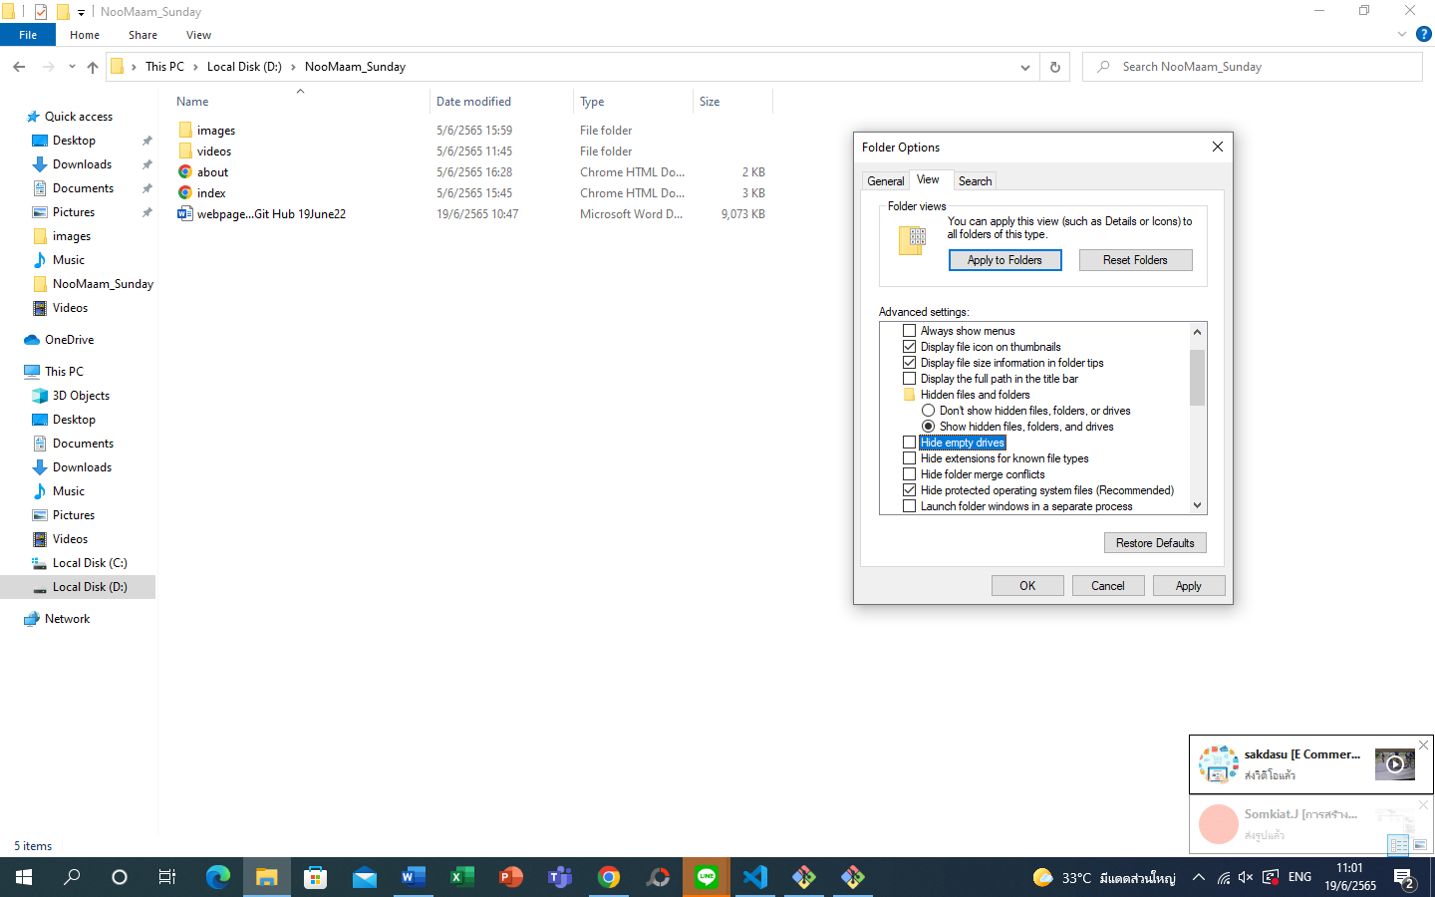folder that’s been hidden will be shown as in this is .git

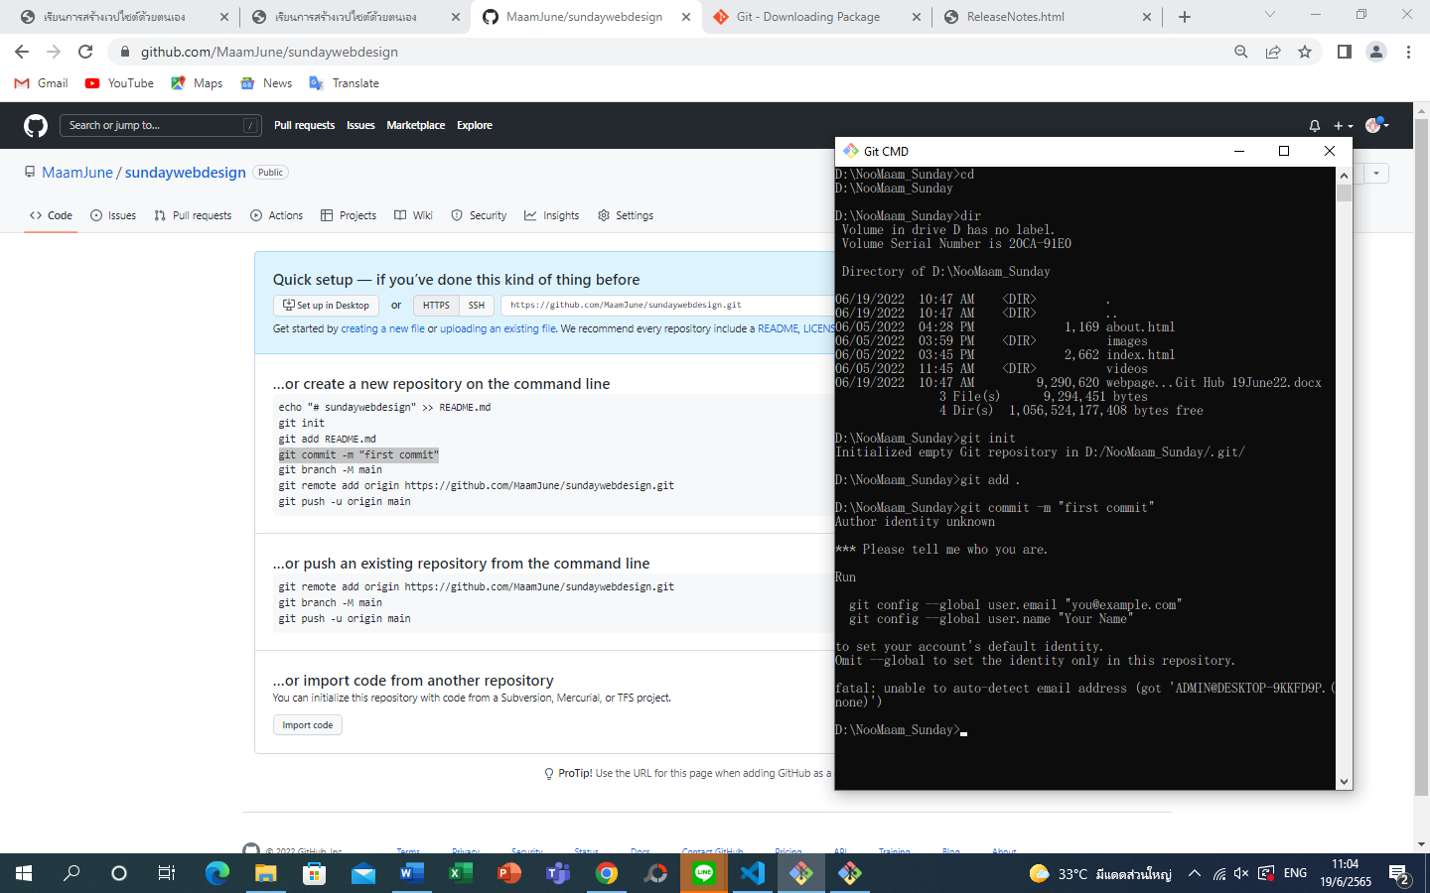add git add .

Add git commit -m “first commit” 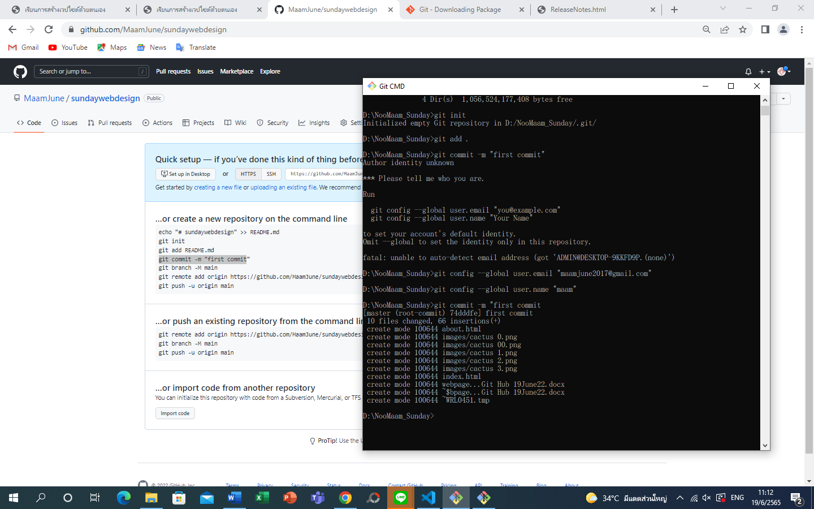Run

git config --global user.email "you@example.com"

git config --global user.name "Your Name"

to set your account's default identity.

Omit --global to set the identity only in this repository.

fatal: unable to auto-detect email address (got 'ADMIN@DESKTOP-9KKFD9P.(none)')

D:\NooMaam_Sunday>git config --global user.email "maamjune2017@gmail.com"

D:\NooMaam_Sunday>git config --global user.name "maam"

If git commit did not activate, go to change confic of the email and user name in “…” and re load git comit again

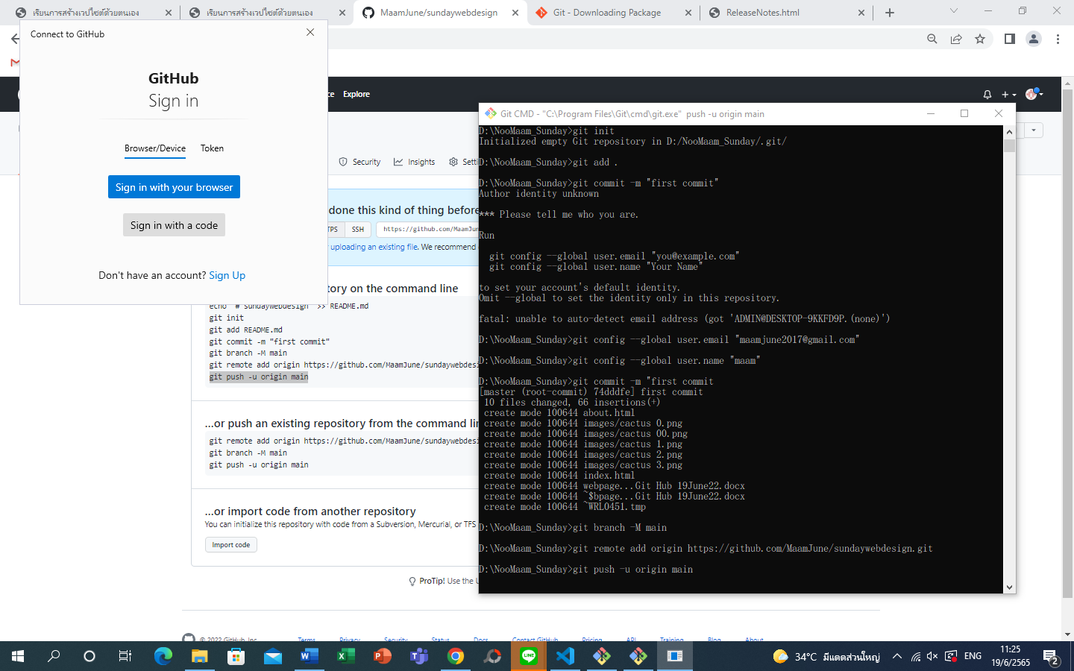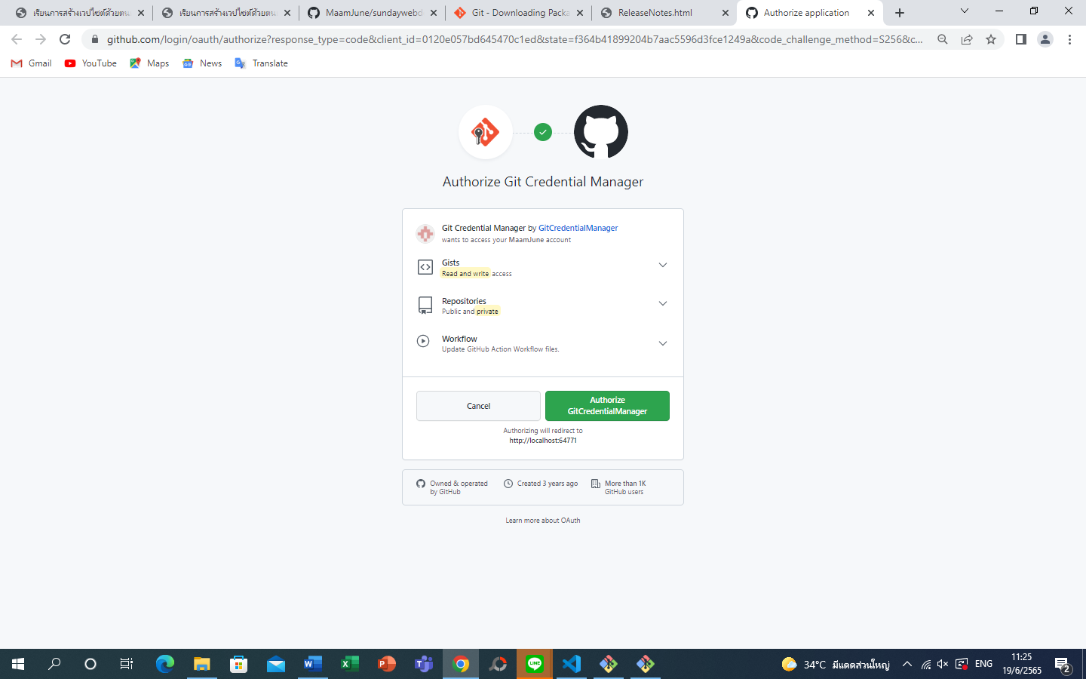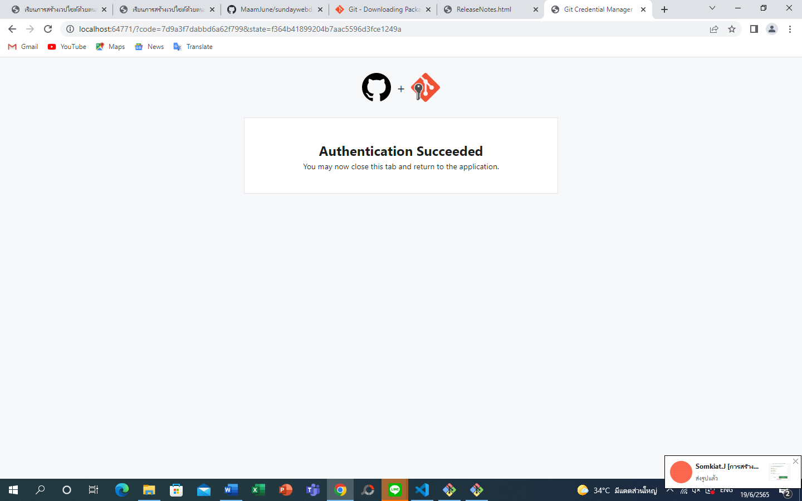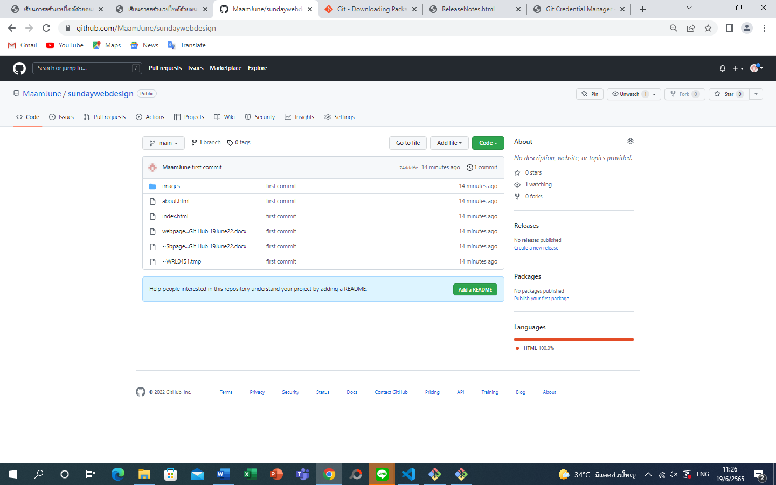

When you go back to github and click on the folder your list will shown up

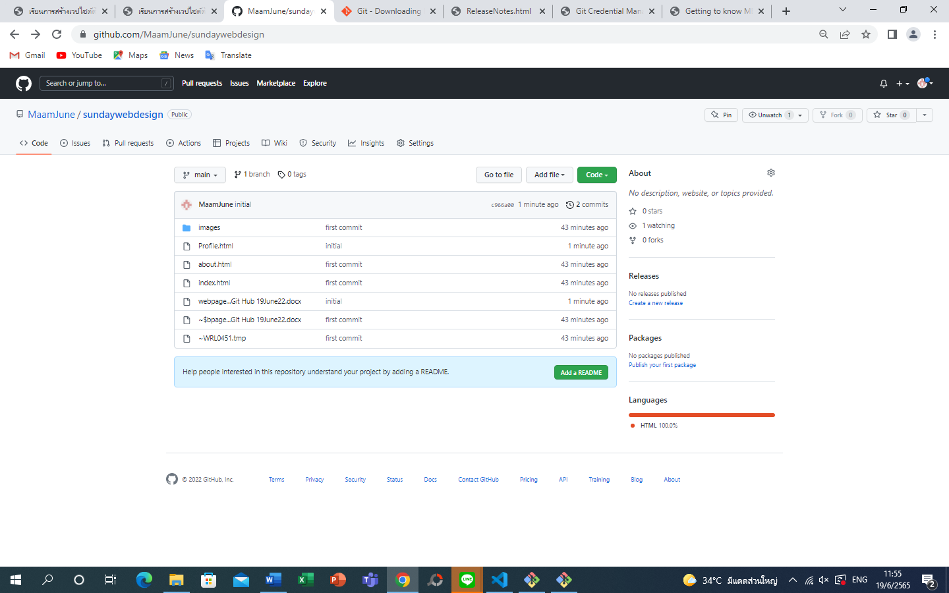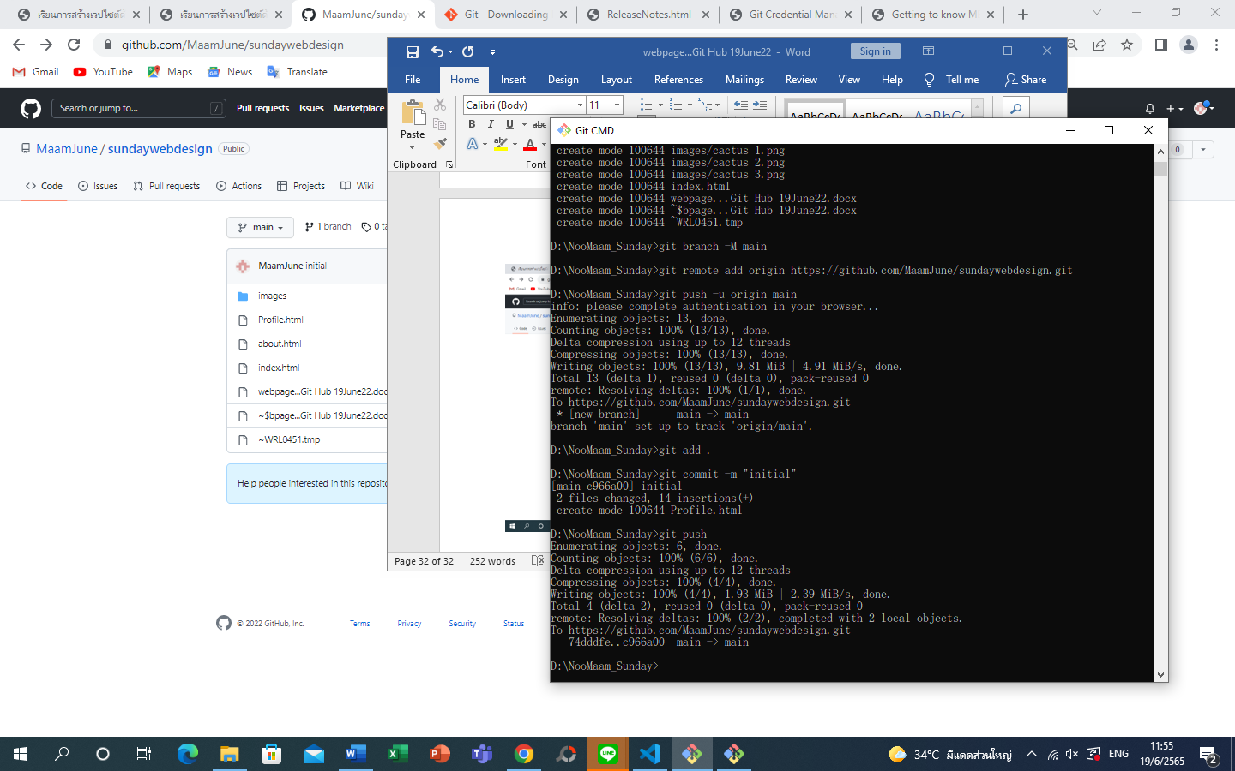

Type > git add .

Type > git commit -m “initial”

Type > git push

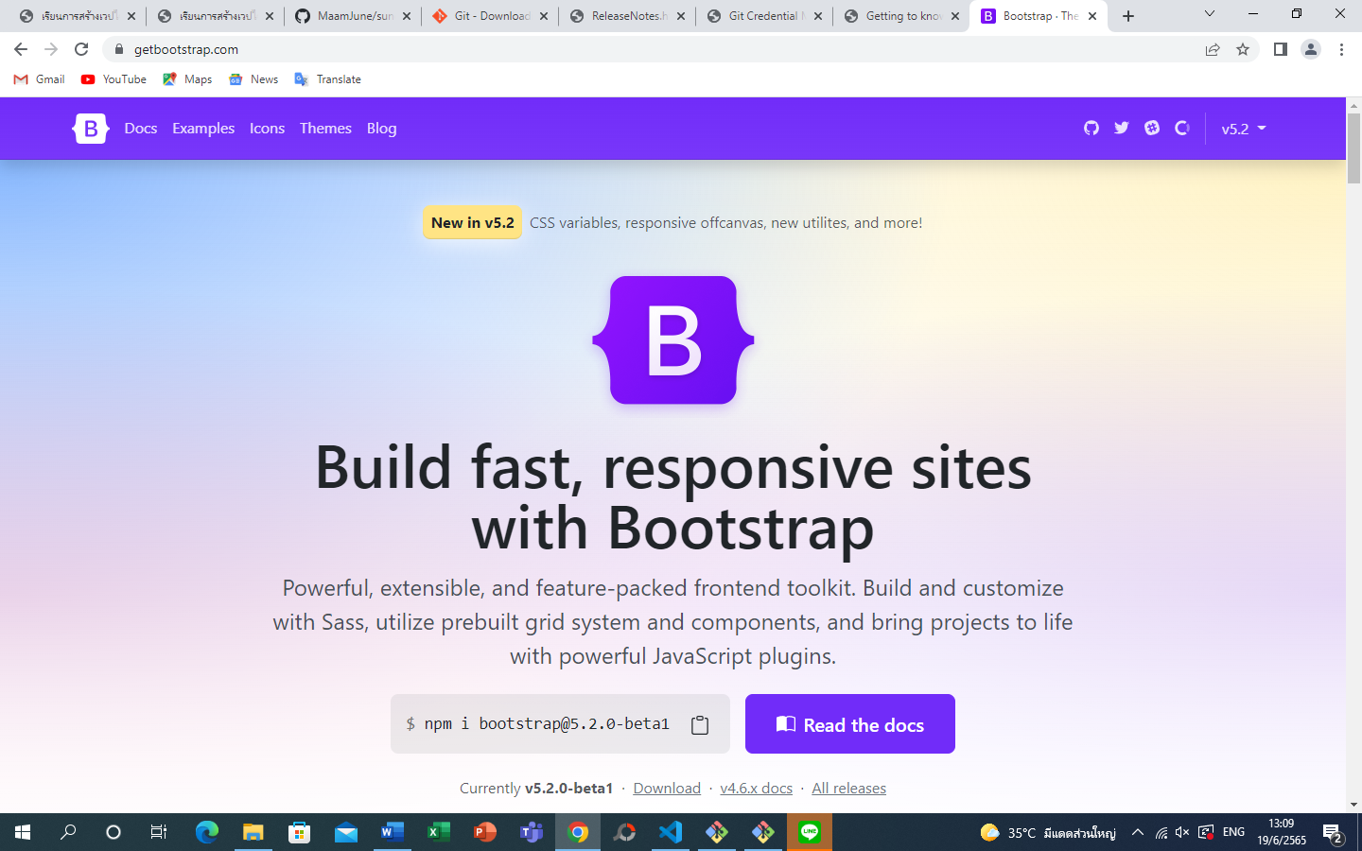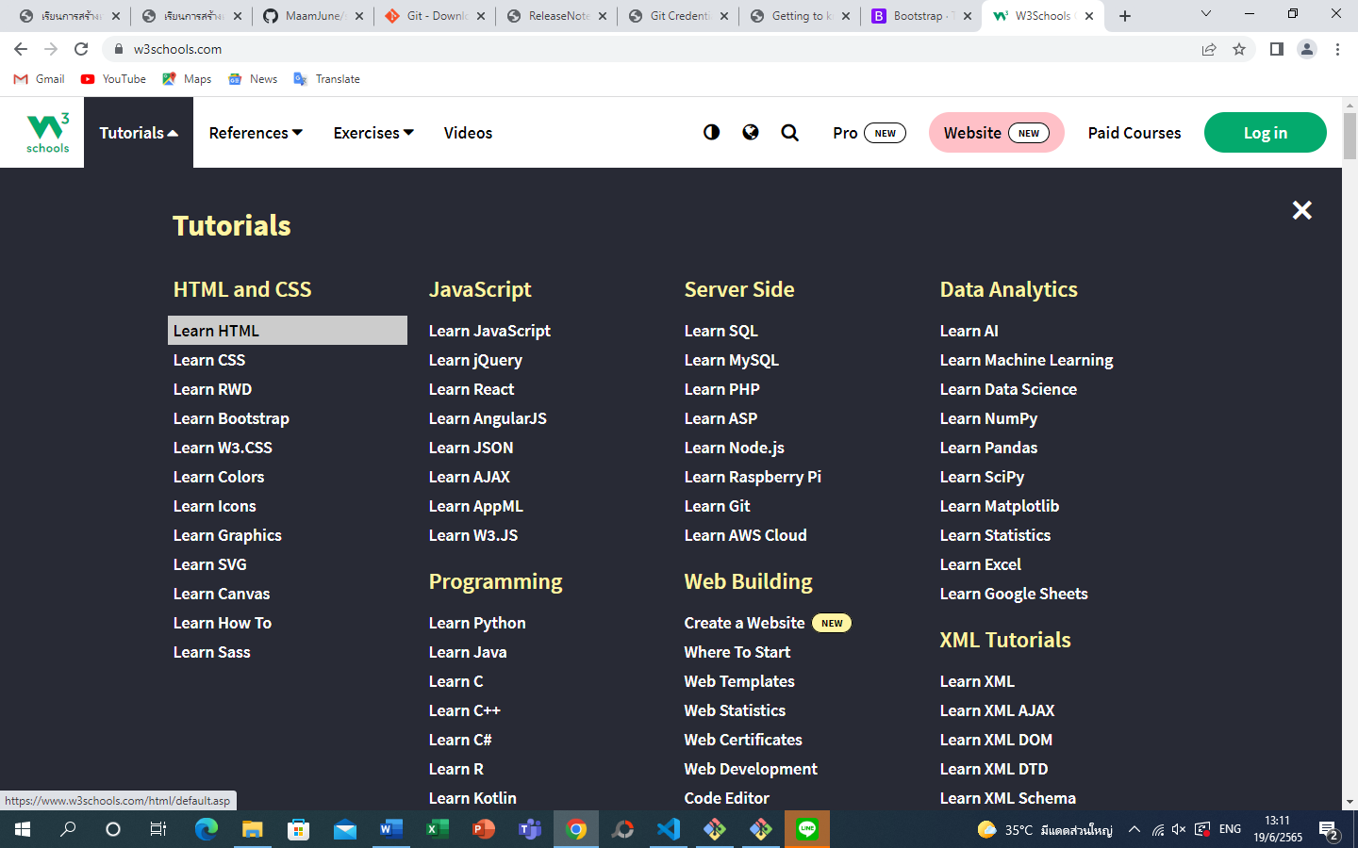https://www.w3schools.com/css/default.asp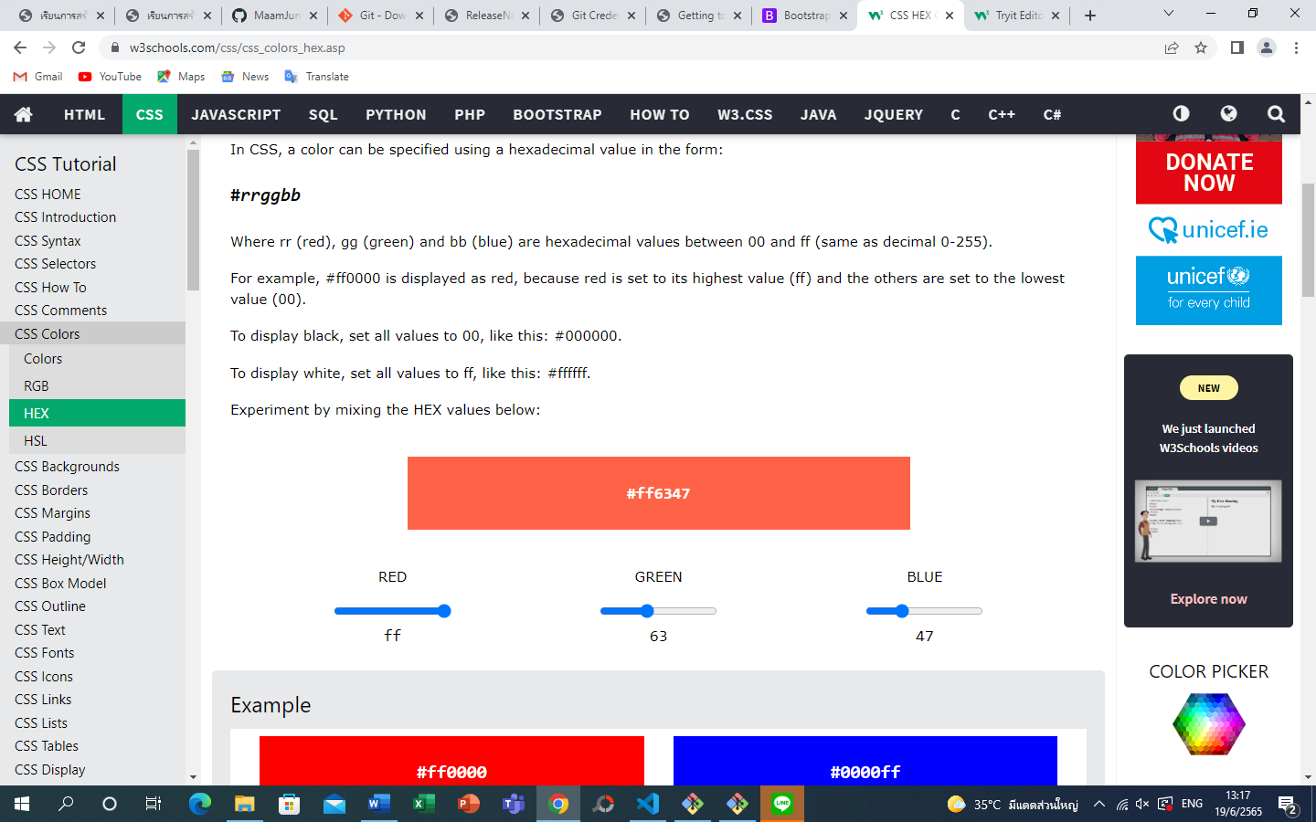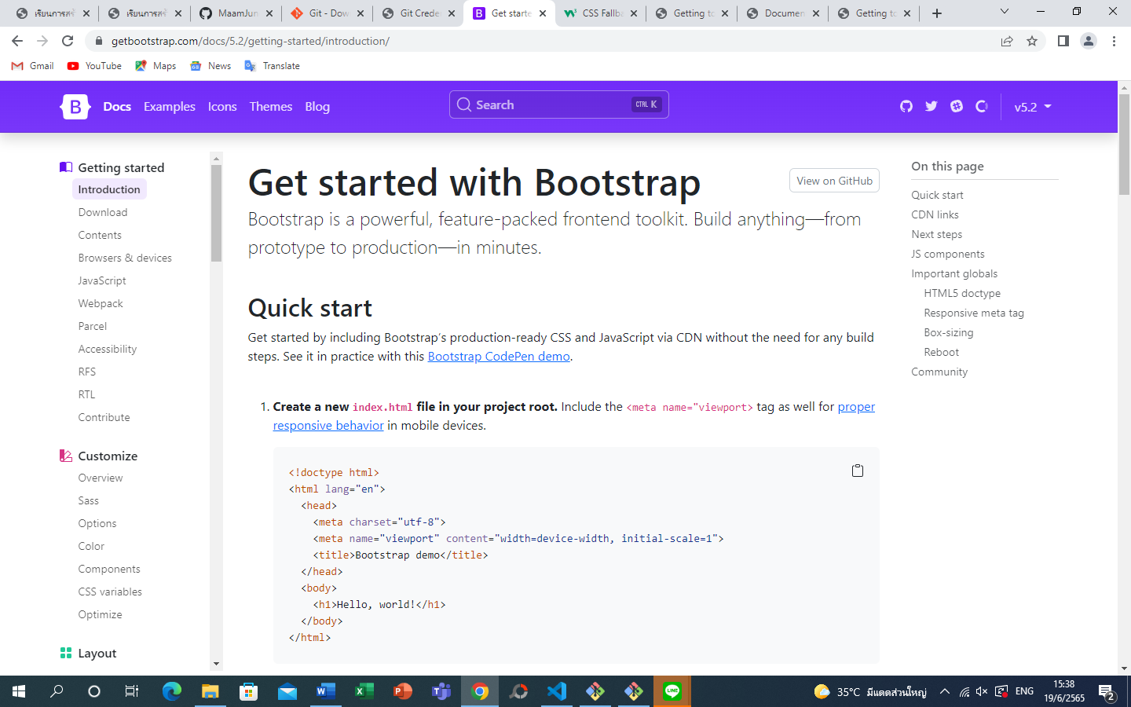

Need to have proper.min.js to activate and upload animation for coding in bootstrap command

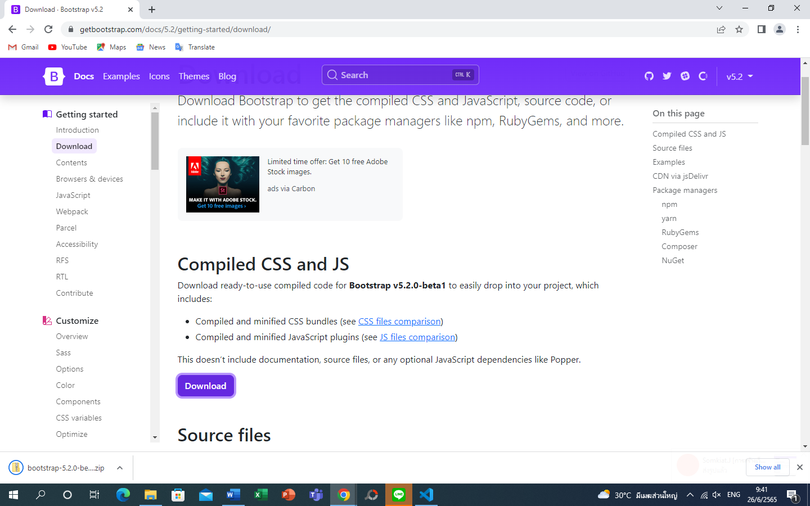

Download bootstrap

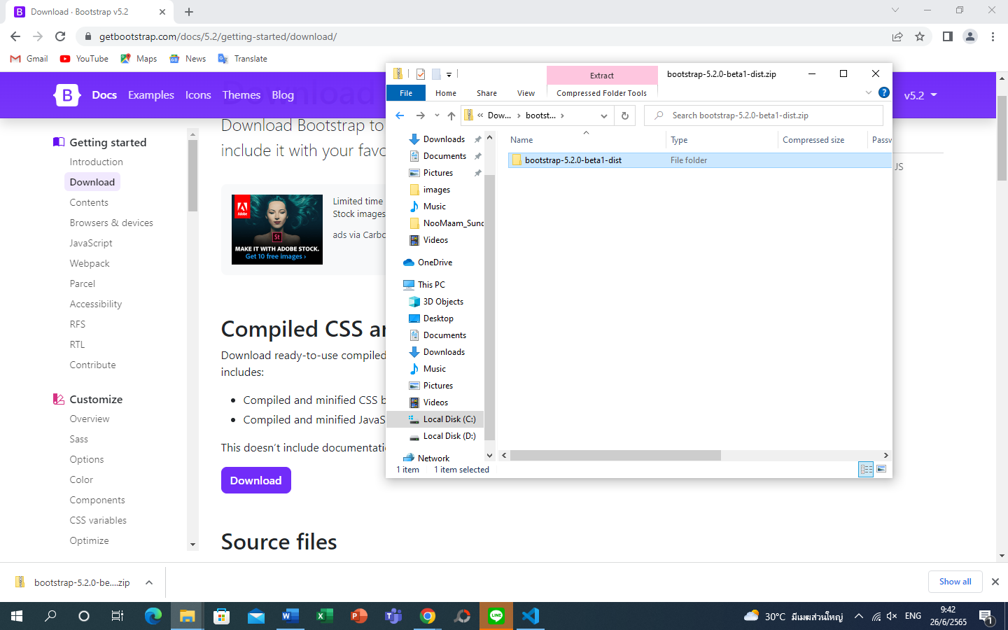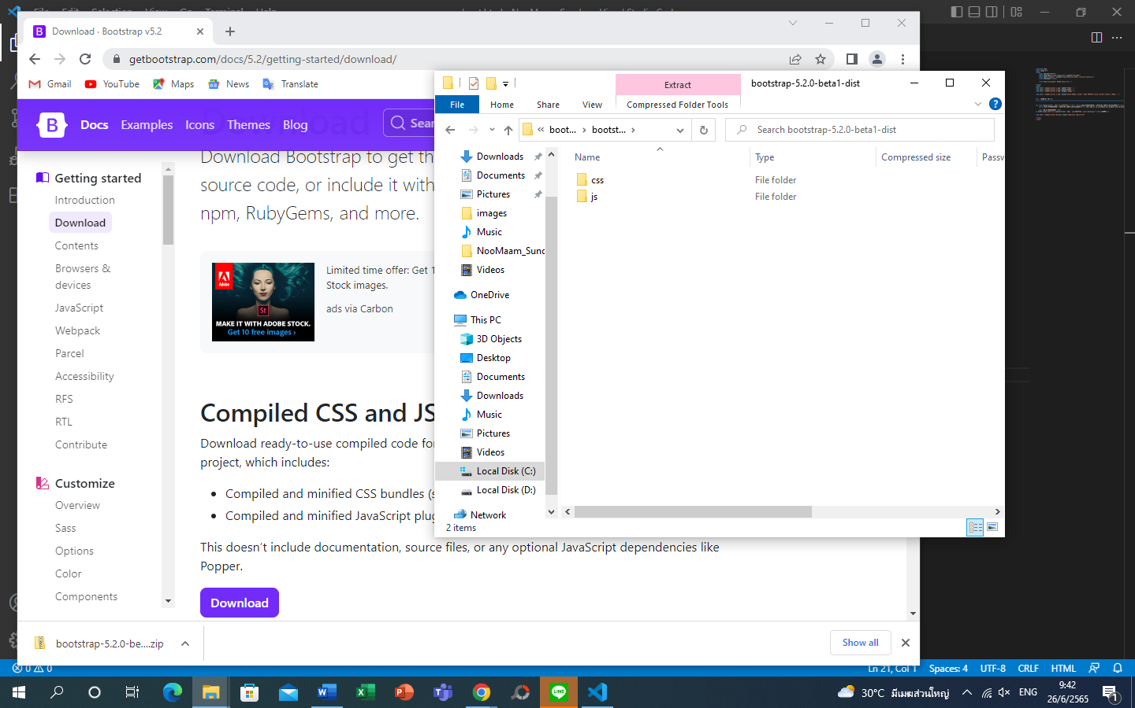

https://cdn.jsdelivr.net/npm/@popperjs/core@2.11.5/dist/umd/popper.min.js

put this path in the tab and call all the code.. copy for use..

……………..

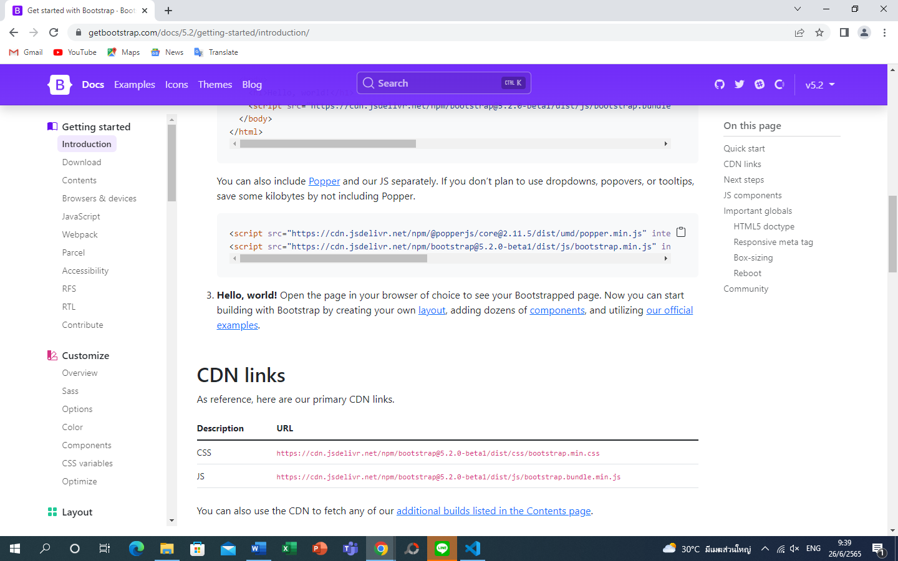

https://cdn.jsdelivr.net/npm/@popperjs/core@2.11.5/dist/umd/popper.min.js

put this path in the tab and call all the code.. copy for use..

……………..

/**

* @popperjs/core v2.11.5 - MIT License

*/

!function(e,t){"object"==typeof exports&&"undefined"!=typeof module?t(exports):"function"==typeof define&&define.amd?define(["exports"],t):t((e="undefined"!=typeof globalThis?globalThis:e||self).Popper={})}(this,(function(e){"use strict";function t(e){if(null==e)return window;if("[object Window]"!==e.toString()){var t=e.ownerDocument;return t&&t.defaultView||window}return e}function n(e){return e instanceof t(e).Element||e instanceof Element}function r(e){return e instanceof t(e).HTMLElement||e instanceof HTMLElement}function o(e){return"undefined"!=typeof ShadowRoot&&(e instanceof t(e).ShadowRoot||e instanceof ShadowRoot)}var i=Math.max,a=Math.min,s=Math.round;function f(e,t){void 0===t&&(t=!1);var n=e.getBoundingClientRect(),o=1,i=1;if(r(e)&&t){var a=e.offsetHeight,f=e.offsetWidth;f>0&&(o=s(n.width)/f||1),a>0&&(i=s(n.height)/a||1)}return{width:n.width/o,height:n.height/i,top:n.top/i,right:n.right/o,bottom:n.bottom/i,left:n.left/o,x:n.left/o,y:n.top/i}}function c(e){var n=t(e);return{scrollLeft:n.pageXOffset,scrollTop:n.pageYOffset}}function p(e){return e?(e.nodeName||"").toLowerCase():null}function u(e){return((n(e)?e.ownerDocument:e.document)||window.document).documentElement}function l(e){return f(u(e)).left+c(e).scrollLeft}function d(e){return t(e).getComputedStyle(e)}function h(e){var t=d(e),n=t.overflow,r=t.overflowX,o=t.overflowY;return/auto|scroll|overlay|hidden/.test(n+o+r)}function m(e,n,o){void 0===o&&(o=!1);var i,a,d=r(n),m=r(n)&&function(e){var t=e.getBoundingClientRect(),n=s(t.width)/e.offsetWidth||1,r=s(t.height)/e.offsetHeight||1;return 1!==n||1!==r}(n),v=u(n),g=f(e,m),y={scrollLeft:0,scrollTop:0},b={x:0,y:0};return(d||!d&&!o)&&(("body"!==p(n)||h(v))&&(y=(i=n)!==t(i)&&r(i)?{scrollLeft:(a=i).scrollLeft,scrollTop:a.scrollTop}:c(i)),r(n)?((b=f(n,!0)).x+=n.clientLeft,b.y+=n.clientTop):v&&(b.x=l(v))),{x:g.left+y.scrollLeft-b.x,y:g.top+y.scrollTop-b.y,width:g.width,height:g.height}}function v(e){var t=f(e),n=e.offsetWidth,r=e.offsetHeight;return Math.abs(t.width-n)<=1&&(n=t.width),Math.abs(t.height-r)<=1&&(r=t.height),{x:e.offsetLeft,y:e.offsetTop,width:n,height:r}}function g(e){return"html"===p(e)?e:e.assignedSlot||e.parentNode||(o(e)?e.host:null)||u(e)}function y(e){return["html","body","#document"].indexOf(p(e))>=0?e.ownerDocument.body:r(e)&&h(e)?e:y(g(e))}function b(e,n){var r;void 0===n&&(n=[]);var o=y(e),i=o===(null==(r=e.ownerDocument)?void 0:r.body),a=t(o),s=i?[a].concat(a.visualViewport||[],h(o)?o:[]):o,f=n.concat(s);return i?f:f.concat(b(g(s)))}function x(e){return["table","td","th"].indexOf(p(e))>=0}function w(e){return r(e)&&"fixed"!==d(e).position?e.offsetParent:null}function O(e){for(var n=t(e),i=w(e);i&&x(i)&&"static"===d(i).position;)i=w(i);return i&&("html"===p(i)||"body"===p(i)&&"static"===d(i).position)?n:i||function(e){var t=-1!==navigator.userAgent.toLowerCase().indexOf("firefox");if(-1!==navigator.userAgent.indexOf("Trident")&&r(e)&&"fixed"===d(e).position)return null;var n=g(e);for(o(n)&&(n=n.host);r(n)&&["html","body"].indexOf(p(n))<0;){var i=d(n);if("none"!==i.transform||"none"!==i.perspective||"paint"===i.contain||-1!==["transform","perspective"].indexOf(i.willChange)||t&&"filter"===i.willChange||t&&i.filter&&"none"!==i.filter)return n;n=n.parentNode}return null}(e)||n}var j="top",E="bottom",D="right",A="left",L="auto",P=[j,E,D,A],M="start",k="end",W="viewport",B="popper",H=P.reduce((function(e,t){return e.concat([t+"-"+M,t+"-"+k])}),[]),T=[].concat(P,[L]).reduce((function(e,t){return e.concat([t,t+"-"+M,t+"-"+k])}),[]),R=["beforeRead","read","afterRead","beforeMain","main","afterMain","beforeWrite","write","afterWrite"];function S(e){var t=new Map,n=new Set,r=[];function o(e){n.add(e.name),[].concat(e.requires||[],e.requiresIfExists||[]).forEach((function(e){if(!n.has(e)){var r=t.get(e);r&&o(r)}})),r.push(e)}return e.forEach((function(e){t.set(e.name,e)})),e.forEach((function(e){n.has(e.name)||o(e)})),r}function C(e){return e.split("-")[0]}function q(e,t){var n=t.getRootNode&&t.getRootNode();if(e.contains(t))return!0;if(n&&o(n)){var r=t;do{if(r&&e.isSameNode(r))return!0;r=r.parentNode||r.host}while(r)}return!1}function V(e){return Object.assign({},e,{left:e.x,top:e.y,right:e.x+e.width,bottom:e.y+e.height})}function N(e,r){return r===W?V(function(e){var n=t(e),r=u(e),o=n.visualViewport,i=r.clientWidth,a=r.clientHeight,s=0,f=0;return o&&(i=o.width,a=o.height,/^((?!chrome|android).)*safari/i.test(navigator.userAgent)||(s=o.offsetLeft,f=o.offsetTop)),{width:i,height:a,x:s+l(e),y:f}}(e)):n(r)?function(e){var t=f(e);return t.top=t.top+e.clientTop,t.left=t.left+e.clientLeft,t.bottom=t.top+e.clientHeight,t.right=t.left+e.clientWidth,t.width=e.clientWidth,t.height=e.clientHeight,t.x=t.left,t.y=t.top,t}(r):V(function(e){var t,n=u(e),r=c(e),o=null==(t=e.ownerDocument)?void 0:t.body,a=i(n.scrollWidth,n.clientWidth,o?o.scrollWidth:0,o?o.clientWidth:0),s=i(n.scrollHeight,n.clientHeight,o?o.scrollHeight:0,o?o.clientHeight:0),f=-r.scrollLeft+l(e),p=-r.scrollTop;return"rtl"===d(o||n).direction&&(f+=i(n.clientWidth,o?o.clientWidth:0)-a),{width:a,height:s,x:f,y:p}}(u(e)))}function I(e,t,o){var s="clippingParents"===t?function(e){var t=b(g(e)),o=["absolute","fixed"].indexOf(d(e).position)>=0&&r(e)?O(e):e;return n(o)?t.filter((function(e){return n(e)&&q(e,o)&&"body"!==p(e)})):[]}(e):[].concat(t),f=[].concat(s,[o]),c=f[0],u=f.reduce((function(t,n){var r=N(e,n);return t.top=i(r.top,t.top),t.right=a(r.right,t.right),t.bottom=a(r.bottom,t.bottom),t.left=i(r.left,t.left),t}),N(e,c));return u.width=u.right-u.left,u.height=u.bottom-u.top,u.x=u.left,u.y=u.top,u}function _(e){return e.split("-")[1]}function F(e){return["top","bottom"].indexOf(e)>=0?"x":"y"}function U(e){var t,n=e.reference,r=e.element,o=e.placement,i=o?C(o):null,a=o?_(o):null,s=n.x+n.width/2-r.width/2,f=n.y+n.height/2-r.height/2;switch(i){case j:t={x:s,y:n.y-r.height};break;case E:t={x:s,y:n.y+n.height};break;case D:t={x:n.x+n.width,y:f};break;case A:t={x:n.x-r.width,y:f};break;default:t={x:n.x,y:n.y}}var c=i?F(i):null;if(null!=c){var p="y"===c?"height":"width";switch(a){case M:t[c]=t[c]-(n[p]/2-r[p]/2);break;case k:t[c]=t[c]+(n[p]/2-r[p]/2)}}return t}function z(e){return Object.assign({},{top:0,right:0,bottom:0,left:0},e)}function X(e,t){return t.reduce((function(t,n){return t[n]=e,t}),{})}function Y(e,t){void 0===t&&(t={});var r=t,o=r.placement,i=void 0===o?e.placement:o,a=r.boundary,s=void 0===a?"clippingParents":a,c=r.rootBoundary,p=void 0===c?W:c,l=r.elementContext,d=void 0===l?B:l,h=r.altBoundary,m=void 0!==h&&h,v=r.padding,g=void 0===v?0:v,y=z("number"!=typeof g?g:X(g,P)),b=d===B?"reference":B,x=e.rects.popper,w=e.elements[m?b:d],O=I(n(w)?w:w.contextElement||u(e.elements.popper),s,p),A=f(e.elements.reference),L=U({reference:A,element:x,strategy:"absolute",placement:i}),M=V(Object.assign({},x,L)),k=d===B?M:A,H={top:O.top-k.top+y.top,bottom:k.bottom-O.bottom+y.bottom,left:O.left-k.left+y.left,right:k.right-O.right+y.right},T=e.modifiersData.offset;if(d===B&&T){var R=T[i];Object.keys(H).forEach((function(e){var t=[D,E].indexOf(e)>=0?1:-1,n=[j,E].indexOf(e)>=0?"y":"x";H[e]+=R[n]*t}))}return H}var G={placement:"bottom",modifiers:[],strategy:"absolute"};function J(){for(var e=arguments.length,t=new Array(e),n=0;n<e;n++)t[n]=arguments[n];return!t.some((function(e){return!(e&&"function"==typeof e.getBoundingClientRect)}))}function K(e){void 0===e&&(e={});var t=e,r=t.defaultModifiers,o=void 0===r?[]:r,i=t.defaultOptions,a=void 0===i?G:i;return function(e,t,r){void 0===r&&(r=a);var i,s,f={placement:"bottom",orderedModifiers:[],options:Object.assign({},G,a),modifiersData:{},elements:{reference:e,popper:t},attributes:{},styles:{}},c=[],p=!1,u={state:f,setOptions:function(r){var i="function"==typeof r?r(f.options):r;l(),f.options=Object.assign({},a,f.options,i),f.scrollParents={reference:n(e)?b(e):e.contextElement?b(e.contextElement):[],popper:b(t)};var s,p,d=function(e){var t=S(e);return R.reduce((function(e,n){return e.concat(t.filter((function(e){return e.phase===n})))}),[])}((s=[].concat(o,f.options.modifiers),p=s.reduce((function(e,t){var n=e[t.name];return e[t.name]=n?Object.assign({},n,t,{options:Object.assign({},n.options,t.options),data:Object.assign({},n.data,t.data)}):t,e}),{}),Object.keys(p).map((function(e){return p[e]}))));return f.orderedModifiers=d.filter((function(e){return e.enabled})),f.orderedModifiers.forEach((function(e){var t=e.name,n=e.options,r=void 0===n?{}:n,o=e.effect;if("function"==typeof o){var i=o({state:f,name:t,instance:u,options:r}),a=function(){};c.push(i||a)}})),u.update()},forceUpdate:function(){if(!p){var e=f.elements,t=e.reference,n=e.popper;if(J(t,n)){f.rects={reference:m(t,O(n),"fixed"===f.options.strategy),popper:v(n)},f.reset=!1,f.placement=f.options.placement,f.orderedModifiers.forEach((function(e){return f.modifiersData[e.name]=Object.assign({},e.data)}));for(var r=0;r<f.orderedModifiers.length;r++)if(!0!==f.reset){var o=f.orderedModifiers[r],i=o.fn,a=o.options,s=void 0===a?{}:a,c=o.name;"function"==typeof i&&(f=i({state:f,options:s,name:c,instance:u})||f)}else f.reset=!1,r=-1}}},update:(i=function(){return new Promise((function(e){u.forceUpdate(),e(f)}))},function(){return s||(s=new Promise((function(e){Promise.resolve().then((function(){s=void 0,e(i())}))}))),s}),destroy:function(){l(),p=!0}};if(!J(e,t))return u;function l(){c.forEach((function(e){return e()})),c=[]}return u.setOptions(r).then((function(e){!p&&r.onFirstUpdate&&r.onFirstUpdate(e)})),u}}var Q={passive:!0};var Z={name:"eventListeners",enabled:!0,phase:"write",fn:function(){},effect:function(e){var n=e.state,r=e.instance,o=e.options,i=o.scroll,a=void 0===i||i,s=o.resize,f=void 0===s||s,c=t(n.elements.popper),p=[].concat(n.scrollParents.reference,n.scrollParents.popper);return a&&p.forEach((function(e){e.addEventListener("scroll",r.update,Q)})),f&&c.addEventListener("resize",r.update,Q),function(){a&&p.forEach((function(e){e.removeEventListener("scroll",r.update,Q)})),f&&c.removeEventListener("resize",r.update,Q)}},data:{}};var $={name:"popperOffsets",enabled:!0,phase:"read",fn:function(e){var t=e.state,n=e.name;t.modifiersData[n]=U({reference:t.rects.reference,element:t.rects.popper,strategy:"absolute",placement:t.placement})},data:{}},ee={top:"auto",right:"auto",bottom:"auto",left:"auto"};function te(e){var n,r=e.popper,o=e.popperRect,i=e.placement,a=e.variation,f=e.offsets,c=e.position,p=e.gpuAcceleration,l=e.adaptive,h=e.roundOffsets,m=e.isFixed,v=f.x,g=void 0===v?0:v,y=f.y,b=void 0===y?0:y,x="function"==typeof h?h({x:g,y:b}):{x:g,y:b};g=x.x,b=x.y;var w=f.hasOwnProperty("x"),L=f.hasOwnProperty("y"),P=A,M=j,W=window;if(l){var B=O(r),H="clientHeight",T="clientWidth";if(B===t(r)&&"static"!==d(B=u(r)).position&&"absolute"===c&&(H="scrollHeight",T="scrollWidth"),B=B,i===j||(i===A||i===D)&&a===k)M=E,b-=(m&&B===W&&W.visualViewport?W.visualViewport.height:B[H])-o.height,b*=p?1:-1;if(i===A||(i===j||i===E)&&a===k)P=D,g-=(m&&B===W&&W.visualViewport?W.visualViewport.width:B[T])-o.width,g*=p?1:-1}var R,S=Object.assign({position:c},l&&ee),C=!0===h?function(e){var t=e.x,n=e.y,r=window.devicePixelRatio||1;return{x:s(t*r)/r||0,y:s(n*r)/r||0}}({x:g,y:b}):{x:g,y:b};return g=C.x,b=C.y,p?Object.assign({},S,((R={})[M]=L?"0":"",R[P]=w?"0":"",R.transform=(W.devicePixelRatio||1)<=1?"translate("+g+"px, "+b+"px)":"translate3d("+g+"px, "+b+"px, 0)",R)):Object.assign({},S,((n={})[M]=L?b+"px":"",n[P]=w?g+"px":"",n.transform="",n))}var ne={name:"computeStyles",enabled:!0,phase:"beforeWrite",fn:function(e){var t=e.state,n=e.options,r=n.gpuAcceleration,o=void 0===r||r,i=n.adaptive,a=void 0===i||i,s=n.roundOffsets,f=void 0===s||s,c={placement:C(t.placement),variation:_(t.placement),popper:t.elements.popper,popperRect:t.rects.popper,gpuAcceleration:o,isFixed:"fixed"===t.options.strategy};null!=t.modifiersData.popperOffsets&&(t.styles.popper=Object.assign({},t.styles.popper,te(Object.assign({},c,{offsets:t.modifiersData.popperOffsets,position:t.options.strategy,adaptive:a,roundOffsets:f})))),null!=t.modifiersData.arrow&&(t.styles.arrow=Object.assign({},t.styles.arrow,te(Object.assign({},c,{offsets:t.modifiersData.arrow,position:"absolute",adaptive:!1,roundOffsets:f})))),t.attributes.popper=Object.assign({},t.attributes.popper,{"data-popper-placement":t.placement})},data:{}};var re={name:"applyStyles",enabled:!0,phase:"write",fn:function(e){var t=e.state;Object.keys(t.elements).forEach((function(e){var n=t.styles[e]||{},o=t.attributes[e]||{},i=t.elements[e];r(i)&&p(i)&&(Object.assign(i.style,n),Object.keys(o).forEach((function(e){var t=o[e];!1===t?i.removeAttribute(e):i.setAttribute(e,!0===t?"":t)})))}))},effect:function(e){var t=e.state,n={popper:{position:t.options.strategy,left:"0",top:"0",margin:"0"},arrow:{position:"absolute"},reference:{}};return Object.assign(t.elements.popper.style,n.popper),t.styles=n,t.elements.arrow&&Object.assign(t.elements.arrow.style,n.arrow),function(){Object.keys(t.elements).forEach((function(e){var o=t.elements[e],i=t.attributes[e]||{},a=Object.keys(t.styles.hasOwnProperty(e)?t.styles[e]:n[e]).reduce((function(e,t){return e[t]="",e}),{});r(o)&&p(o)&&(Object.assign(o.style,a),Object.keys(i).forEach((function(e){o.removeAttribute(e)})))}))}},requires:["computeStyles"]};var oe={name:"offset",enabled:!0,phase:"main",requires:["popperOffsets"],fn:function(e){var t=e.state,n=e.options,r=e.name,o=n.offset,i=void 0===o?[0,0]:o,a=T.reduce((function(e,n){return e[n]=function(e,t,n){var r=C(e),o=[A,j].indexOf(r)>=0?-1:1,i="function"==typeof n?n(Object.assign({},t,{placement:e})):n,a=i[0],s=i[1];return a=a||0,s=(s||0)*o,[A,D].indexOf(r)>=0?{x:s,y:a}:{x:a,y:s}}(n,t.rects,i),e}),{}),s=a[t.placement],f=s.x,c=s.y;null!=t.modifiersData.popperOffsets&&(t.modifiersData.popperOffsets.x+=f,t.modifiersData.popperOffsets.y+=c),t.modifiersData[r]=a}},ie={left:"right",right:"left",bottom:"top",top:"bottom"};function ae(e){return e.replace(/left|right|bottom|top/g,(function(e){return ie[e]}))}var se={start:"end",end:"start"};function fe(e){return e.replace(/start|end/g,(function(e){return se[e]}))}function ce(e,t){void 0===t&&(t={});var n=t,r=n.placement,o=n.boundary,i=n.rootBoundary,a=n.padding,s=n.flipVariations,f=n.allowedAutoPlacements,c=void 0===f?T:f,p=_(r),u=p?s?H:H.filter((function(e){return _(e)===p})):P,l=u.filter((function(e){return c.indexOf(e)>=0}));0===l.length&&(l=u);var d=l.reduce((function(t,n){return t[n]=Y(e,{placement:n,boundary:o,rootBoundary:i,padding:a})[C(n)],t}),{});return Object.keys(d).sort((function(e,t){return d[e]-d[t]}))}var pe={name:"flip",enabled:!0,phase:"main",fn:function(e){var t=e.state,n=e.options,r=e.name;if(!t.modifiersData[r]._skip){for(var o=n.mainAxis,i=void 0===o||o,a=n.altAxis,s=void 0===a||a,f=n.fallbackPlacements,c=n.padding,p=n.boundary,u=n.rootBoundary,l=n.altBoundary,d=n.flipVariations,h=void 0===d||d,m=n.allowedAutoPlacements,v=t.options.placement,g=C(v),y=f||(g===v||!h?[ae(v)]:function(e){if(C(e)===L)return[];var t=ae(e);return[fe(e),t,fe(t)]}(v)),b=[v].concat(y).reduce((function(e,n){return e.concat(C(n)===L?ce(t,{placement:n,boundary:p,rootBoundary:u,padding:c,flipVariations:h,allowedAutoPlacements:m}):n)}),[]),x=t.rects.reference,w=t.rects.popper,O=new Map,P=!0,k=b[0],W=0;W<b.length;W++){var B=b[W],H=C(B),T=_(B)===M,R=[j,E].indexOf(H)>=0,S=R?"width":"height",q=Y(t,{placement:B,boundary:p,rootBoundary:u,altBoundary:l,padding:c}),V=R?T?D:A:T?E:j;x[S]>w[S]&&(V=ae(V));var N=ae(V),I=[];if(i&&I.push(q[H]<=0),s&&I.push(q[V]<=0,q[N]<=0),I.every((function(e){return e}))){k=B,P=!1;break}O.set(B,I)}if(P)for(var F=function(e){var t=b.find((function(t){var n=O.get(t);if(n)return n.slice(0,e).every((function(e){return e}))}));if(t)return k=t,"break"},U=h?3:1;U>0;U--){if("break"===F(U))break}t.placement!==k&&(t.modifiersData[r]._skip=!0,t.placement=k,t.reset=!0)}},requiresIfExists:["offset"],data:{_skip:!1}};function ue(e,t,n){return i(e,a(t,n))}var le={name:"preventOverflow",enabled:!0,phase:"main",fn:function(e){var t=e.state,n=e.options,r=e.name,o=n.mainAxis,s=void 0===o||o,f=n.altAxis,c=void 0!==f&&f,p=n.boundary,u=n.rootBoundary,l=n.altBoundary,d=n.padding,h=n.tether,m=void 0===h||h,g=n.tetherOffset,y=void 0===g?0:g,b=Y(t,{boundary:p,rootBoundary:u,padding:d,altBoundary:l}),x=C(t.placement),w=_(t.placement),L=!w,P=F(x),k="x"===P?"y":"x",W=t.modifiersData.popperOffsets,B=t.rects.reference,H=t.rects.popper,T="function"==typeof y?y(Object.assign({},t.rects,{placement:t.placement})):y,R="number"==typeof T?{mainAxis:T,altAxis:T}:Object.assign({mainAxis:0,altAxis:0},T),S=t.modifiersData.offset?t.modifiersData.offset[t.placement]:null,q={x:0,y:0};if(W){if(s){var V,N="y"===P?j:A,I="y"===P?E:D,U="y"===P?"height":"width",z=W[P],X=z+b[N],G=z-b[I],J=m?-H[U]/2:0,K=w===M?B[U]:H[U],Q=w===M?-H[U]:-B[U],Z=t.elements.arrow,$=m&&Z?v(Z):{width:0,height:0},ee=t.modifiersData["arrow#persistent"]?t.modifiersData["arrow#persistent"].padding:{top:0,right:0,bottom:0,left:0},te=ee[N],ne=ee[I],re=ue(0,B[U],$[U]),oe=L?B[U]/2-J-re-te-R.mainAxis:K-re-te-R.mainAxis,ie=L?-B[U]/2+J+re+ne+R.mainAxis:Q+re+ne+R.mainAxis,ae=t.elements.arrow&&O(t.elements.arrow),se=ae?"y"===P?ae.clientTop||0:ae.clientLeft||0:0,fe=null!=(V=null==S?void 0:S[P])?V:0,ce=z+ie-fe,pe=ue(m?a(X,z+oe-fe-se):X,z,m?i(G,ce):G);W[P]=pe,q[P]=pe-z}if(c){var le,de="x"===P?j:A,he="x"===P?E:D,me=W[k],ve="y"===k?"height":"width",ge=me+b[de],ye=me-b[he],be=-1!==[j,A].indexOf(x),xe=null!=(le=null==S?void 0:S[k])?le:0,we=be?ge:me-B[ve]-H[ve]-xe+R.altAxis,Oe=be?me+B[ve]+H[ve]-xe-R.altAxis:ye,je=m&&be?function(e,t,n){var r=ue(e,t,n);return r>n?n:r}(we,me,Oe):ue(m?we:ge,me,m?Oe:ye);W[k]=je,q[k]=je-me}t.modifiersData[r]=q}},requiresIfExists:["offset"]};var de={name:"arrow",enabled:!0,phase:"main",fn:function(e){var t,n=e.state,r=e.name,o=e.options,i=n.elements.arrow,a=n.modifiersData.popperOffsets,s=C(n.placement),f=F(s),c=[A,D].indexOf(s)>=0?"height":"width";if(i&&a){var p=function(e,t){return z("number"!=typeof(e="function"==typeof e?e(Object.assign({},t.rects,{placement:t.placement})):e)?e:X(e,P))}(o.padding,n),u=v(i),l="y"===f?j:A,d="y"===f?E:D,h=n.rects.reference[c]+n.rects.reference[f]-a[f]-n.rects.popper[c],m=a[f]-n.rects.reference[f],g=O(i),y=g?"y"===f?g.clientHeight||0:g.clientWidth||0:0,b=h/2-m/2,x=p[l],w=y-u[c]-p[d],L=y/2-u[c]/2+b,M=ue(x,L,w),k=f;n.modifiersData[r]=((t={})[k]=M,t.centerOffset=M-L,t)}},effect:function(e){var t=e.state,n=e.options.element,r=void 0===n?"[data-popper-arrow]":n;null!=r&&("string"!=typeof r||(r=t.elements.popper.querySelector(r)))&&q(t.elements.popper,r)&&(t.elements.arrow=r)},requires:["popperOffsets"],requiresIfExists:["preventOverflow"]};function he(e,t,n){return void 0===n&&(n={x:0,y:0}),{top:e.top-t.height-n.y,right:e.right-t.width+n.x,bottom:e.bottom-t.height+n.y,left:e.left-t.width-n.x}}function me(e){return[j,D,E,A].some((function(t){return e[t]>=0}))}var ve={name:"hide",enabled:!0,phase:"main",requiresIfExists:["preventOverflow"],fn:function(e){var t=e.state,n=e.name,r=t.rects.reference,o=t.rects.popper,i=t.modifiersData.preventOverflow,a=Y(t,{elementContext:"reference"}),s=Y(t,{altBoundary:!0}),f=he(a,r),c=he(s,o,i),p=me(f),u=me(c);t.modifiersData[n]={referenceClippingOffsets:f,popperEscapeOffsets:c,isReferenceHidden:p,hasPopperEscaped:u},t.attributes.popper=Object.assign({},t.attributes.popper,{"data-popper-reference-hidden":p,"data-popper-escaped":u})}},ge=K({defaultModifiers:[Z,$,ne,re]}),ye=[Z,$,ne,re,oe,pe,le,de,ve],be=K({defaultModifiers:ye});e.applyStyles=re,e.arrow=de,e.computeStyles=ne,e.createPopper=be,e.createPopperLite=ge,e.defaultModifiers=ye,e.detectOverflow=Y,e.eventListeners=Z,e.flip=pe,e.hide=ve,e.offset=oe,e.popperGenerator=K,e.popperOffsets=$,e.preventOverflow=le,Object.defineProperty(e,"__esModule",{value:!0})}));

//# sourceMappingURL=popper.min.js.map

…………………………

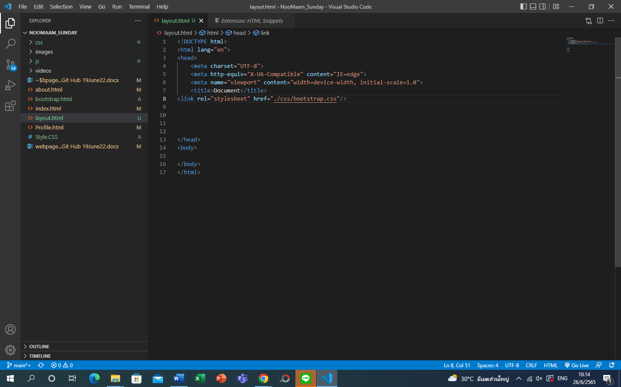

Insert <link ……. /bootstrap.css.”/>

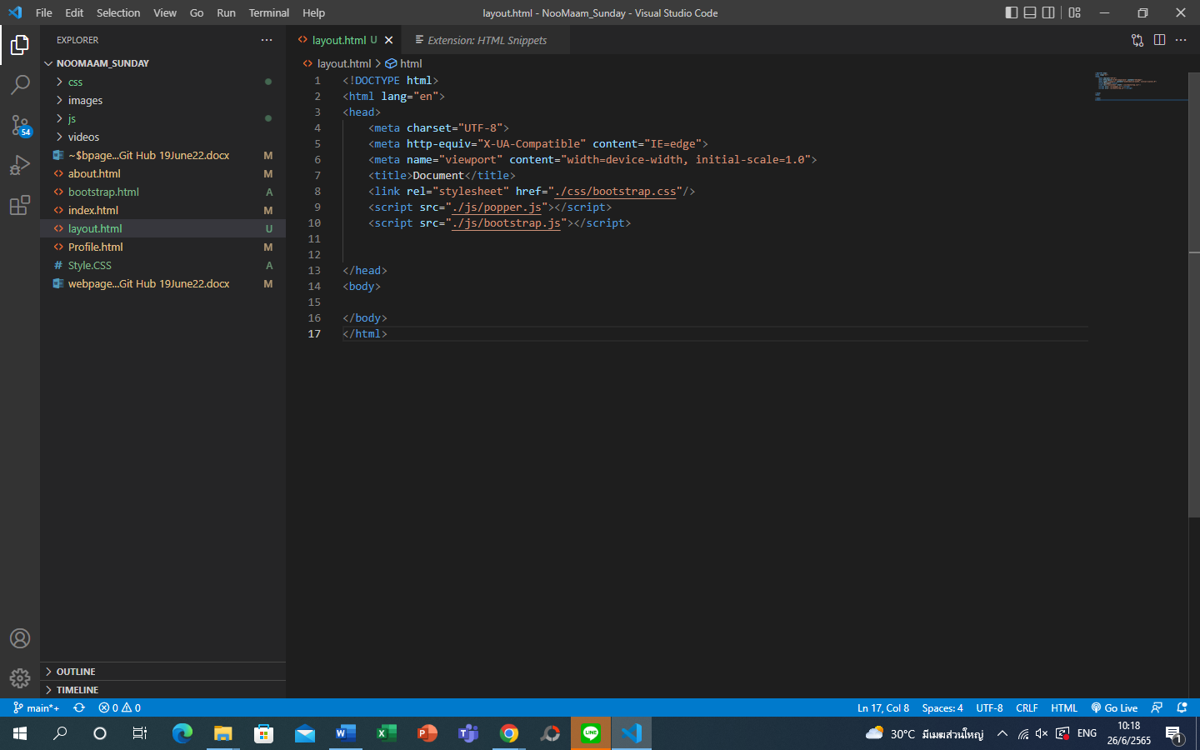

<script src="./js/popper.js"></script>

<script src="./js/bootstrap.js"></script>

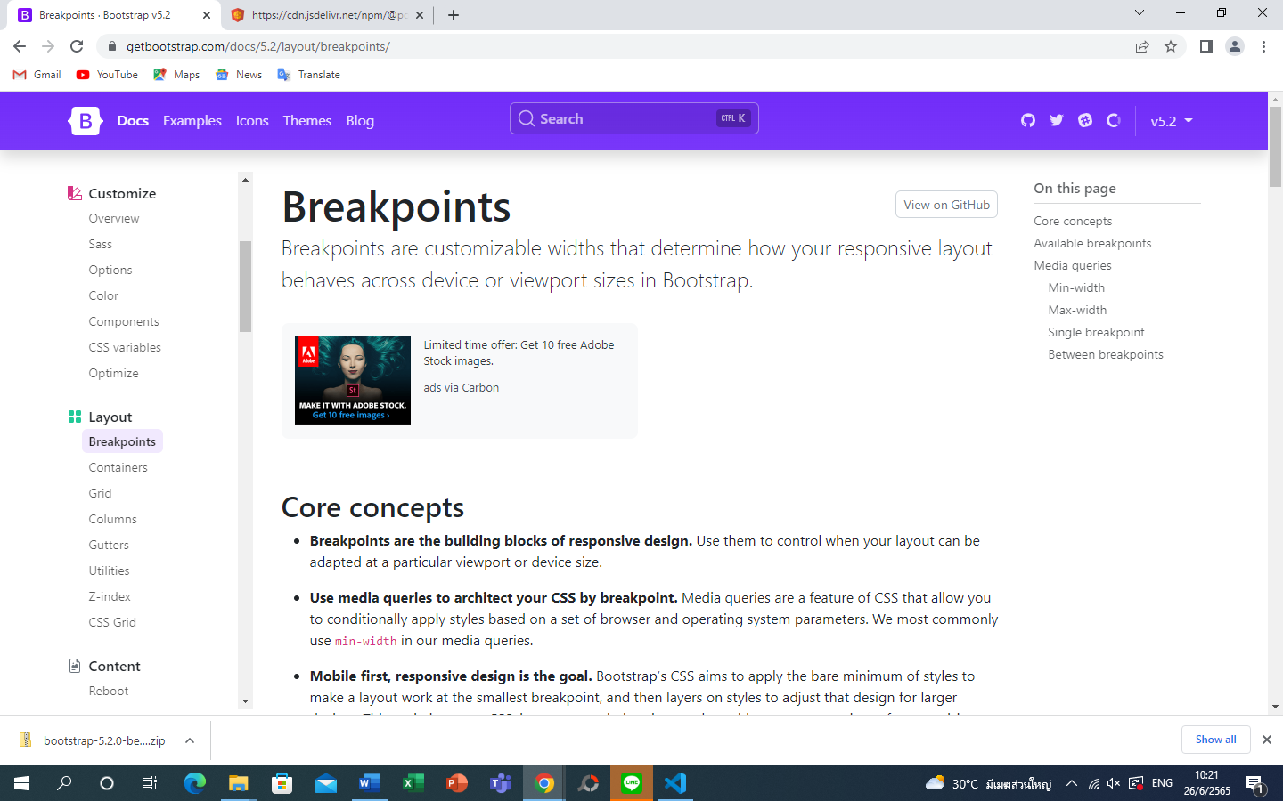 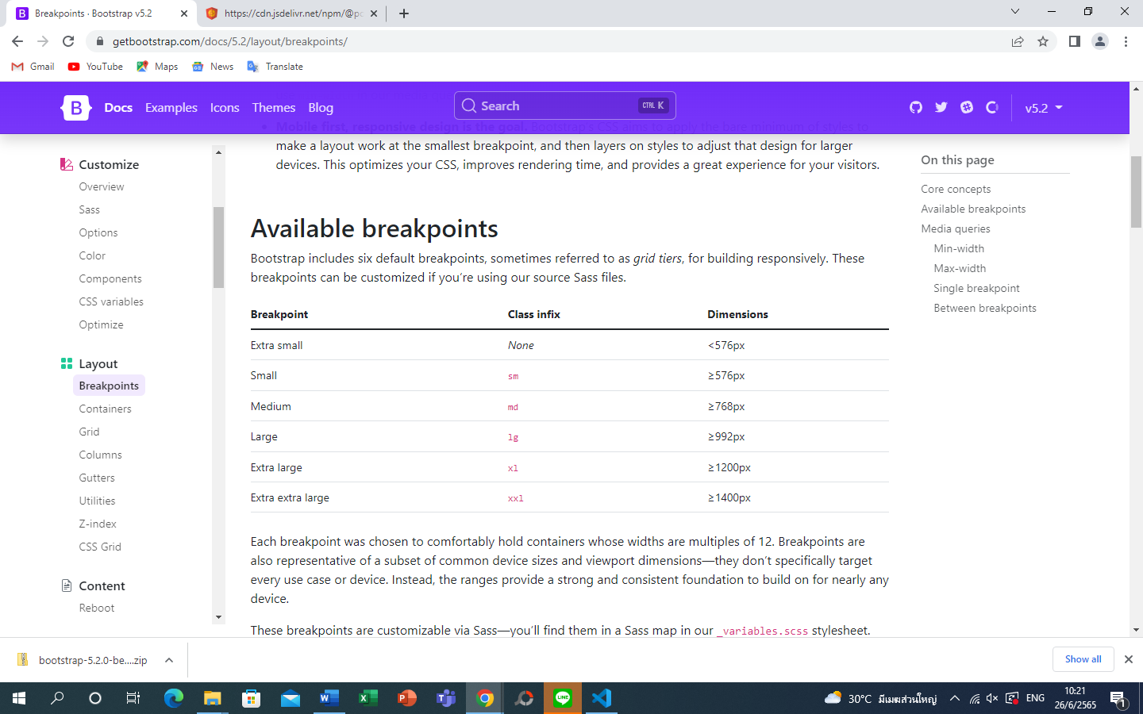 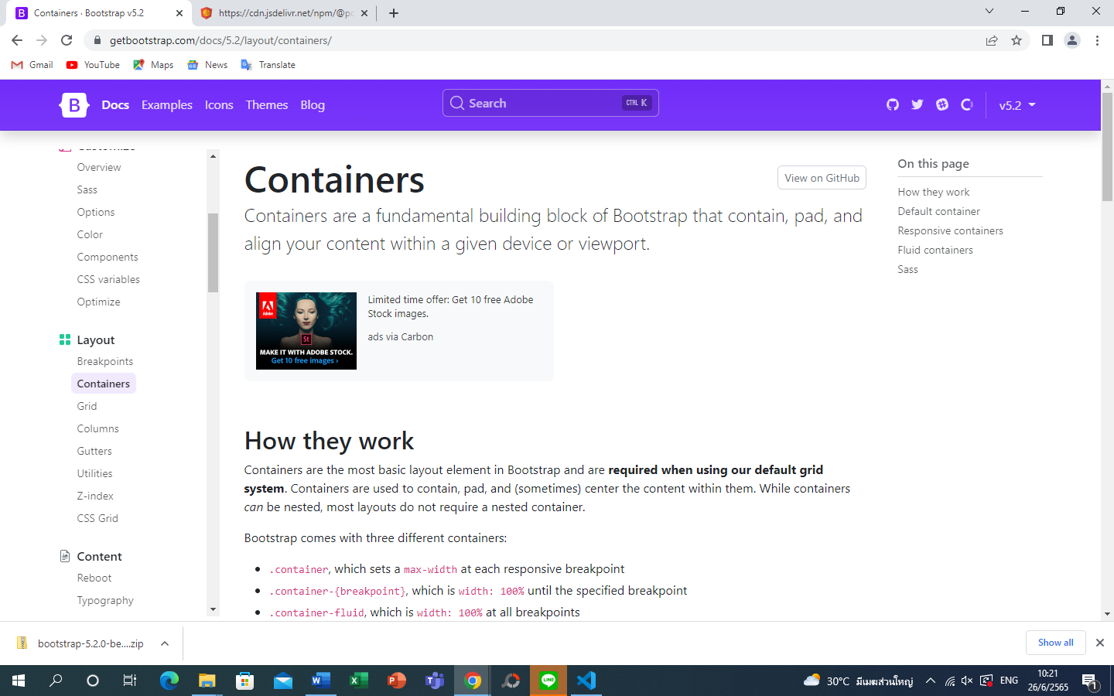 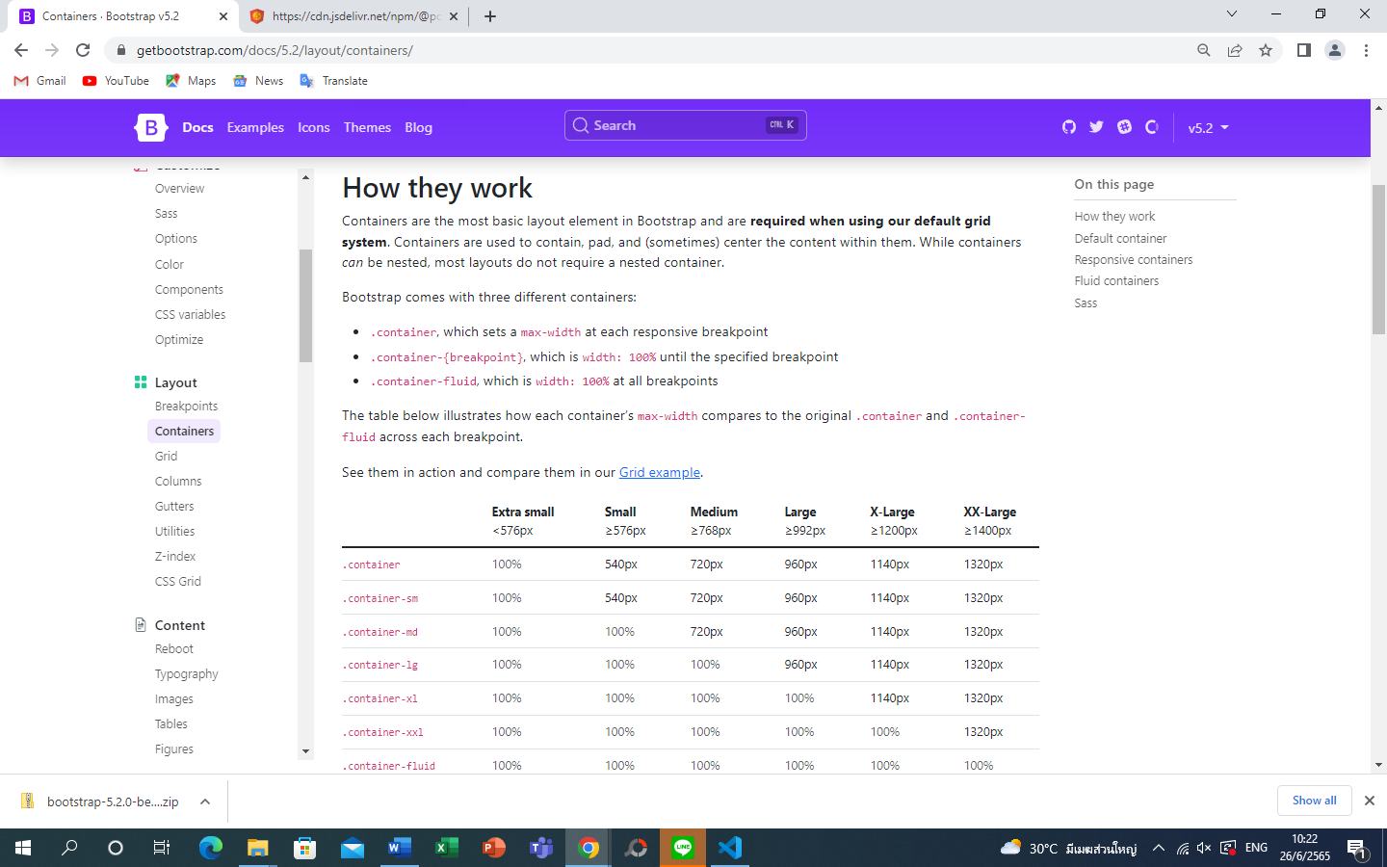

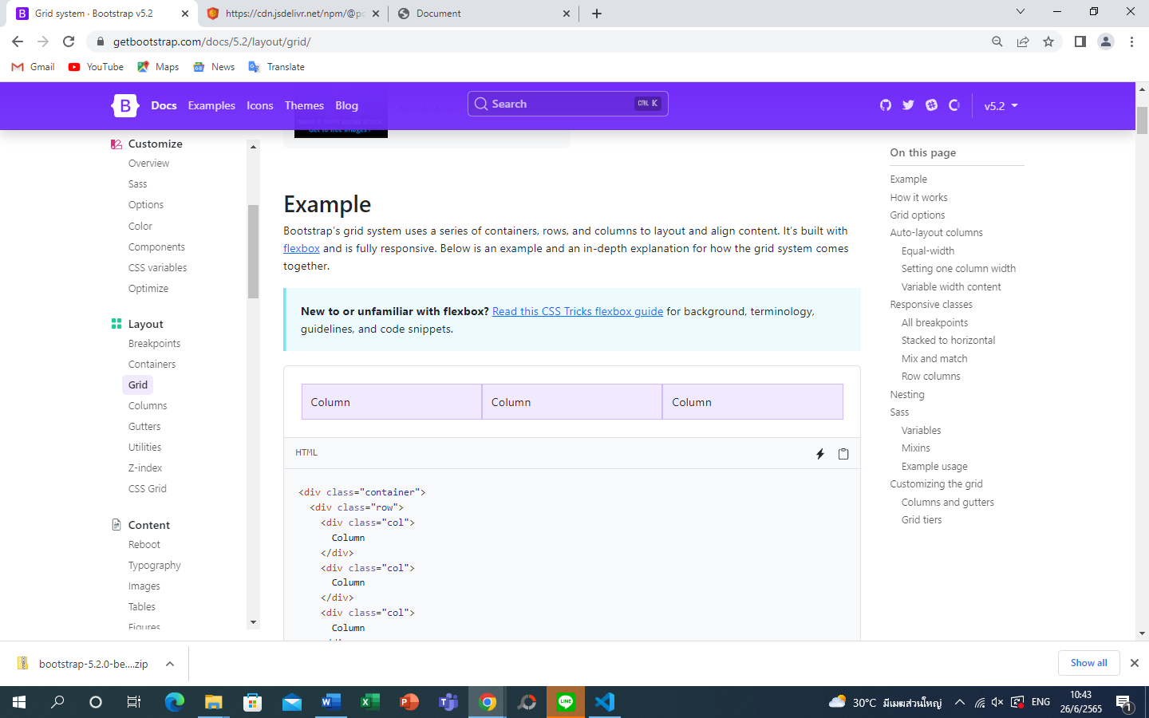 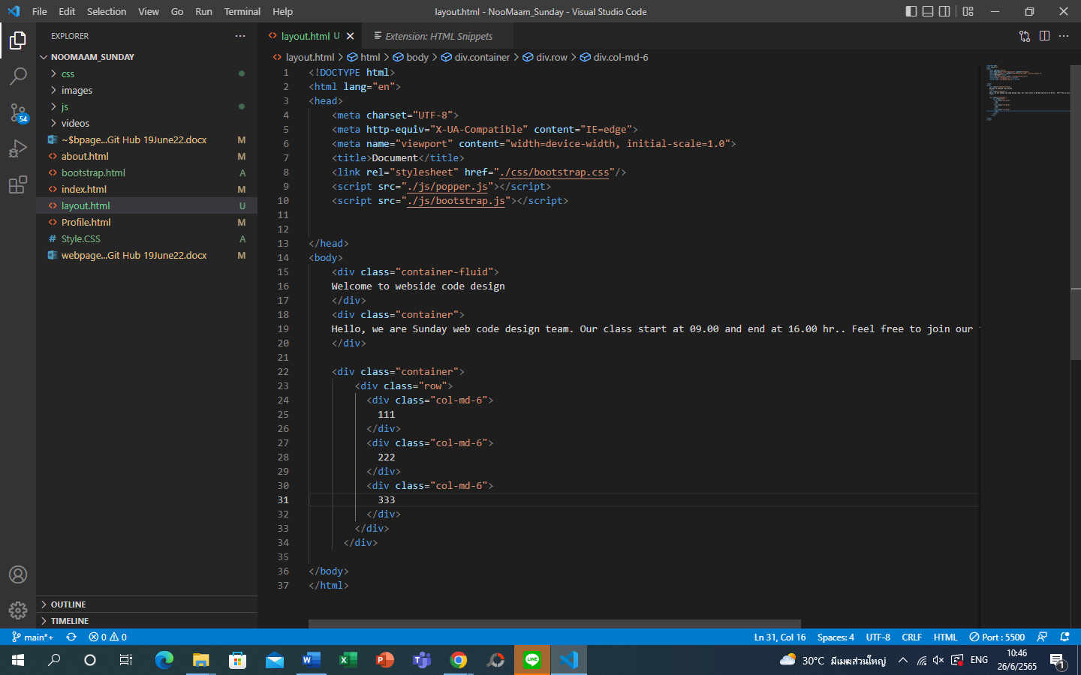 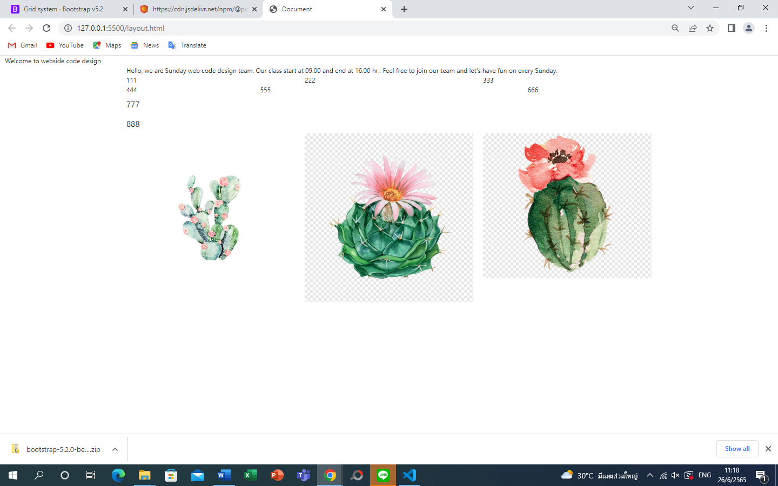 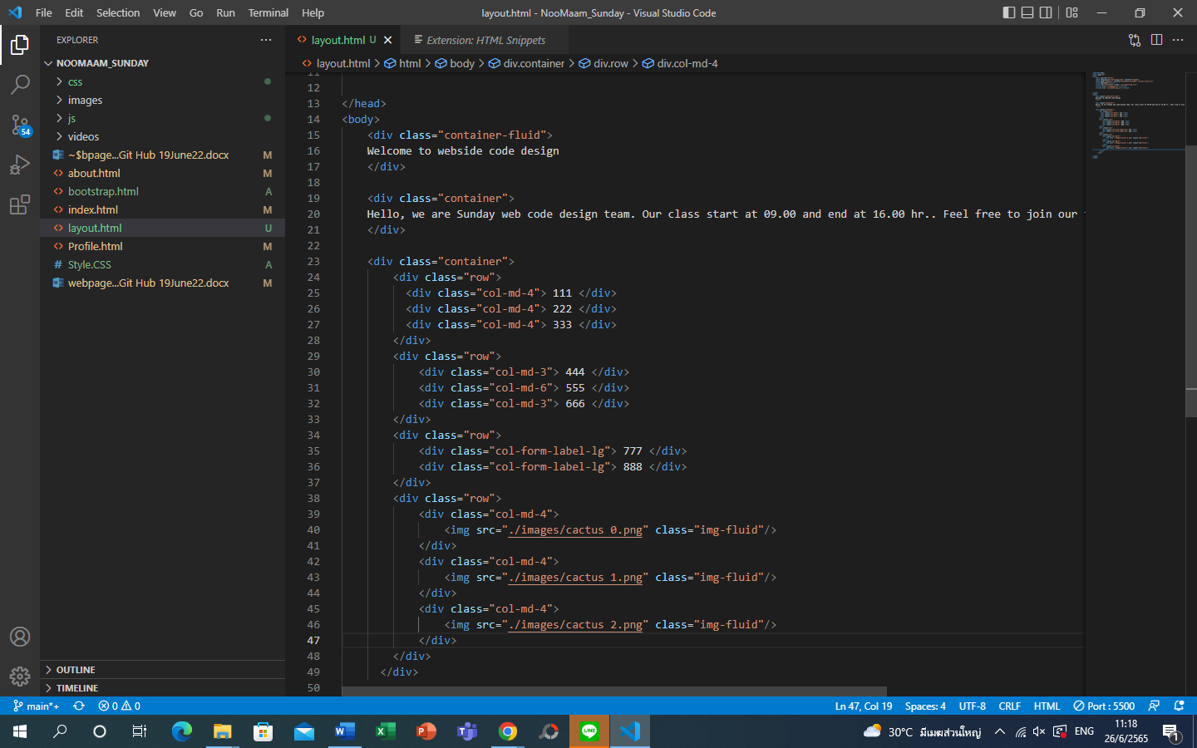 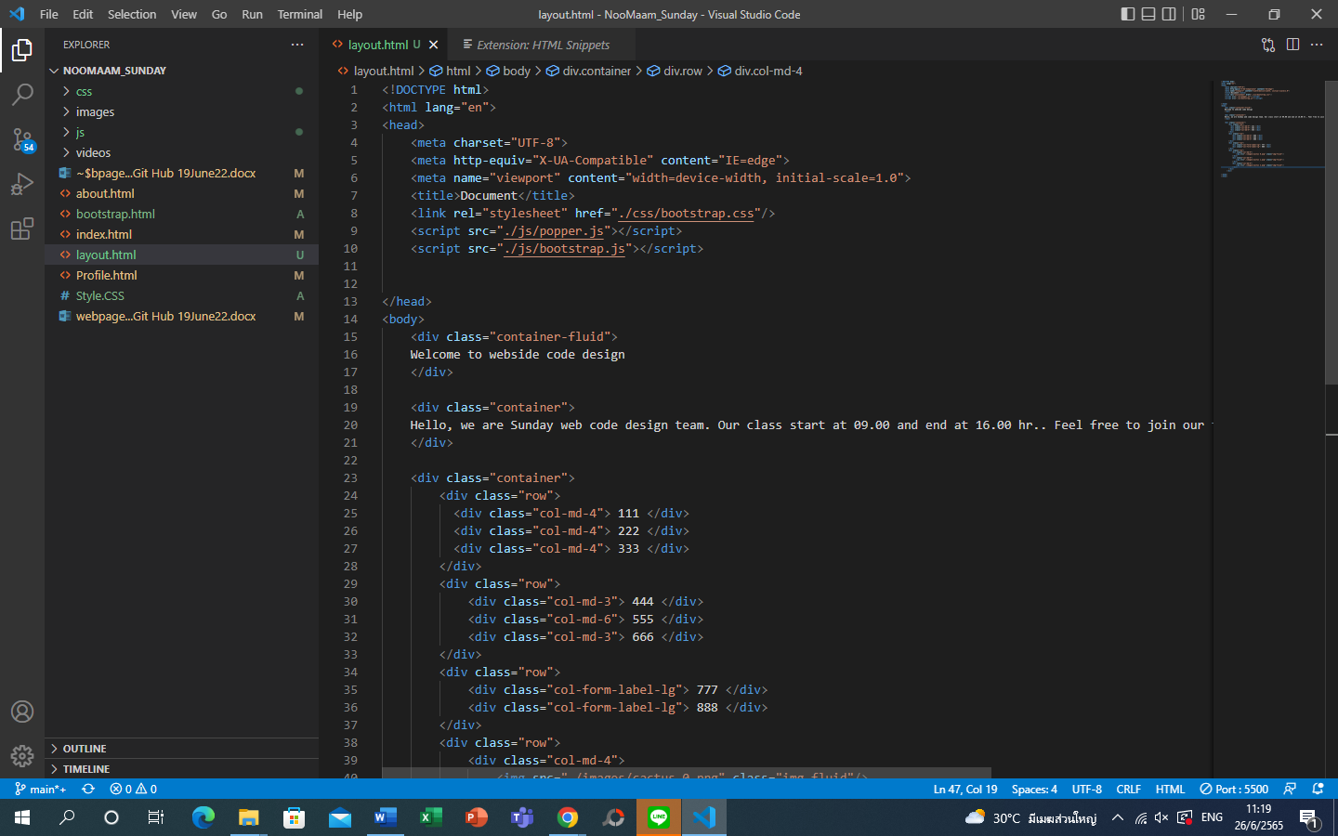 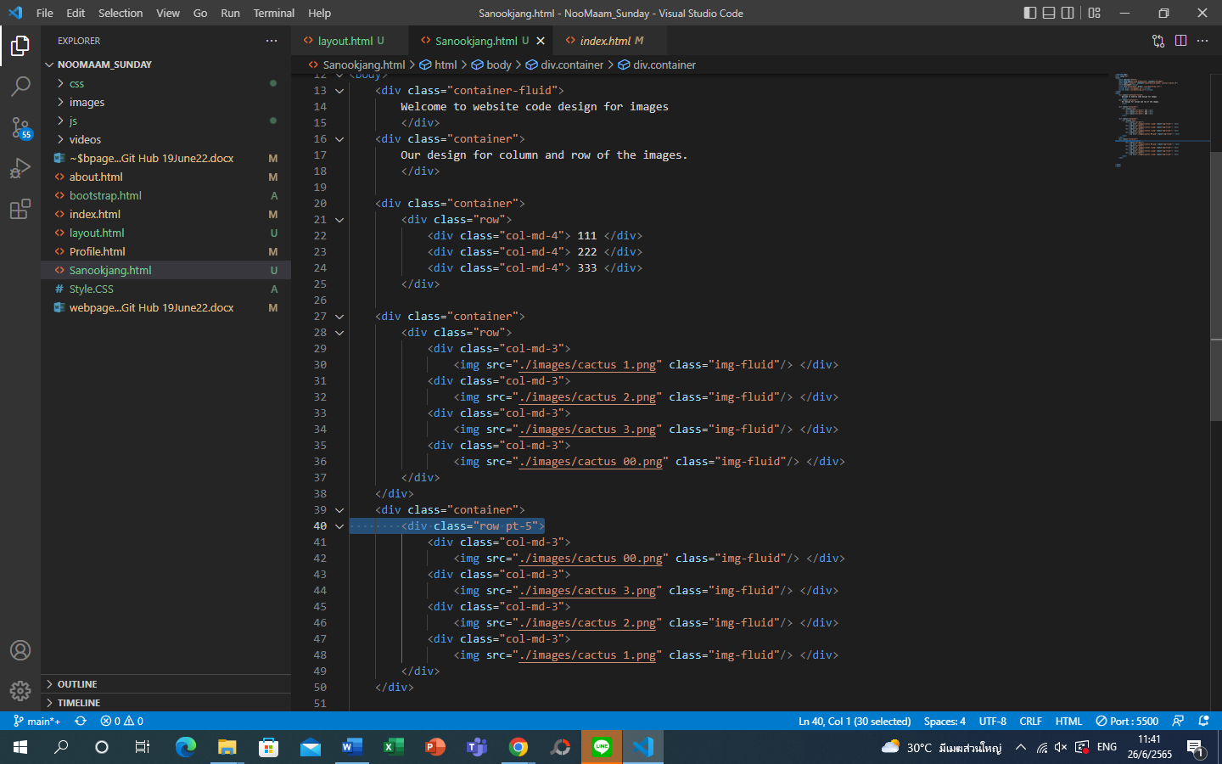

Input pt-5 to divide the picture with space 5 pixel

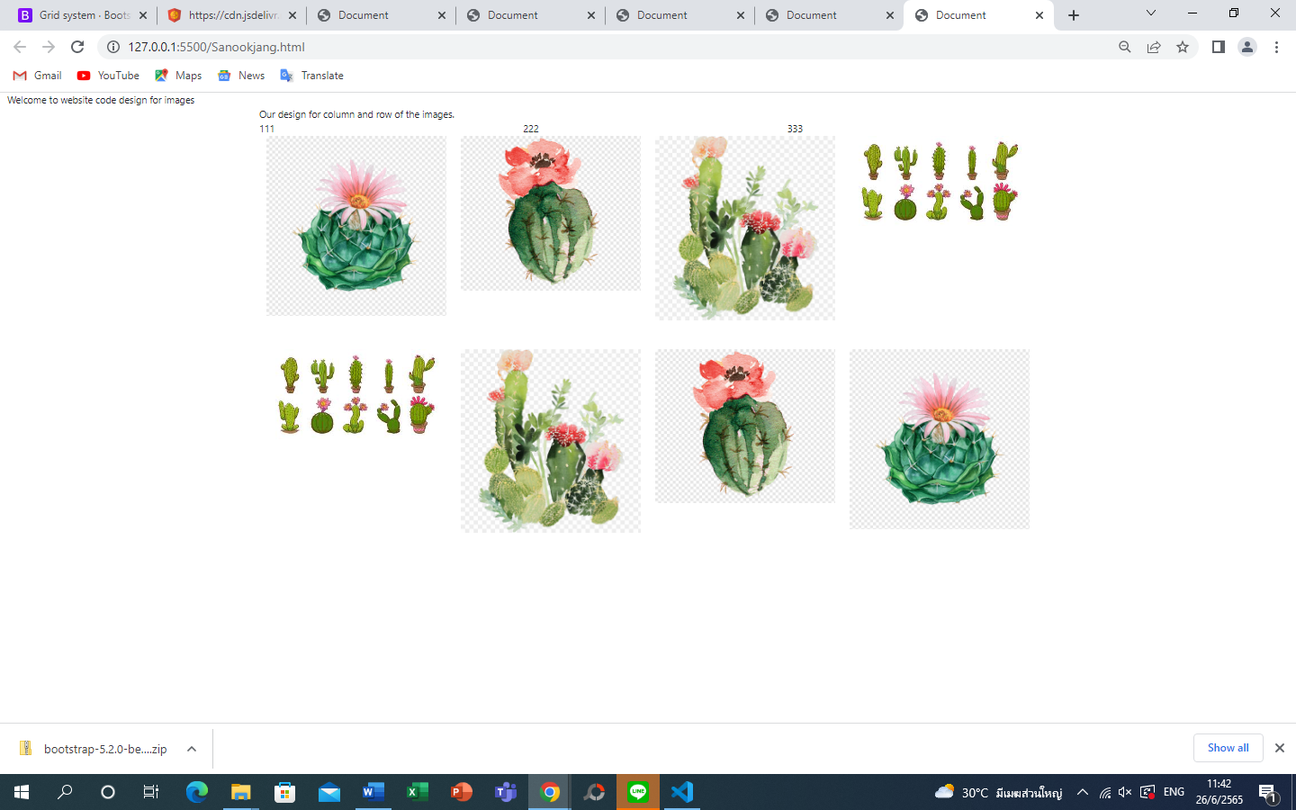 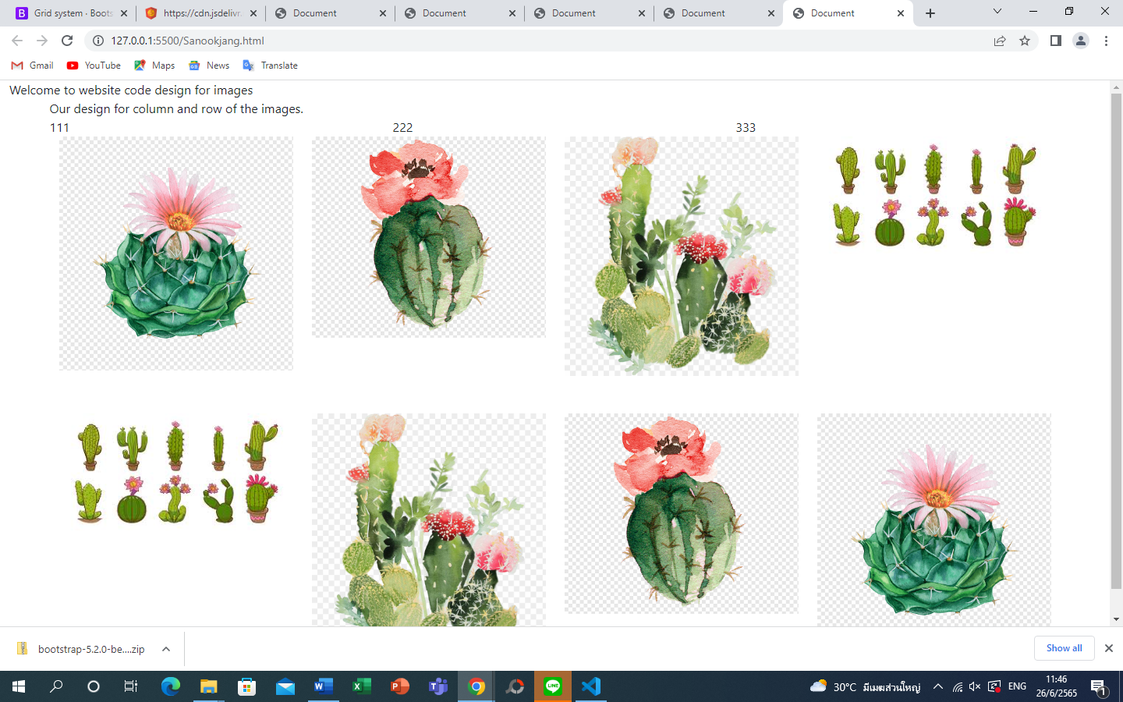 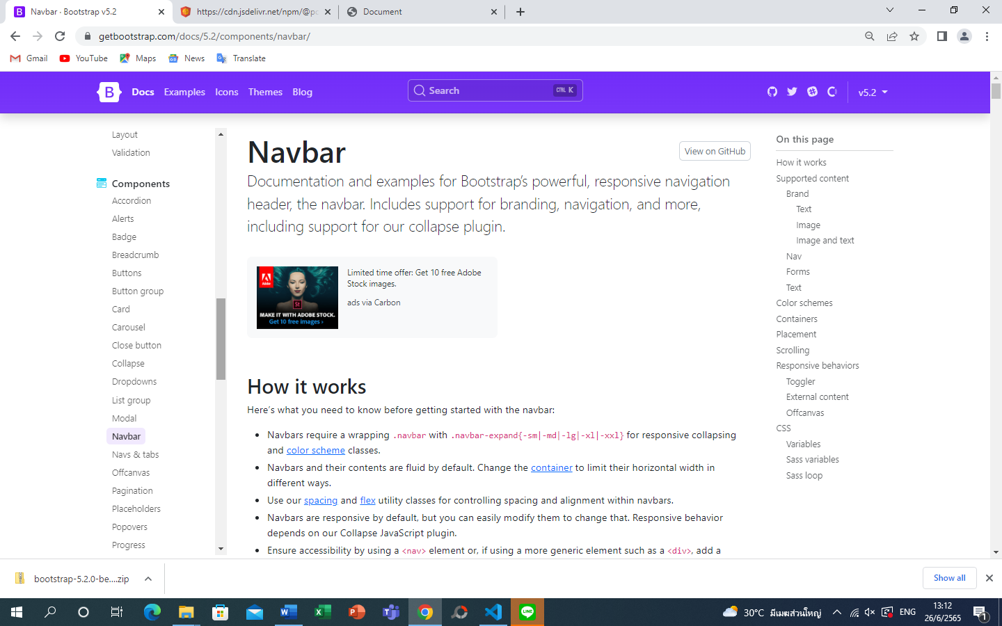 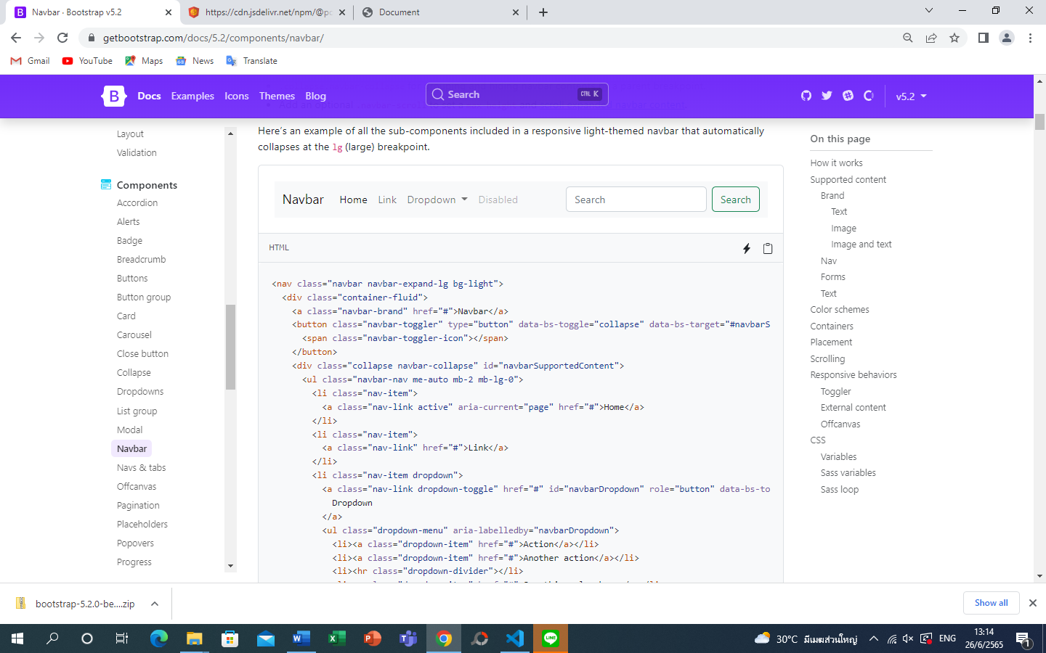 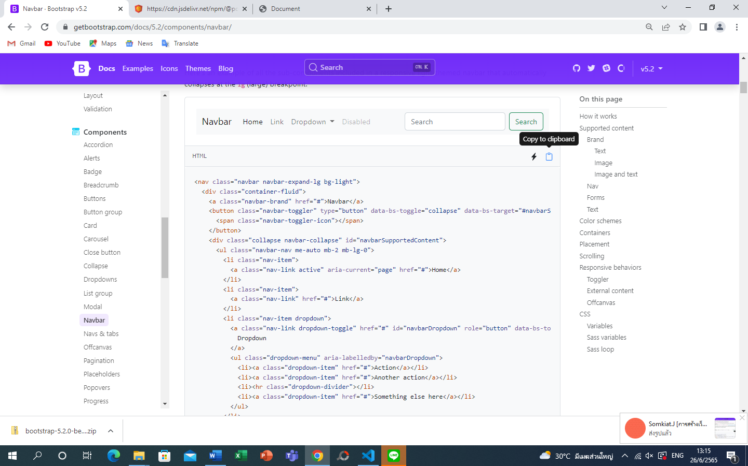click to copy to clipboard

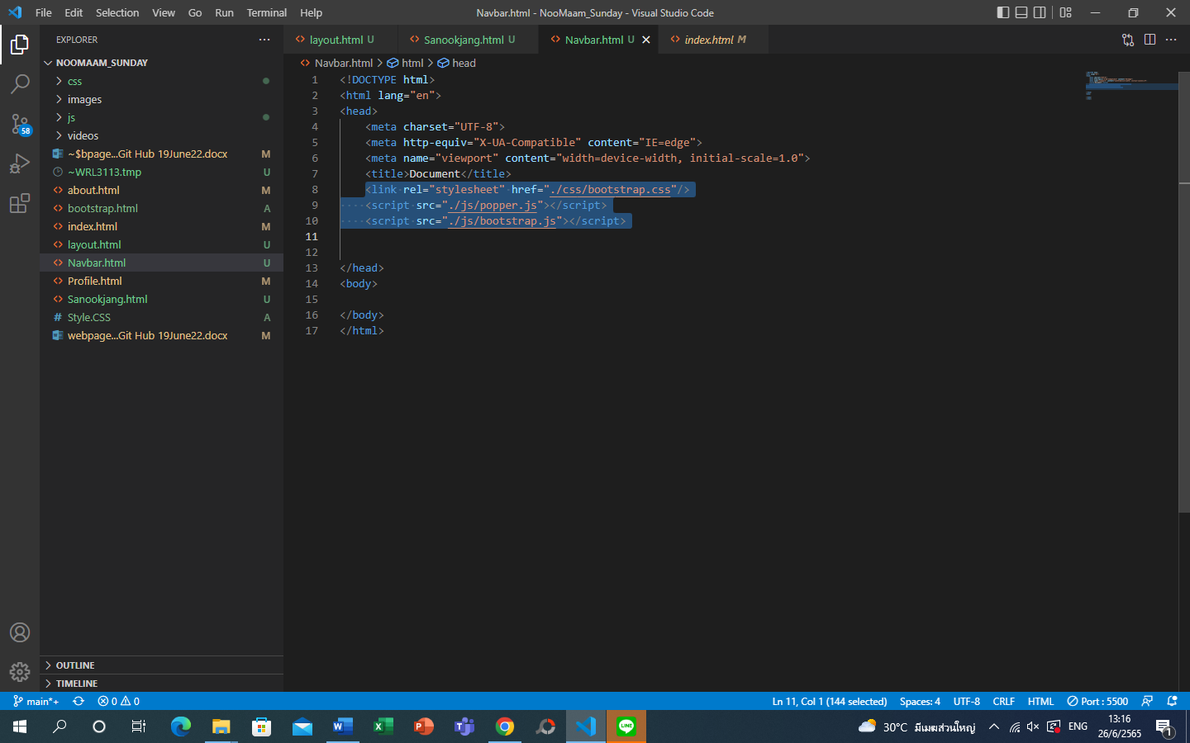add three line of the link to new folder

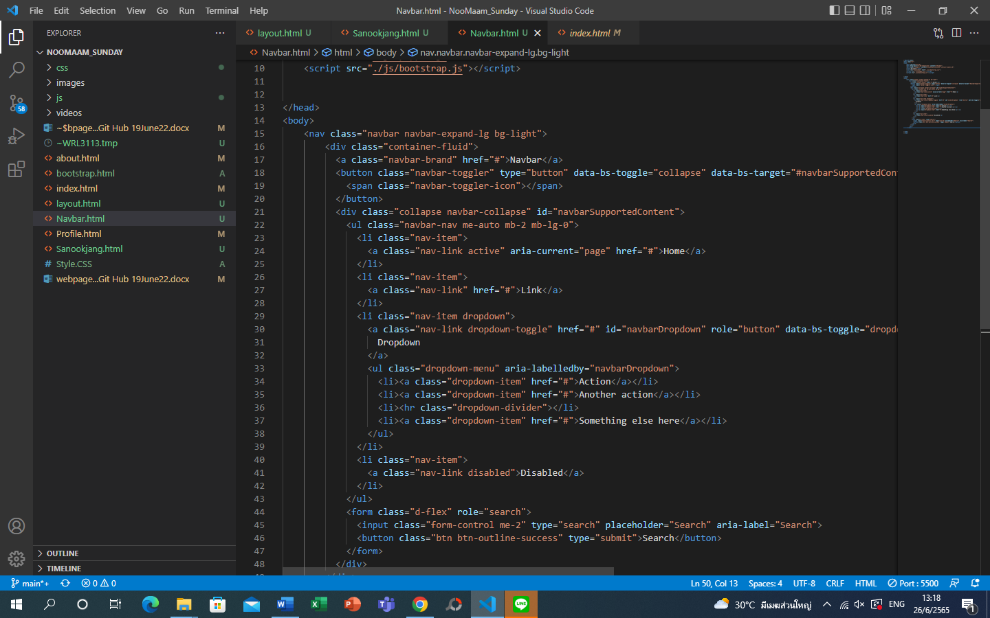copy code from navbar in bootstrap to code by using Ctrl V

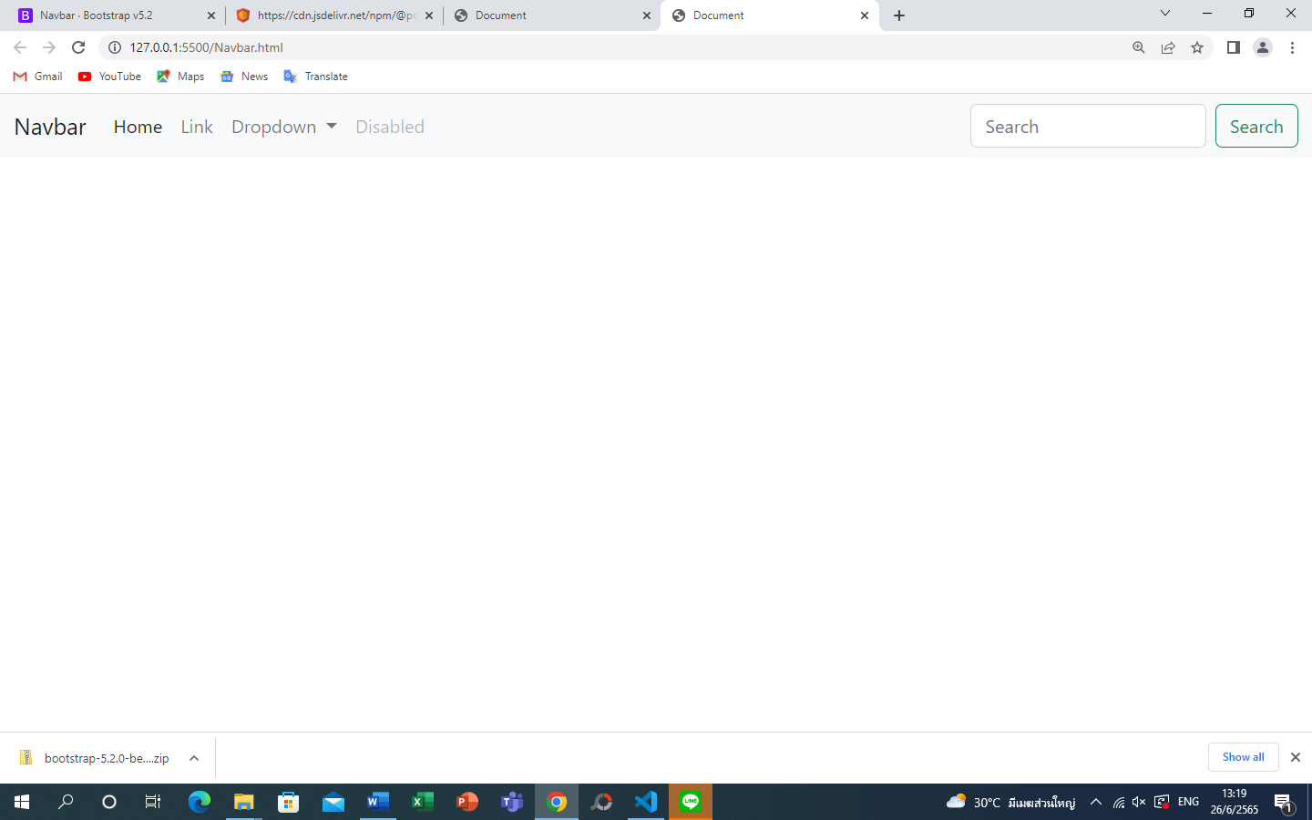 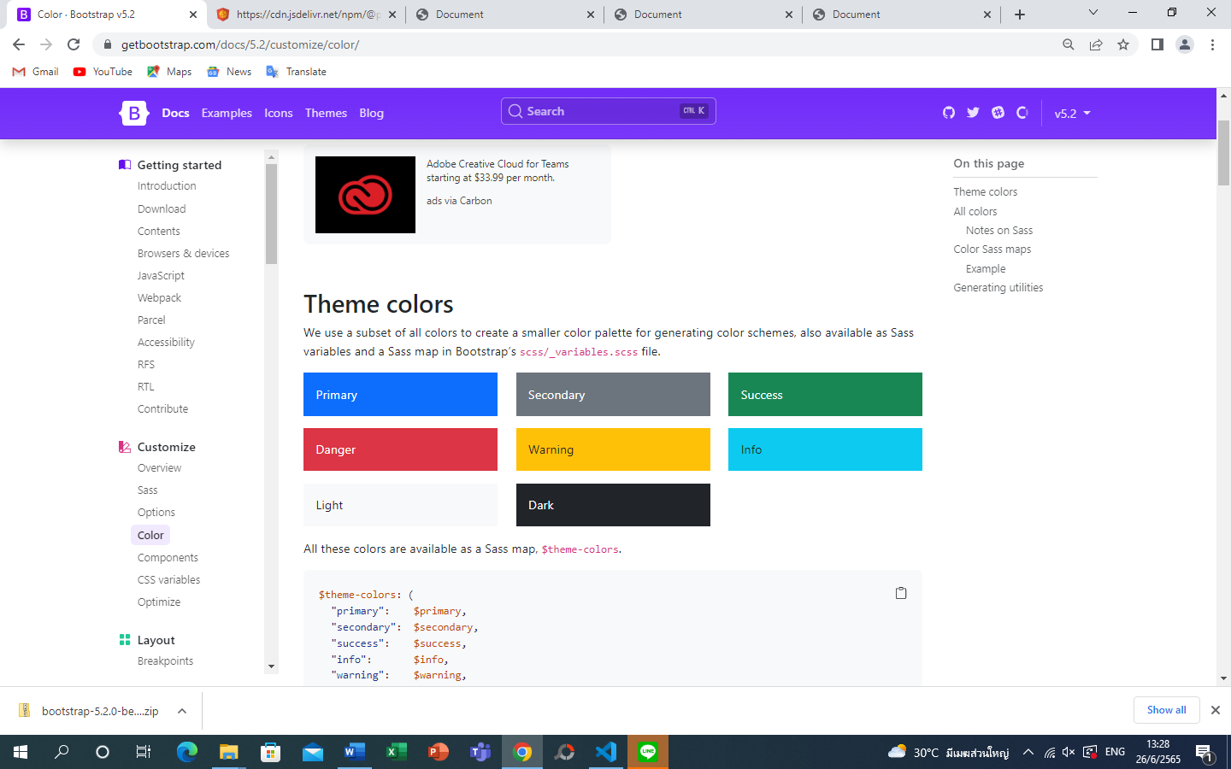

Remember keywords of each color code

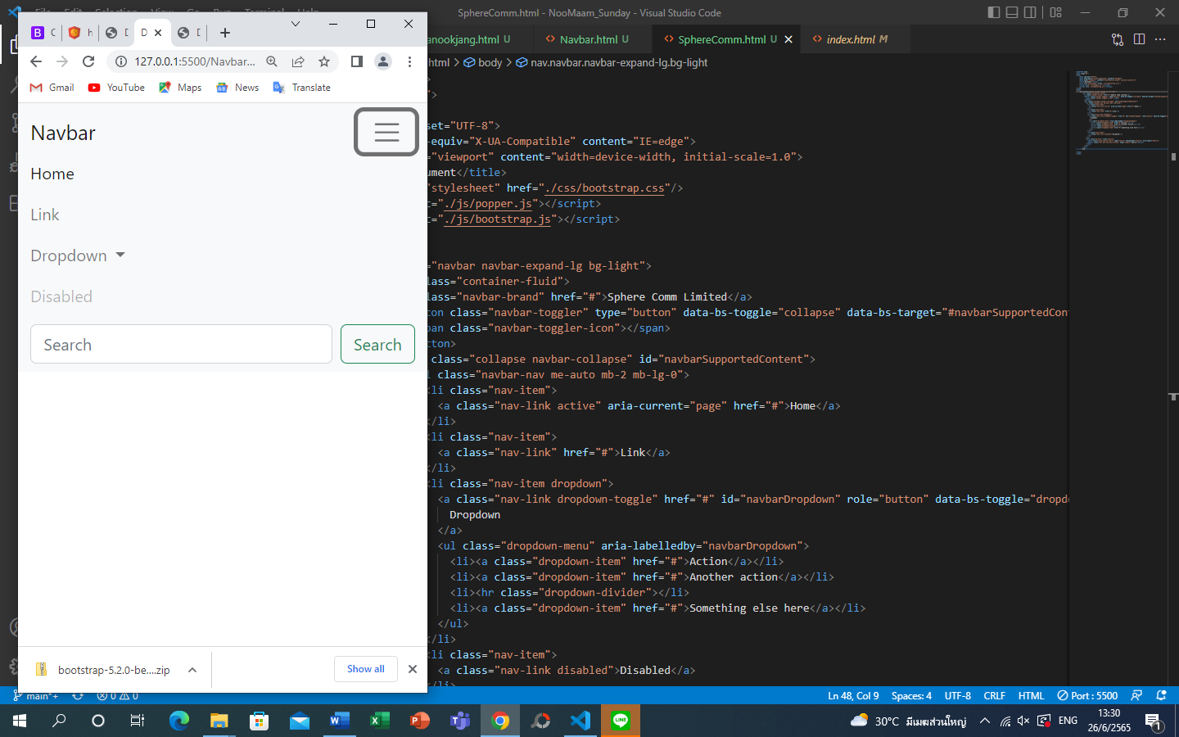เมื่อเราย่อขนาด window size จะเปลี่ยน Bar เป็น Responsive drop bar 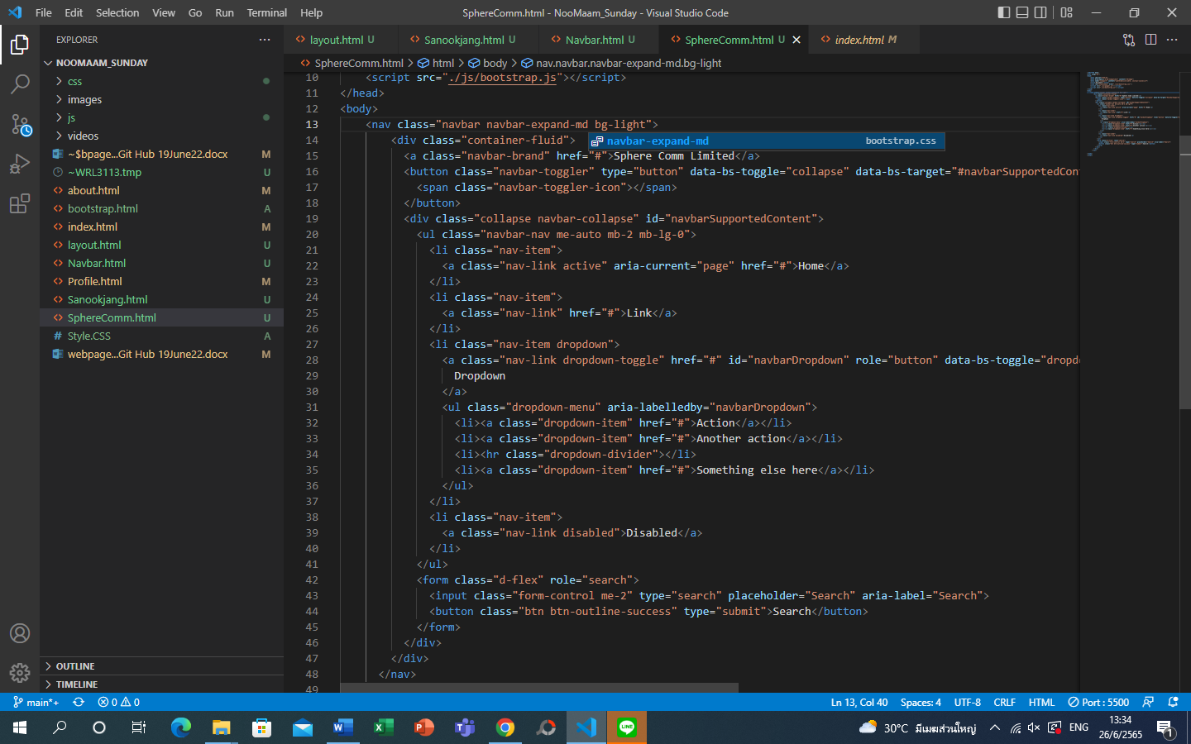

ถ้าใช้ md แทน lg จะสามารถเห็น bar จนกว่าจะได้อีกระดับ

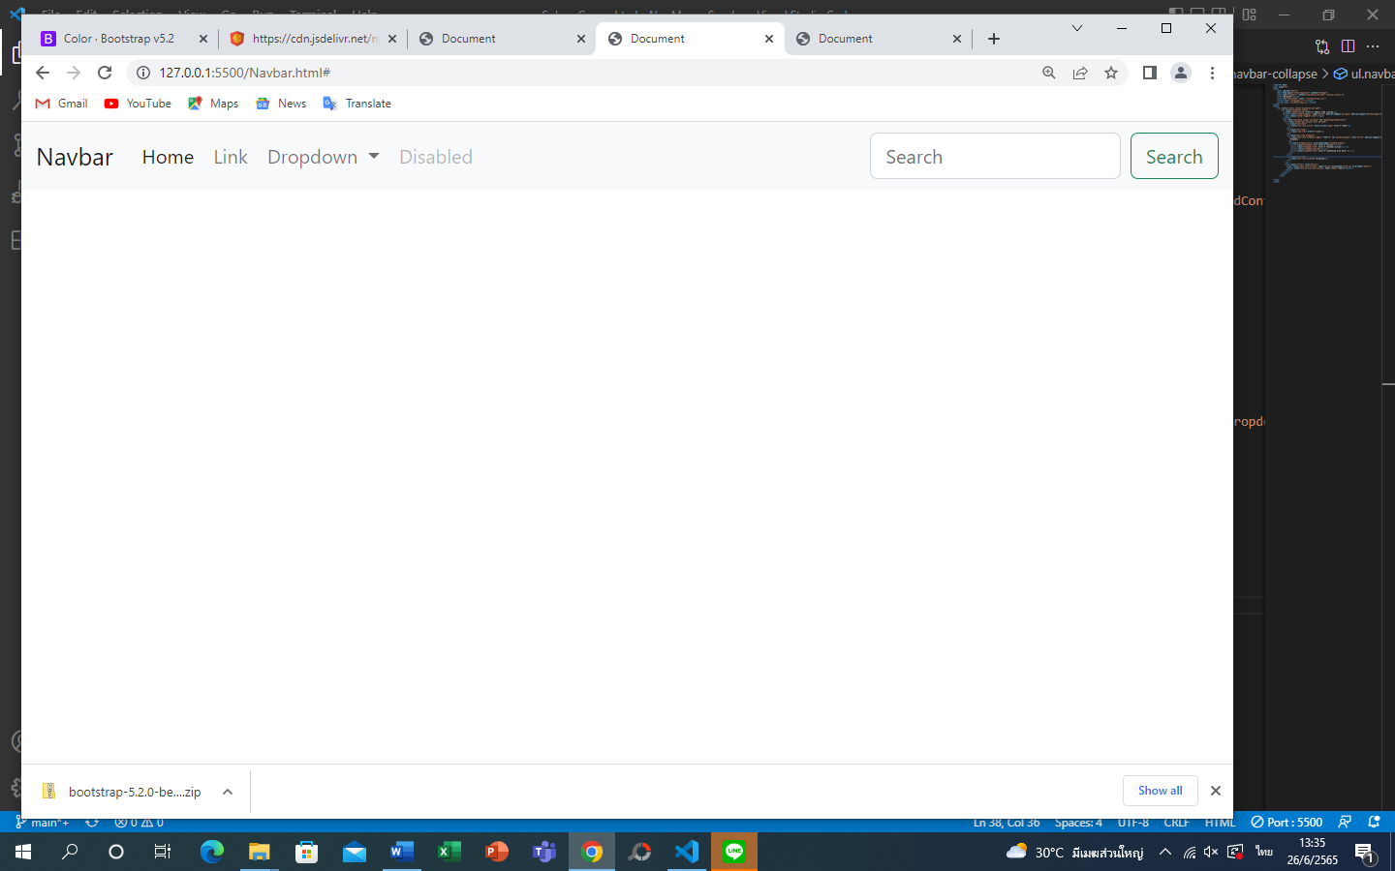 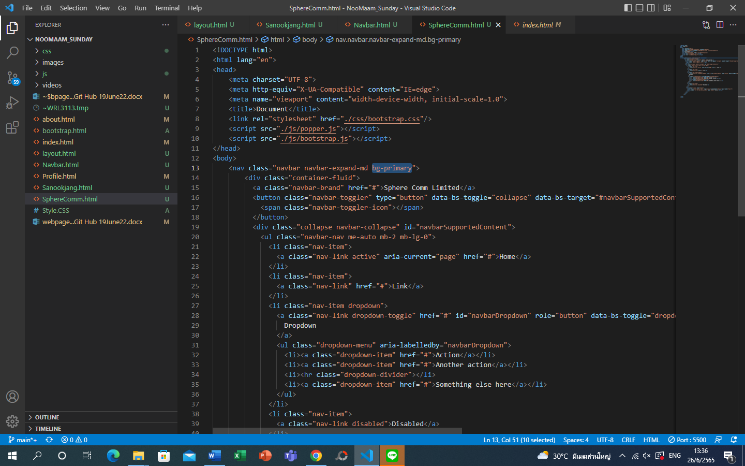 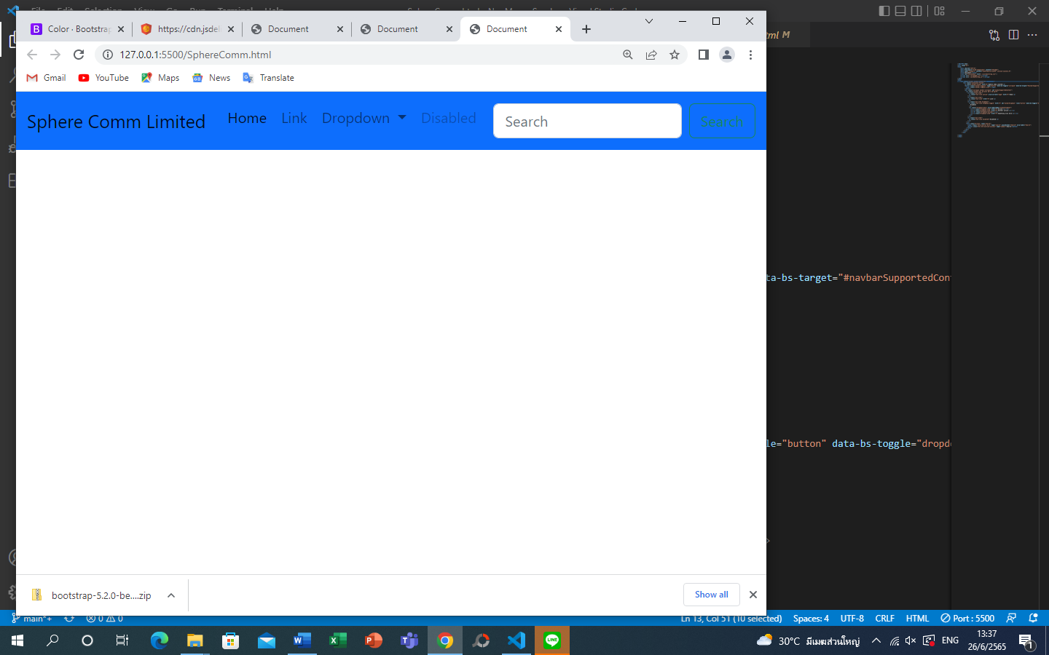 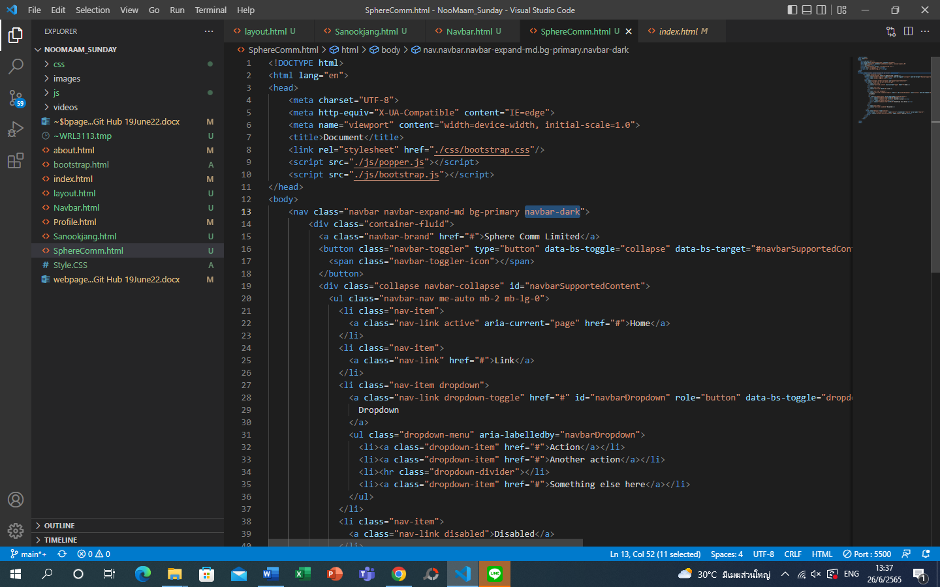navbar dark to change font color to view

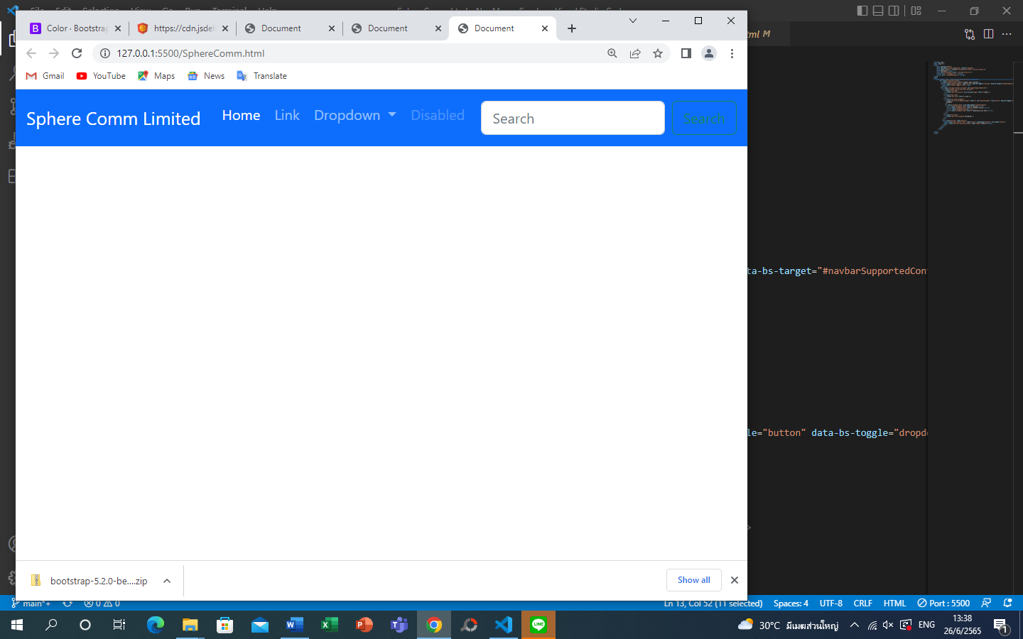 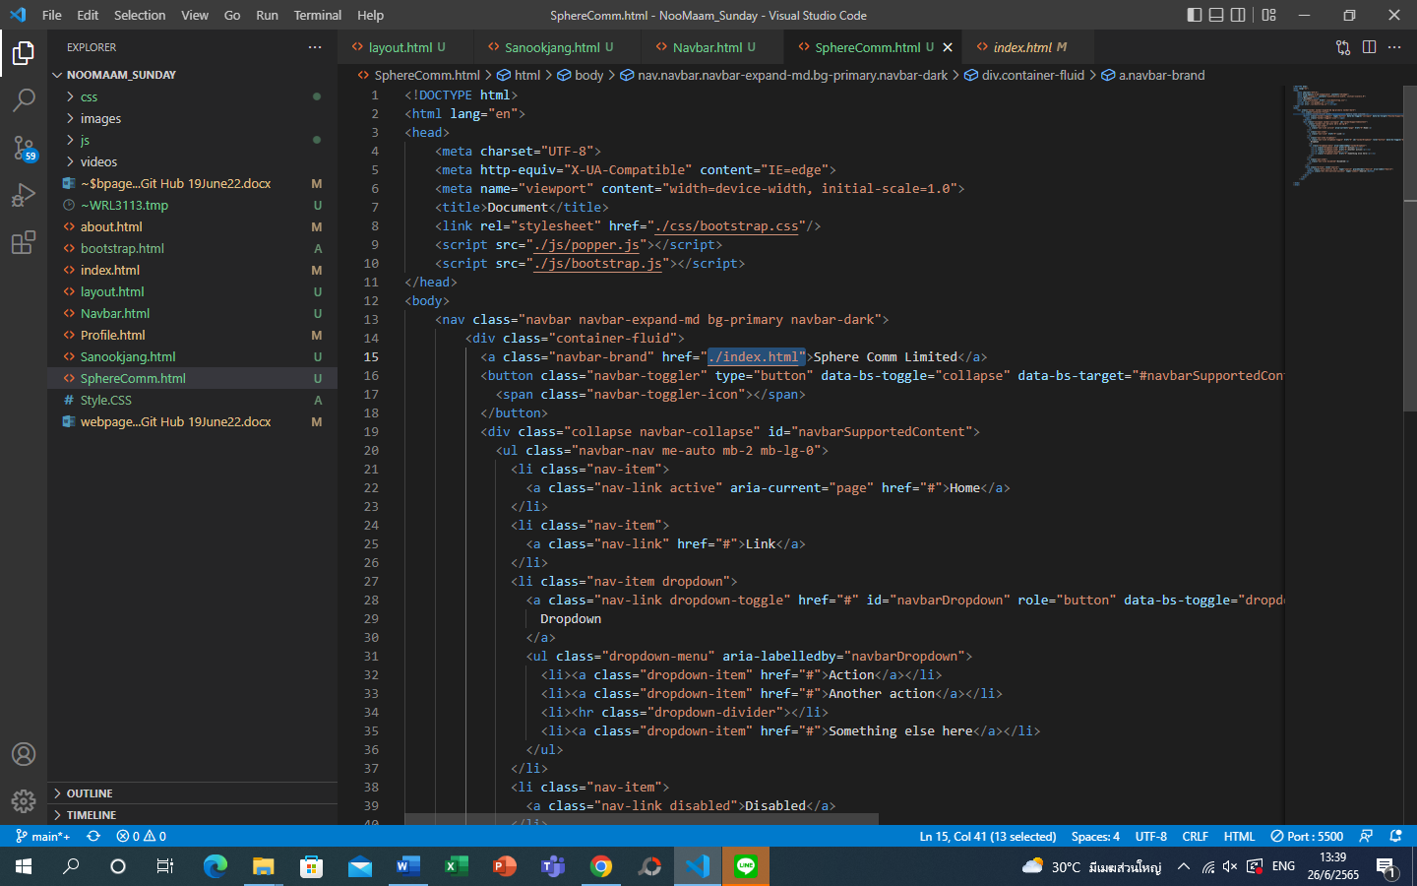

Input brand name and link

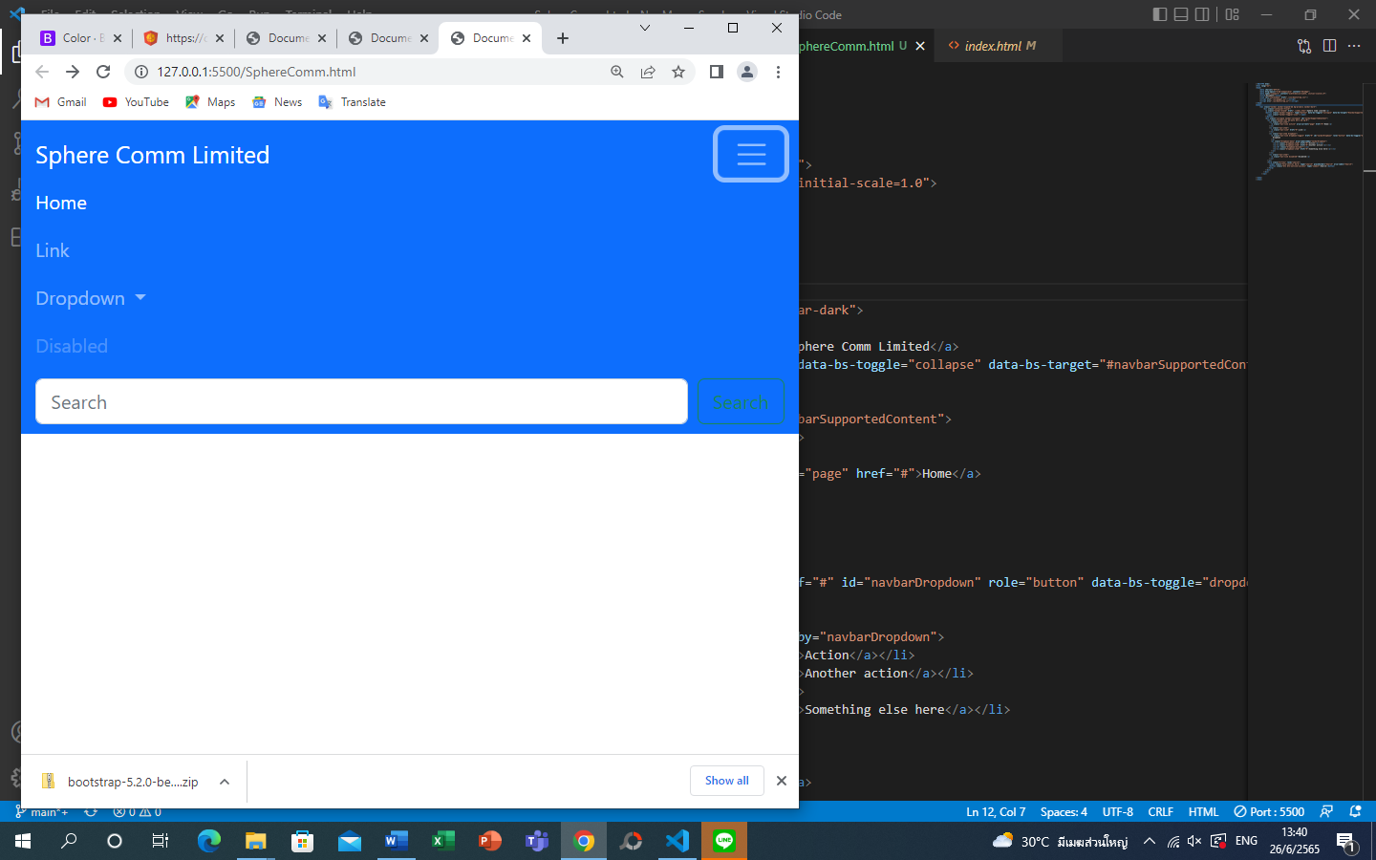

Navbar botton

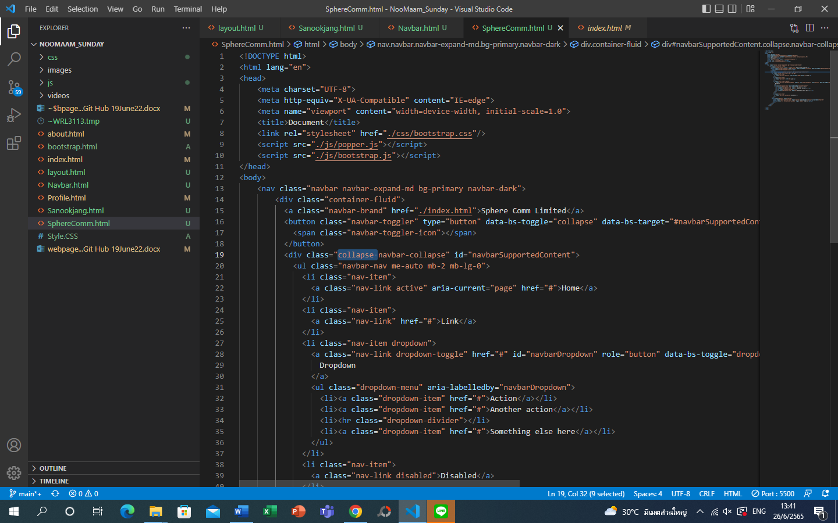

Collapse to call bar

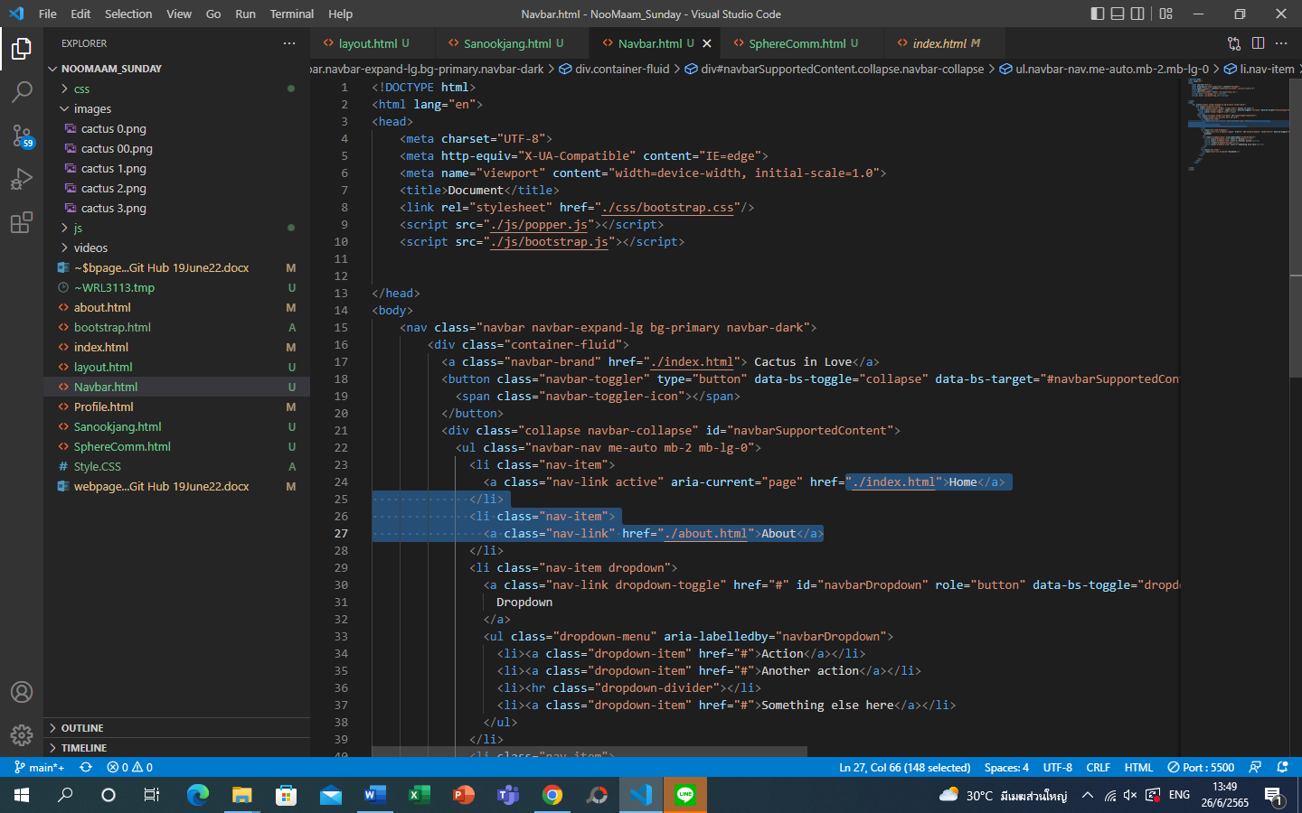

Chang icon name and add link / don’t forget to put/a> to end the code command

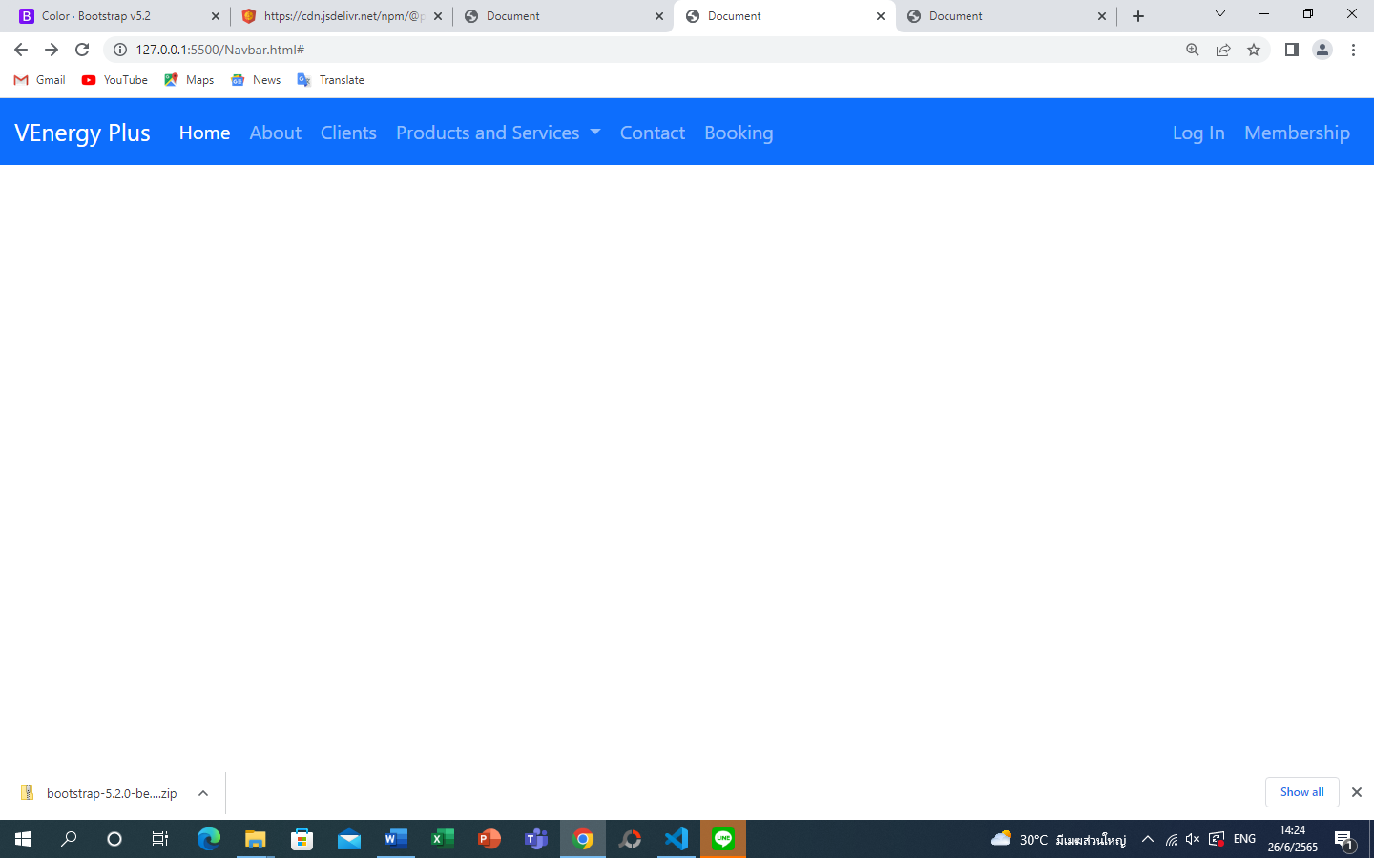 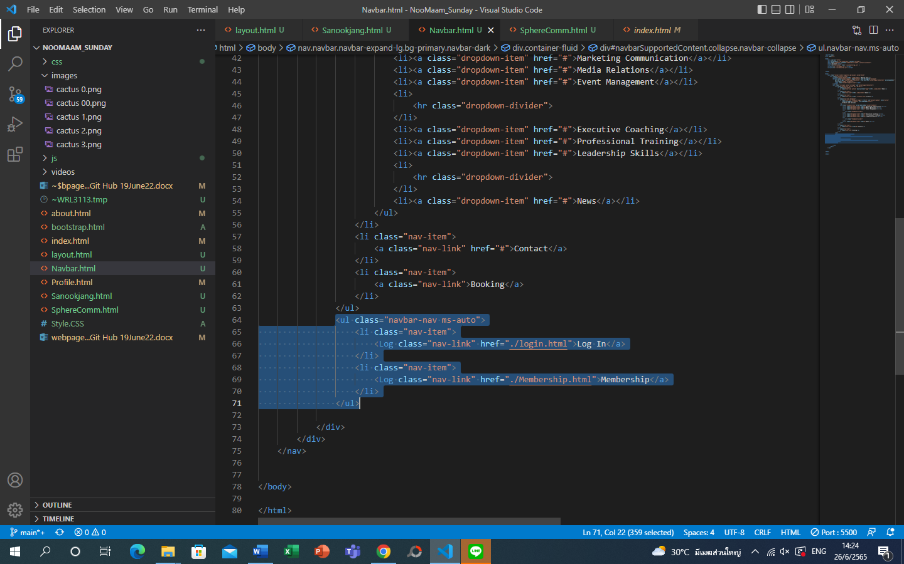

Add ‘log in’ and ‘membership’ icon at the right corner

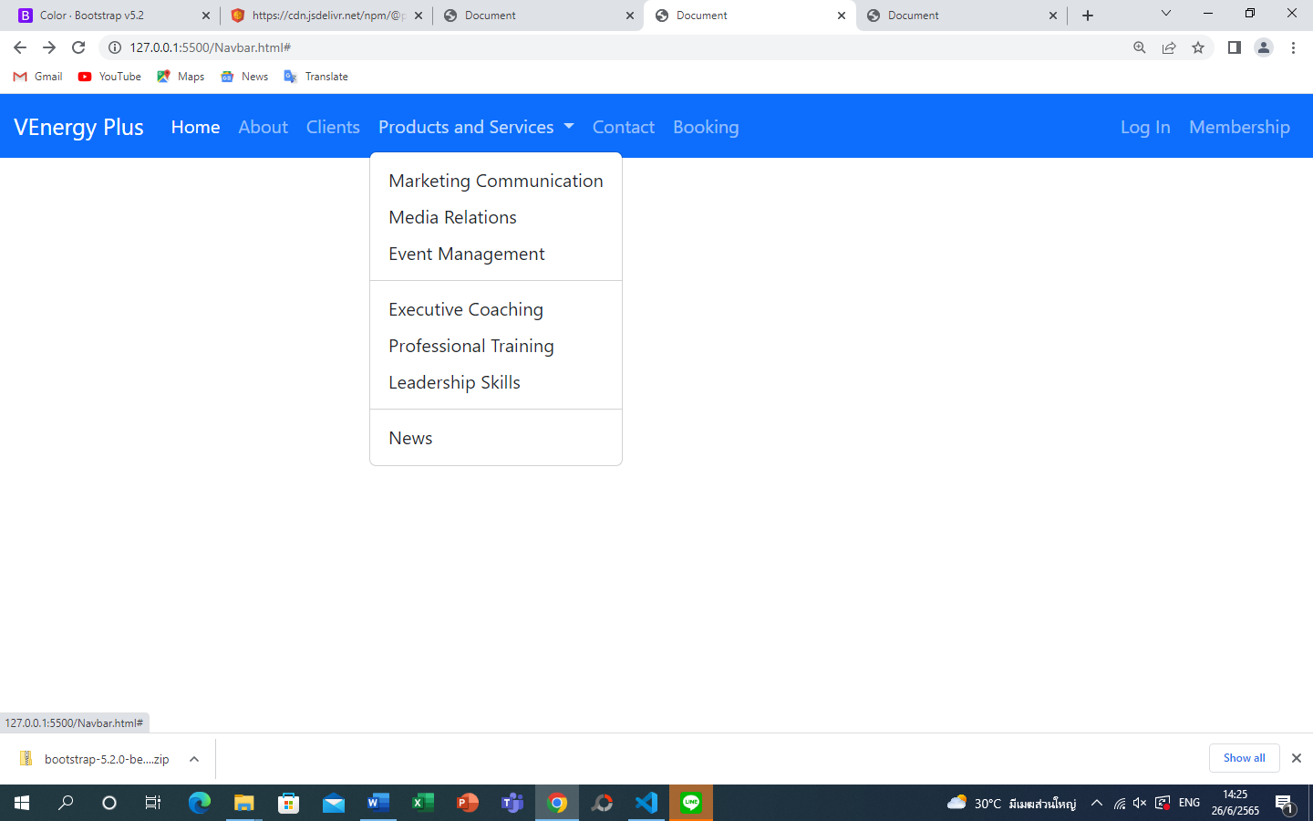 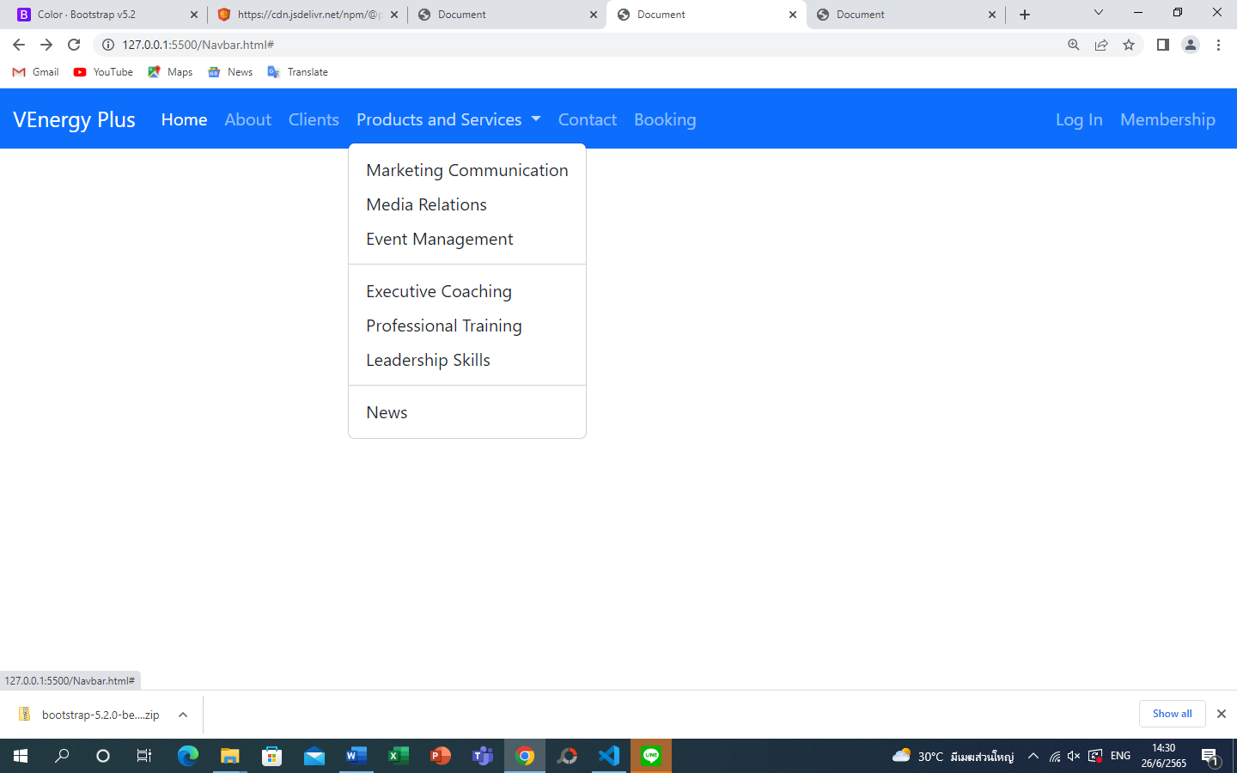 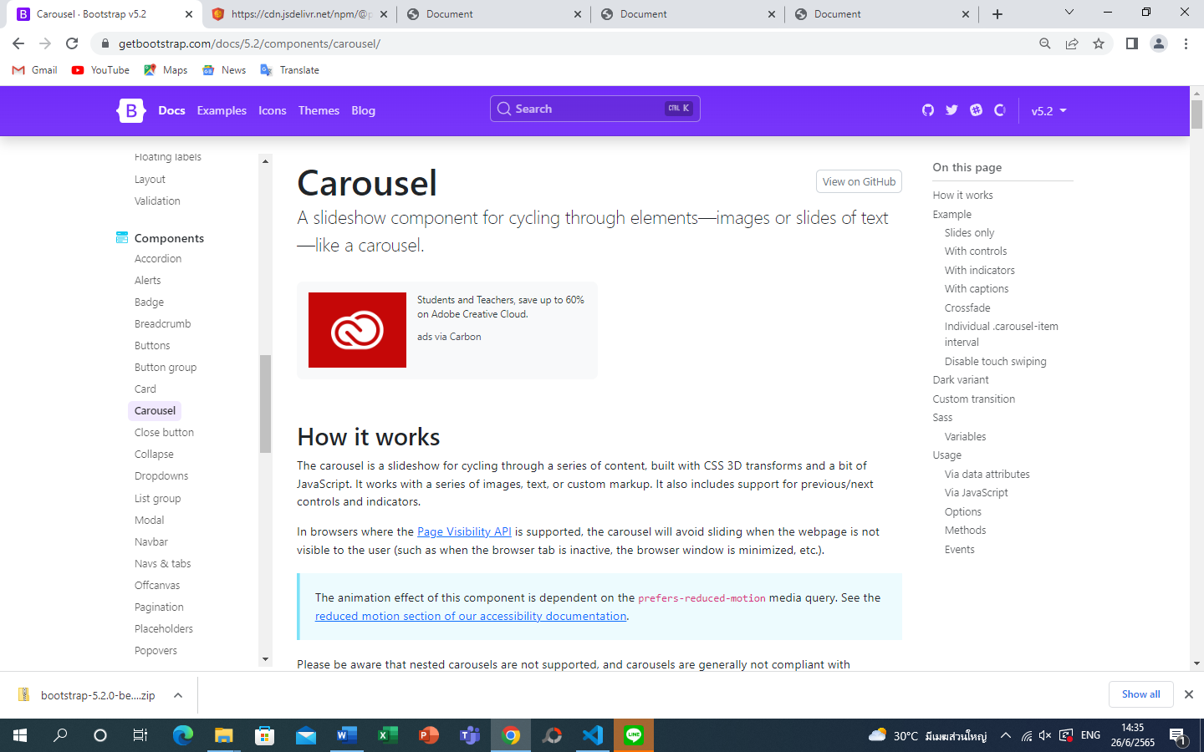 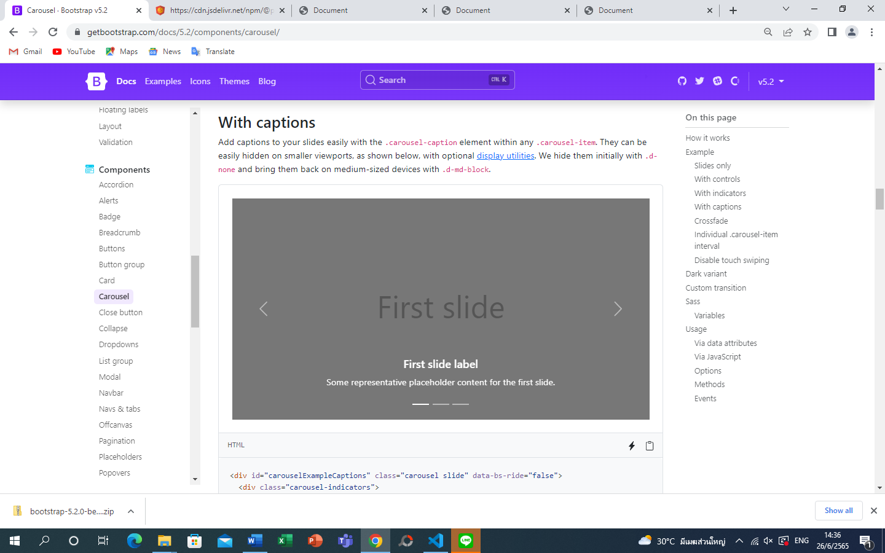input carousel

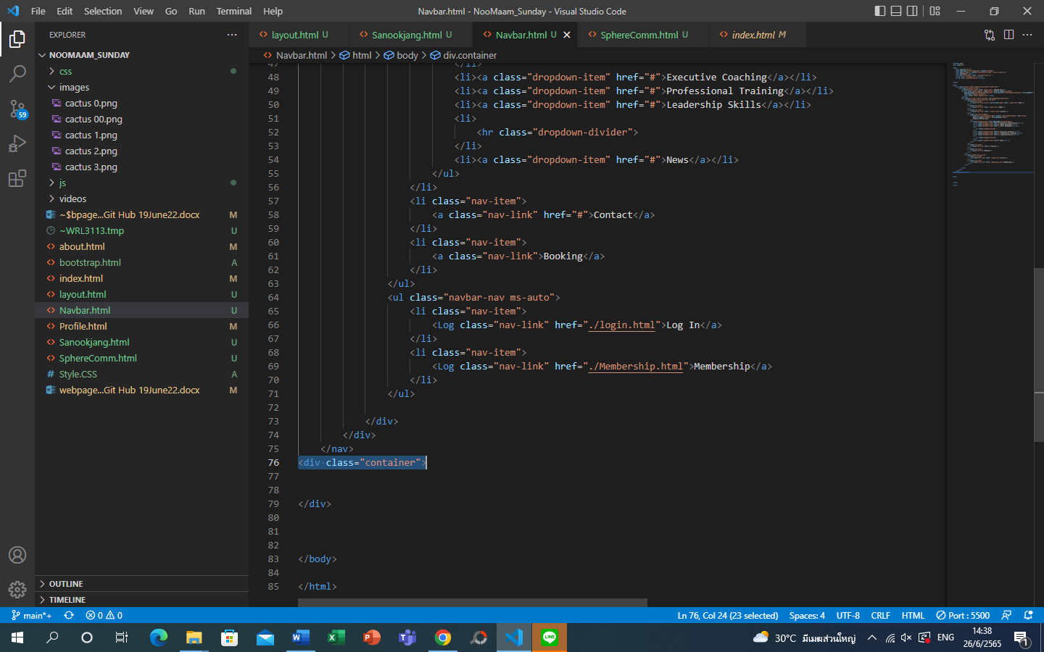input container first

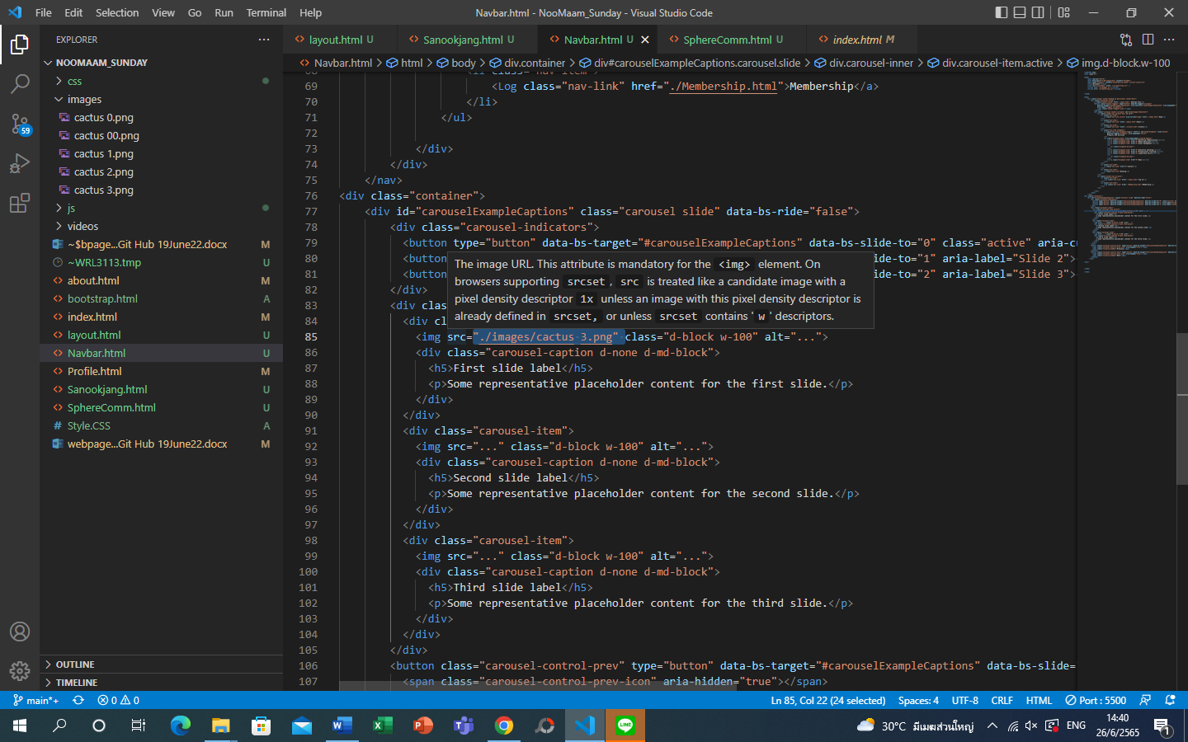insert image links

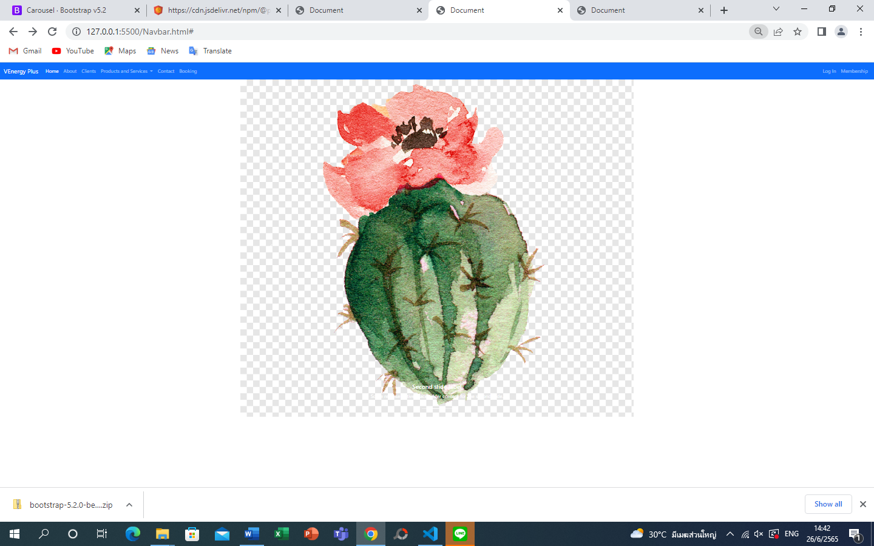 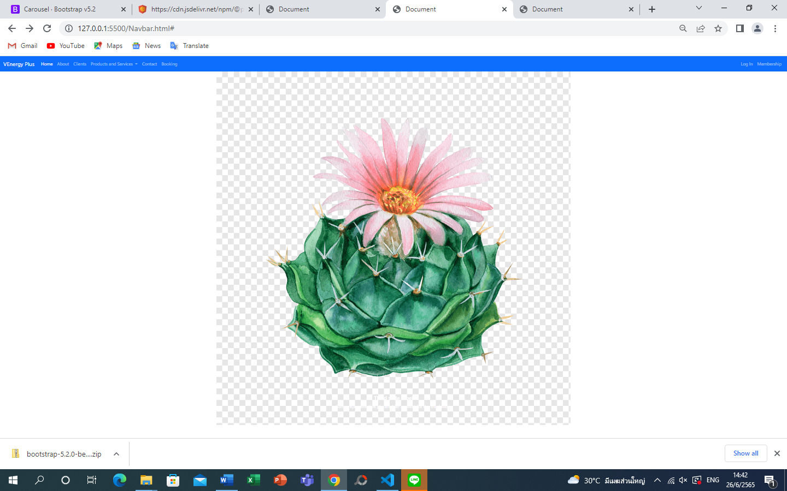 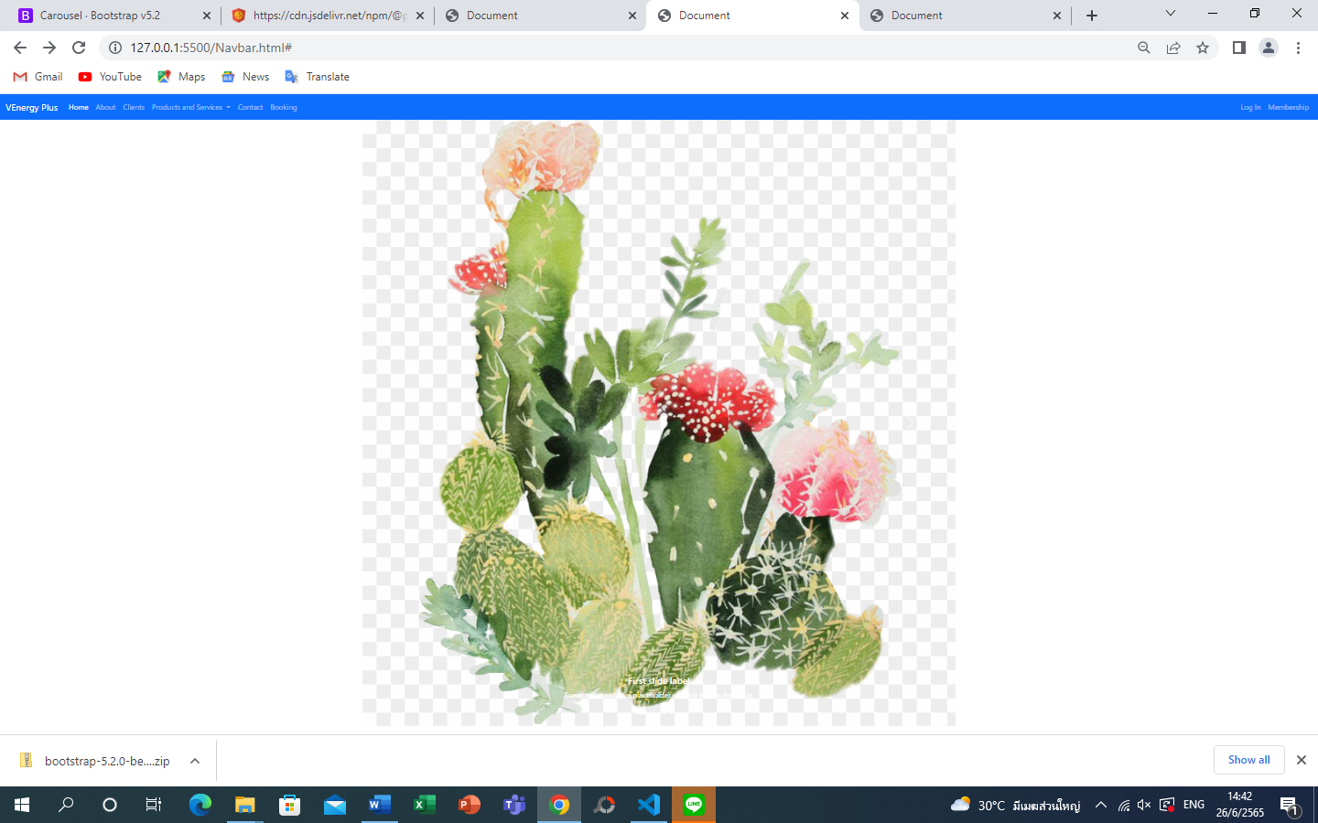 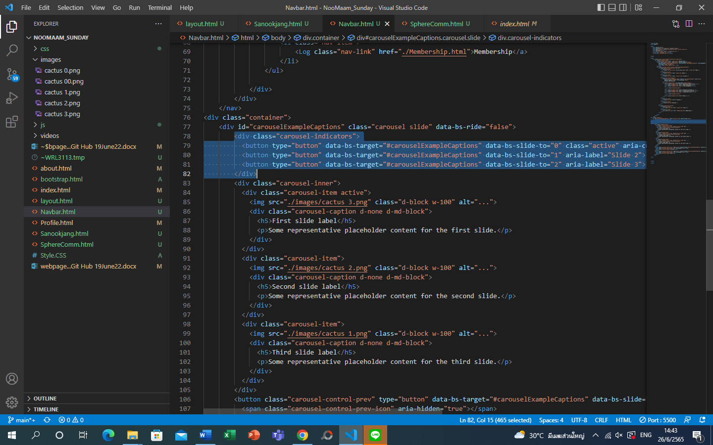 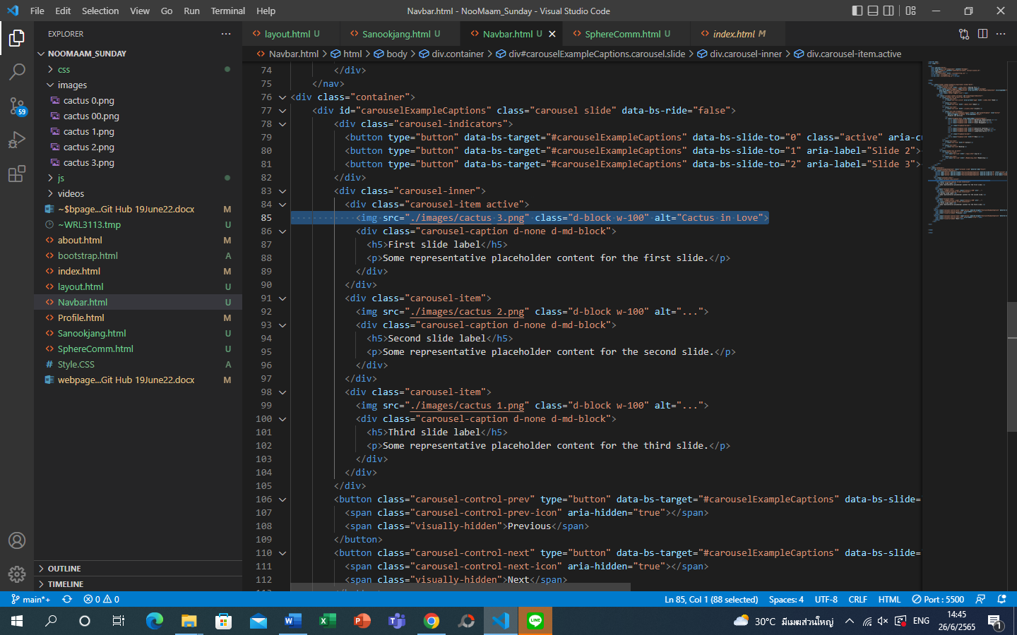insert text on slide

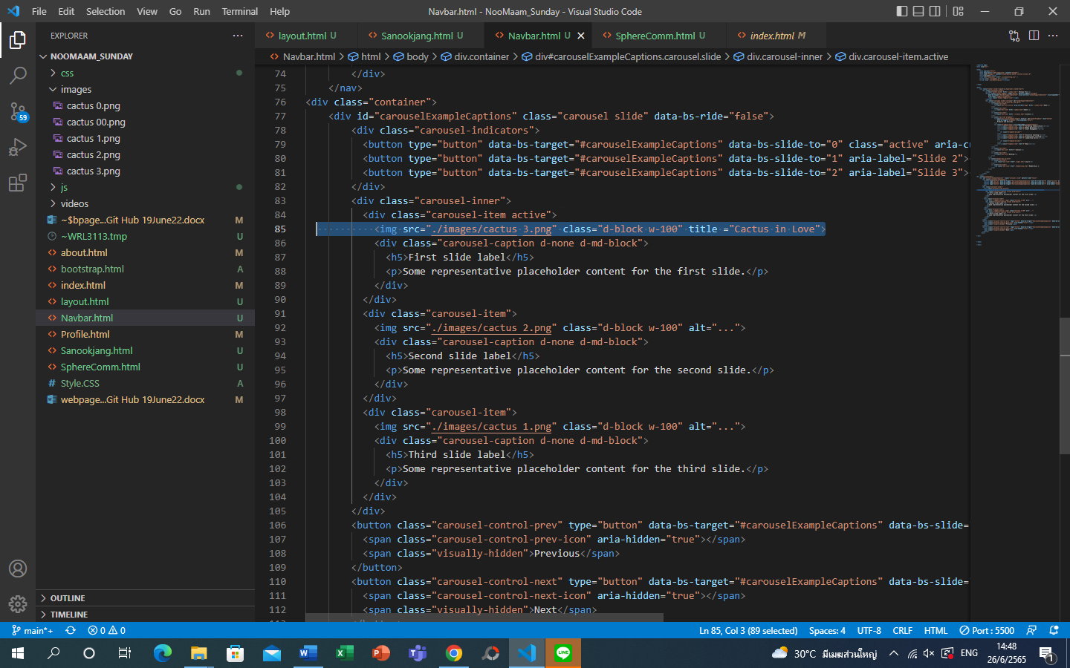change to title for mouse text

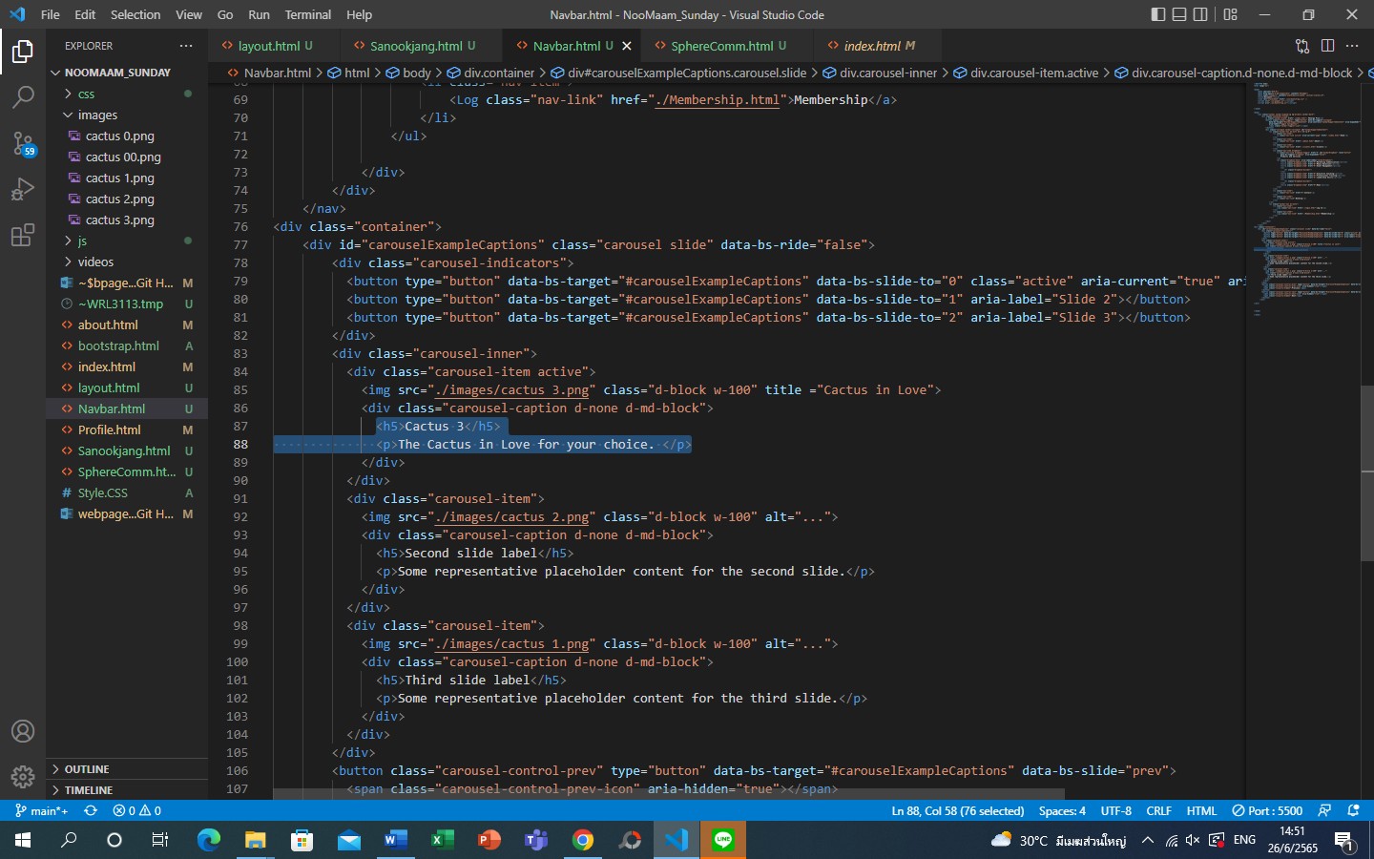change label caption text of each slide

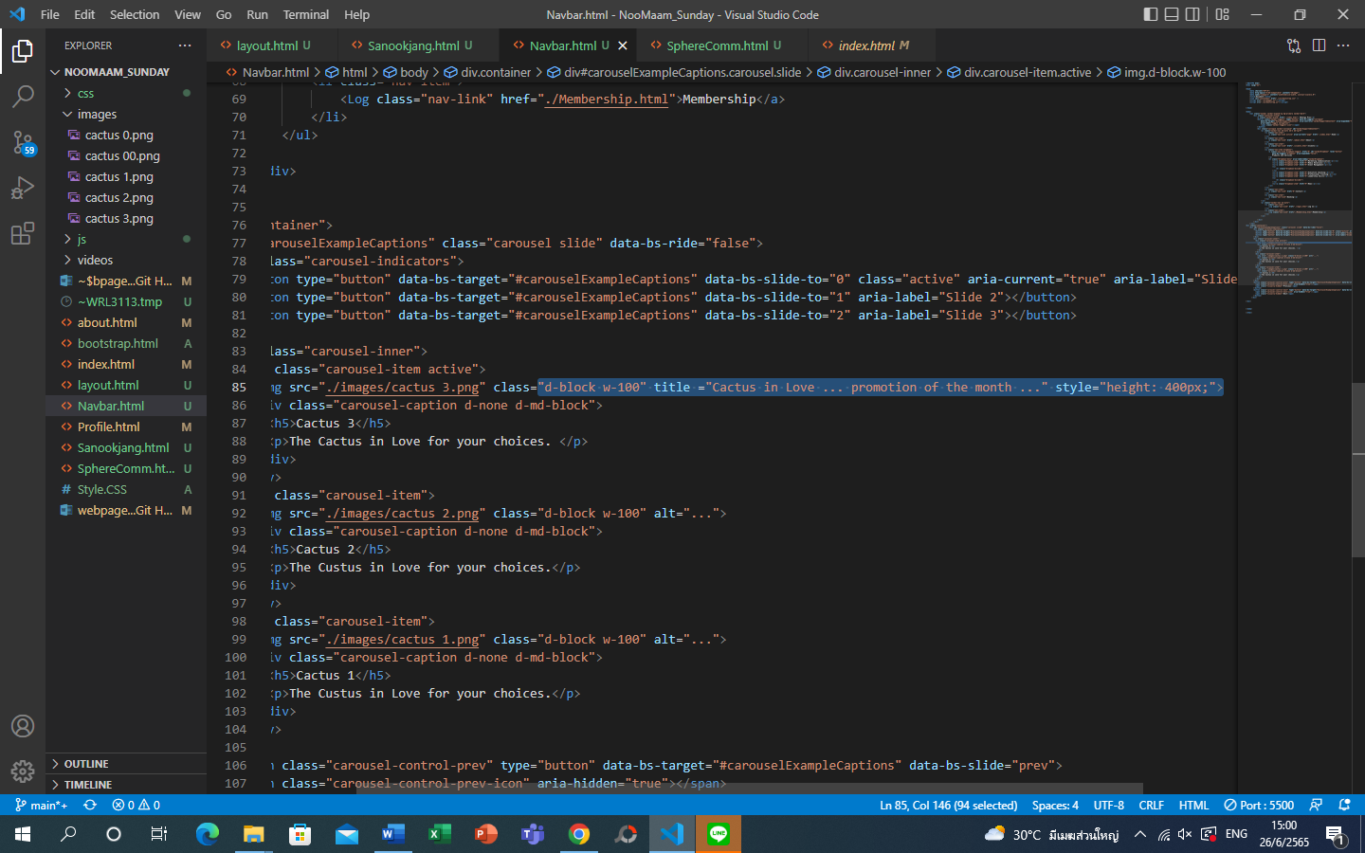change image size

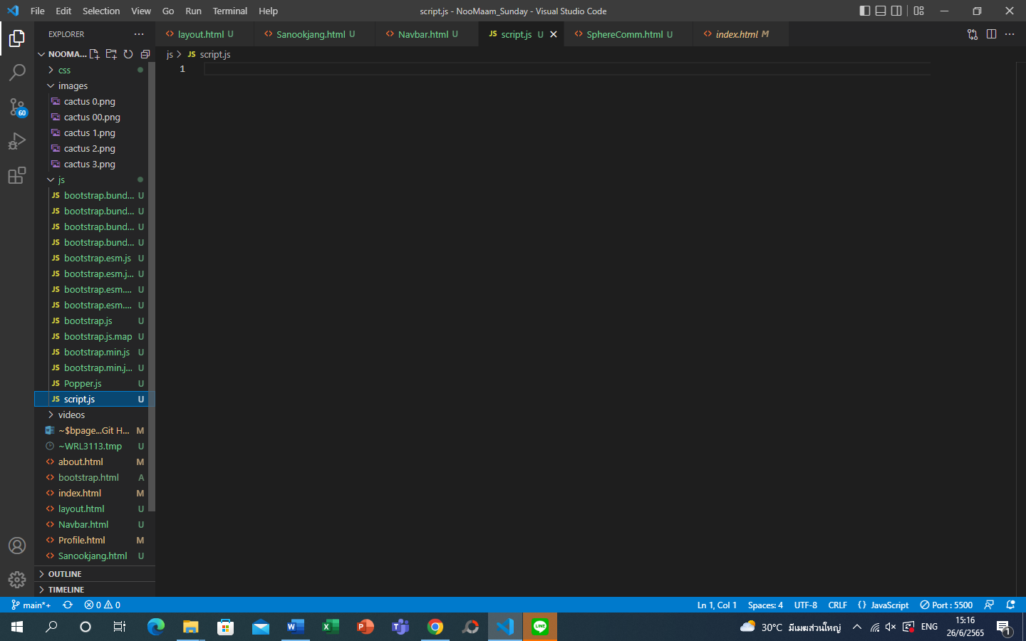create file script.js to initiate auto run slide

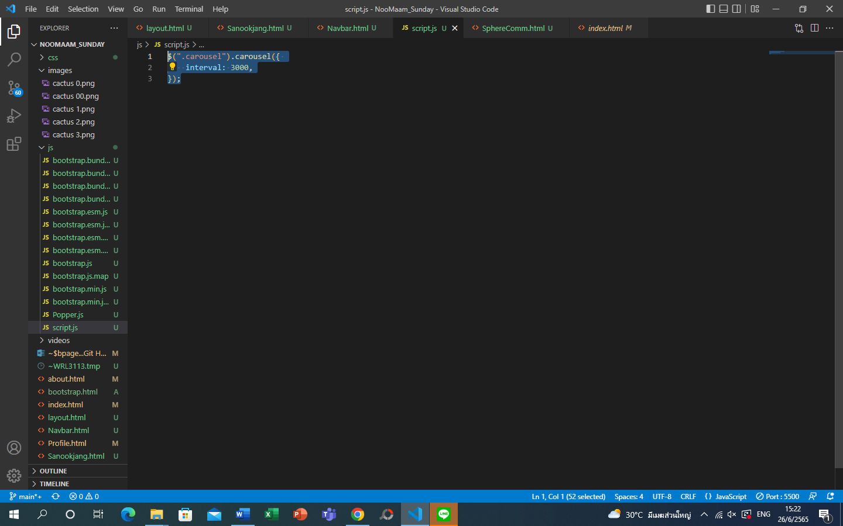

Interval number for how fast on auto slide show

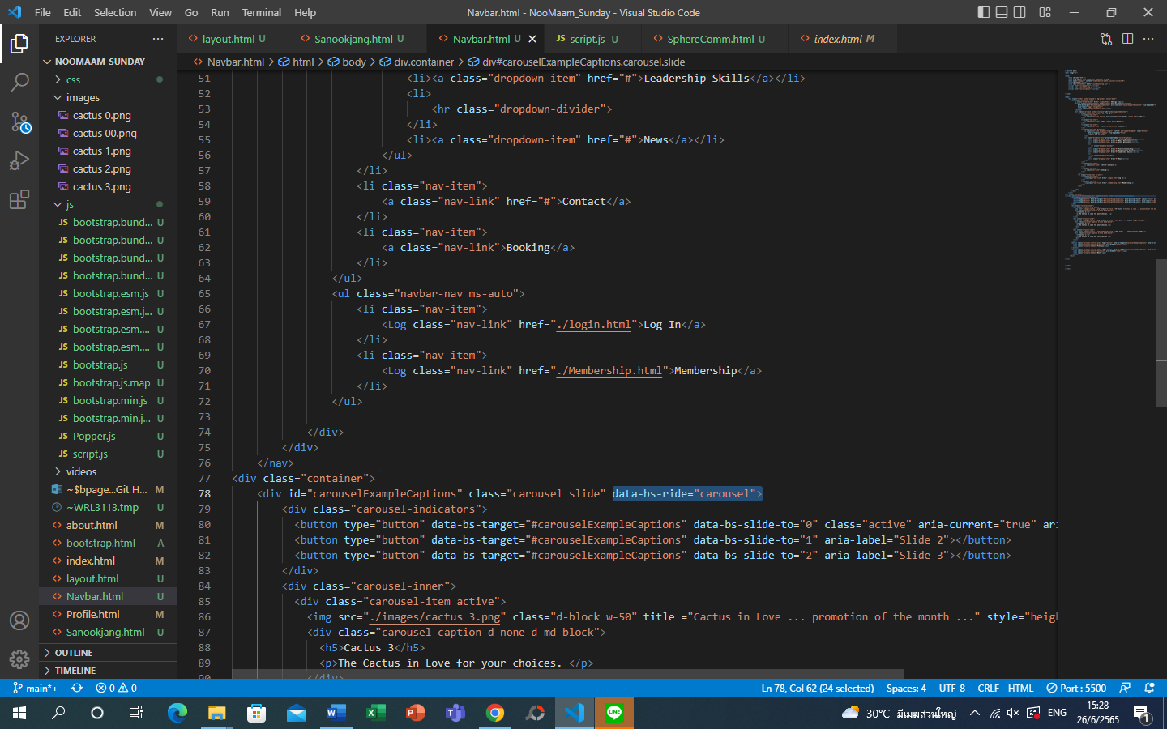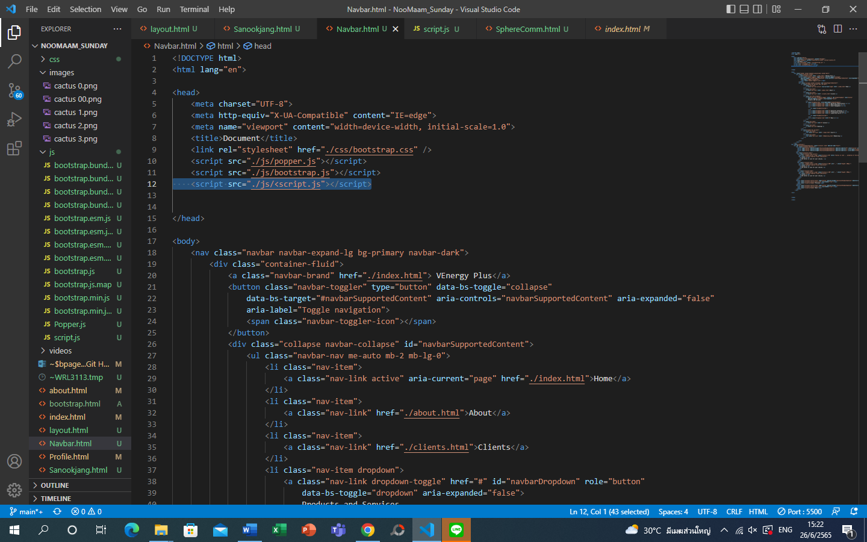input code as bootstrap / change ‘false’ in data-bs-ride to ‘carousel’

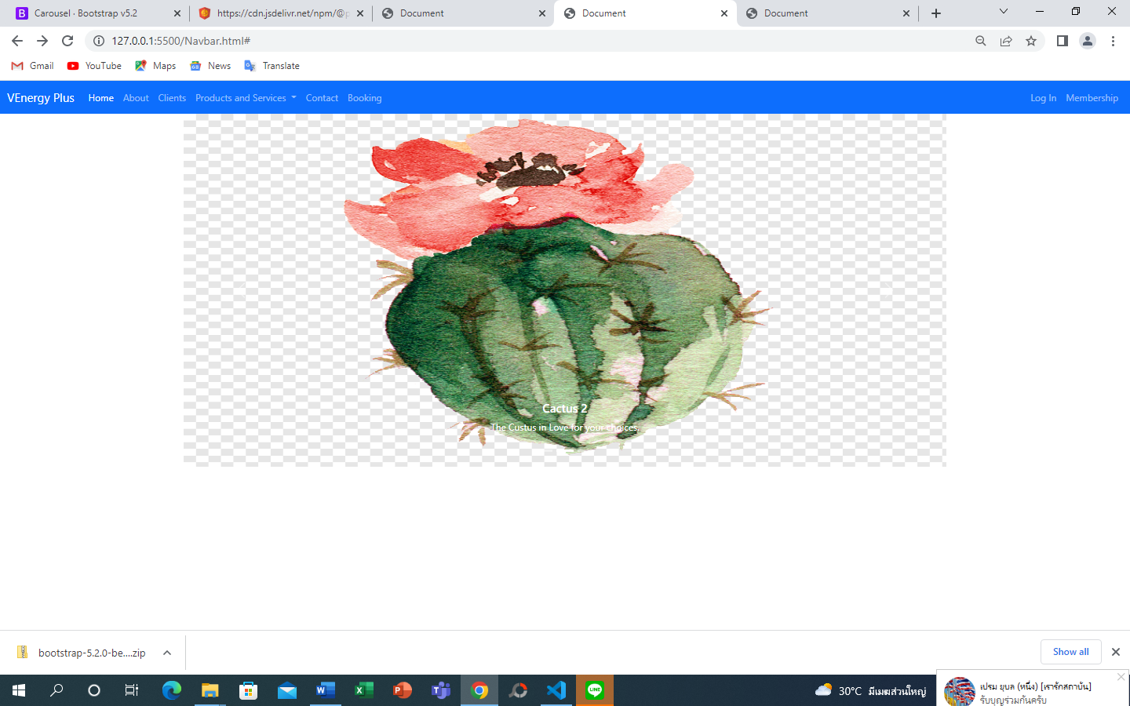 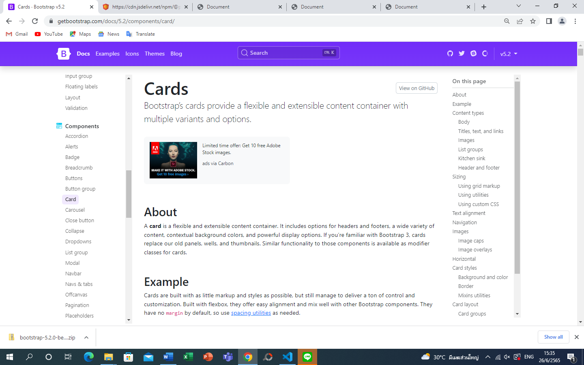 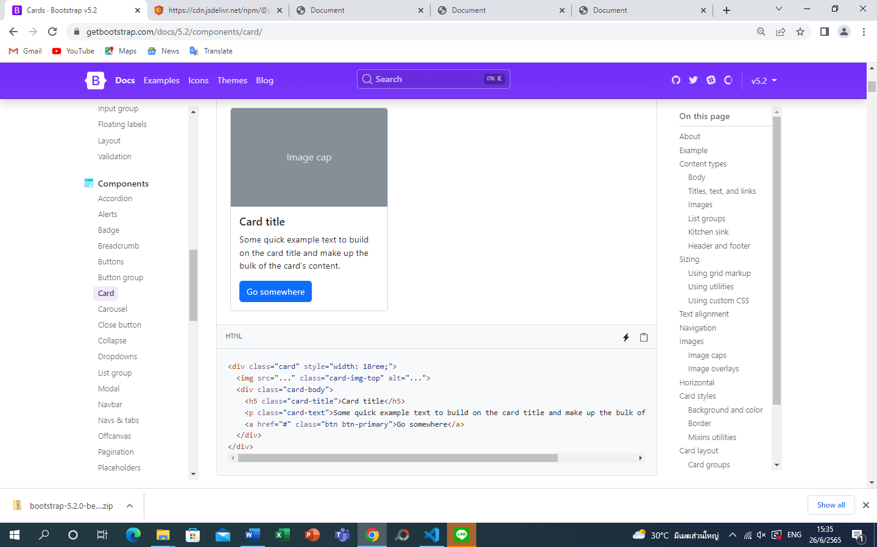 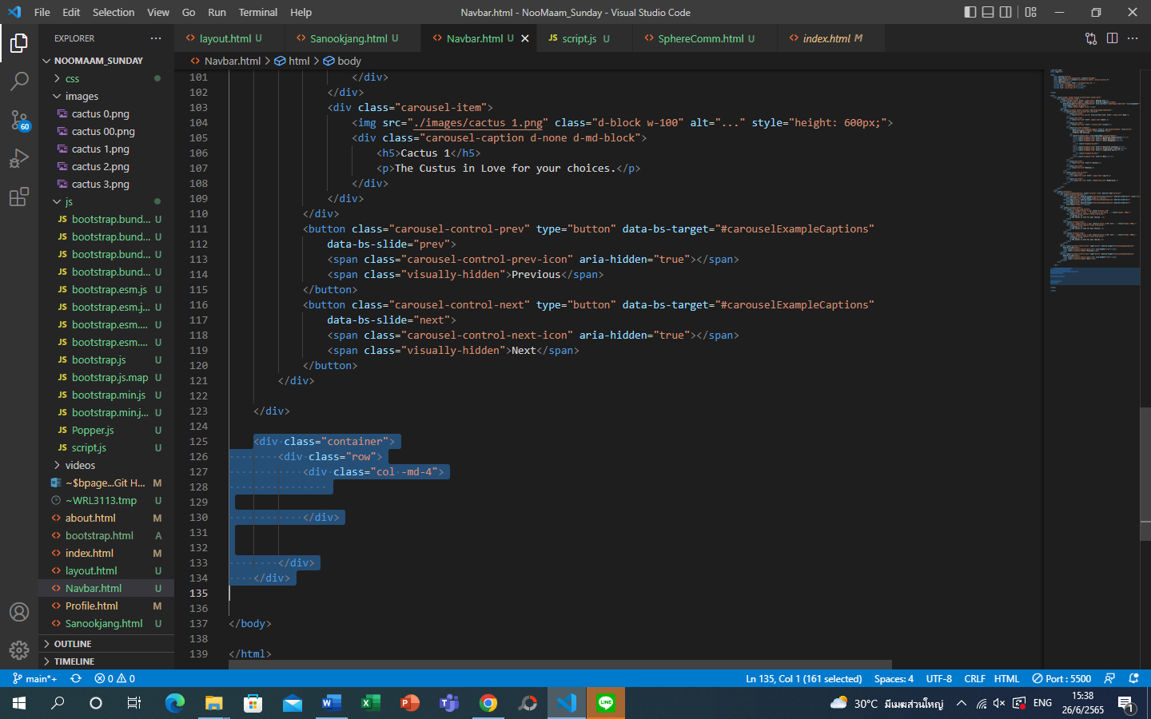create card by create container with row and column